SUBCOURSE EDITION
SA0746 7

CAPACITIVE REACTANCE,
CAPACITANCE, AND RC
TRANSIENTS IN RC SERIES AND
PARALLEL CIRCUITS



INDEX

Introduction ii

Lesson 1 1

Lesson 2 87

i

CORRESPONDENCE COURSE
OF THE
UNITED STATES ARMY INTELLIGENCE SCHOOL, FORT DEVENS

SUBCOURSE 746, EDITION 7

CAPACITIVE REACTANCE, CAPACITANCE, AND RC TRANSIENTS
IN RC SERIES AND PARALLEL CIRCUITS

EDITION 7
7 CREDIT HOURS
REVIEWED: 1988

INTRODUCTION

This subcourse consists of two lessons. One is concerned with capacitance, capacitive reactance, and resistance in simple series and parallel circuits. This lesson will enable the student to solve for problems dealing with these electrical properties as well as provide him with an understanding of Kirchoff's voltage law, the phase relationship between current and voltage in purely capacitive and RC series circuits, and vectorial plotting. The second lesson presents a procedure intended to simplify the analysis of RC circuits. This method is to consider the output voltage changes with dc voltages applied.

Supplementary Training Material Provided - None

Material to be provided by the student - None
Prerequisites: 1. CAPACITANCE, USAISD Subcourse No. 745, October 1979

2. RELATED MATHEMATICS AND THE GENERATION OF A SINEWAVE, USAISD Subcourse No. 736, September 1978

Seven credit hours will be awarded for successful completion of this subcourse.

ii

LESSON 1

OBJECTIVE: The student will

1. select the phase relationship between current and applied voltage in a capacitive circuit.

2. select the correct computation for capacitive reactance.

3. select the reference used when vectorially plotting the characteristics of a series RC circuit.

4. select the requirement necessary for using Kirchoff's voltage law in a series RC: circuit.

5. solve for applied voltage and phase angle.

6. solve for impedance and phase angle.

7. solve for current.

8. solve for Pt, Px and Pa.

9. select the statement identifying the phase angle in a series RC circuit.

10. solve for PF and Pt in a series RC circuit with Pa and phase angle given.

11. solve for the total capacitance of a series circuit.

12. solve for the total capacitance and the capacitive reactance of a parallel circuit.

13. solve for the unknown value of θ, Z, Iline, ER, and EC in a series RC circuit.

14. solve for EC in a parallel circuit.

15. solve for total charge (Qt) in a parallel circuit.

16. solve for Qt in a series circuit.

17. solve for EC, in a series circuit.

18. solve for the maximum voltage that can be applied, considering the safety factor.

1

TASK: Using the applicable formulae, you will solve for unknown values of capacitance, capacitive reactance, impedance, current, resistor/capacitor voltages, phase angle, power, and total charges existing in simple series and parallel circuits. Additionally you will be required to employ Kirchoff's law of voltages, and vectorial plotting when solving certain problems in series RC circuits.

CONDITIONS: You will have this booklet for self-paced study. All information required is contained herein.

STANDARDS: You will not be limited to the amount of time you may expend on this lesson or subcourse as a whole; however, you must conform to the minimum progress requirements set forth in chapter 3, DA Pam 351-20-18.

REFERENCES: 1. Basic Electricity. NAVPERS 10086-A. Washington, D.C.: U.S. Government Printing Office, 1960. Chapter 9, pages 149-159, and chapter 10, pages 166-169.

2. Dawes, Chester. Electrical Engineering, Volume 2. Fourth Edition. New York: McGraw-Hill. Chapter 2, pages 34-38.

3. Mandl, Mathew. Fundamentals of Electric and Electronic Circuits. Prentice-Hall, 1964. Chapter 9, pages 157-175.

2

INSTRUCTIONAL CONTENT

1. INTRODUCTION:

Presented in this lesson are formulae for solving for total capacitance in both series and parallel circuits, capacitive reactance, phase angle, impedance, current, and voltage. Also considered are Kirchoff's voltage law, the use of vectors to represent the voltage relationship of ER, and EC, and the phase relationship existing between current and voltage.

3

1. Capacitance is defined as that quality of a circuit that enables energy to be stored in an electric field. A capacitor is a device that possesses the quality of capacitance. t a d-c voltage is applied across an uncharged capacitor, a large initial current is established. As the capacitor charges toward the applied voltage, the current decreases exponentially until the capacitor is completely charged.
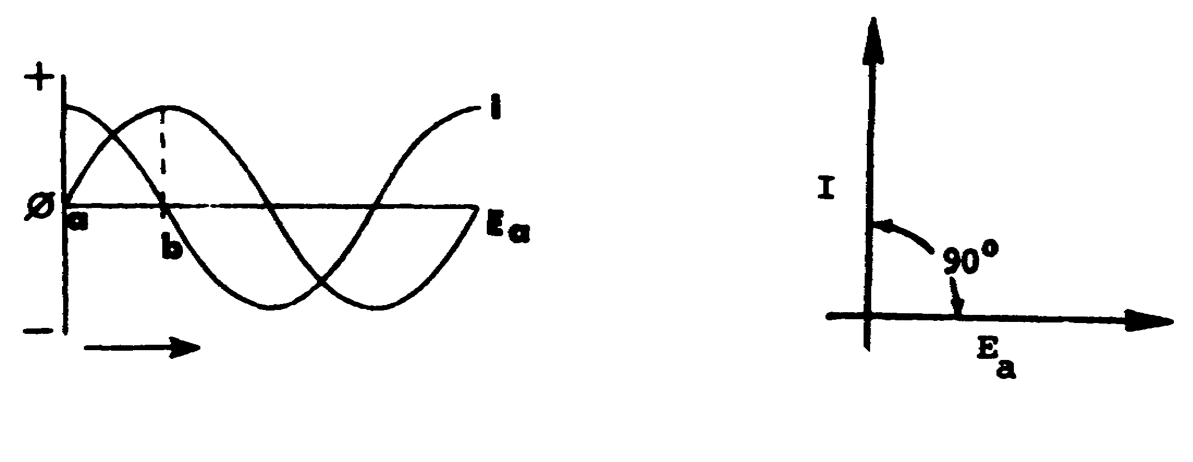
A B

The graph in figure A above illustrates that when a sine wave of voltage is applied to a pure capacitance, maximum current flaws as the voltage begins to rise tram zero (point a on figure A). The current is zero when the voltage across the capacitor is at a maximum (point b on figure A). The current leads the applied voltage by 90°, as indicated in the vectorial diagram in figure B.

In a purely capacitive circuit, the current ________________the
(leads/lags)
applied voltage by 90°.

leads

5

2. Capacitive reactance (Xc) is equal to the ratio of the effective voltage across the capacitor to the effective current,

Xc =  (1)

It is known that current in a capacitive circuit varies directly with the angular velocity (2πf), the capacitance, and the voltage,

I = 2πfCE (2)

Dividing both sides of equation (2) by E,

 = 2πfC (3)

Taking the reciprocal of both sides of equation (3),

= 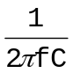 (4)

Substituting equation (1) into equation (4),

XC =

Capacitive reactance is measured in ohms and represents the opposition to current in a capacitive circuit.

6

2. (Continued)

Compute the capacitive reactance in the circuit below.

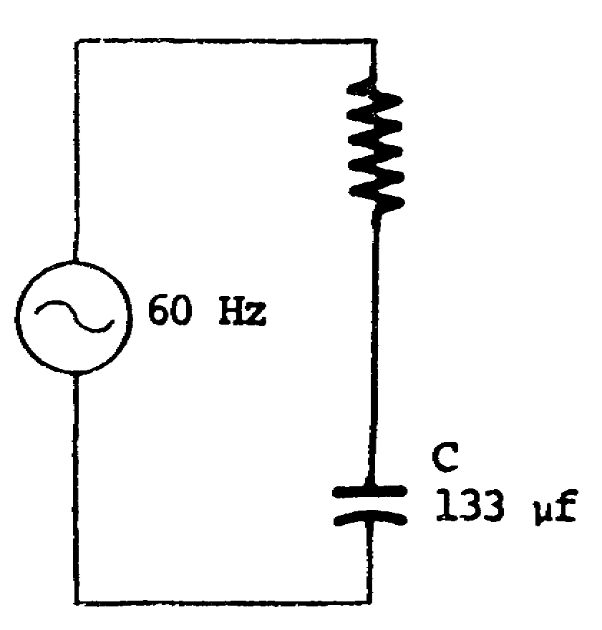

Xc = _____________

Xc = 20 Ω SOLUTION

Xc =

= 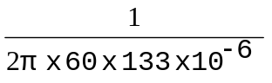

Xc = 20 Ω

3. Select the phase relationship between current (I) and applied voltage (Ea) in a purely capacitive circuit.

a. Current lags the applied voltage by 90°.
b. Applied voltage leads the current by 90º.
c. Applied voltage is in phase with the current.
d. Current leads the applied voltage by 90º.

7

d.

4. Current is used as the reference when vectorially plotting the characteristics of a series KC circuit. In an a-c circuit that is purely resistive, the applied voltage is in phase with the current. In an a-c circuit that is purely capacitive, the applied voltage lags the current by 90º. In a series circuit containing both capacitance and resistance, the applied voltage lags the current by sane angle between 0° and 90°.
As shown in figure A below, ER and Ec mist be added vectorially to find Ea in a series RC circuit.
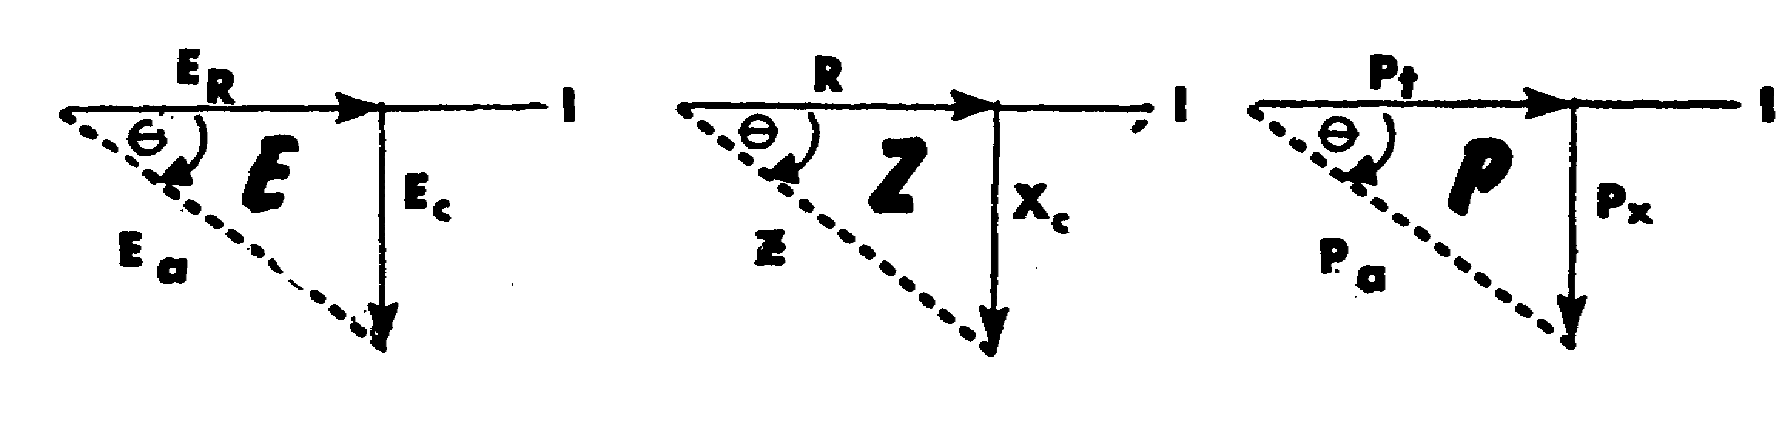
A B C

In figure B, R ad Xc are added vectorially to find Z. Similarly, Pt and Px are added vectorially to find Pa. The phase angle is between 0º and -90º. It is always a negative angle, because Ec, Xc, and Px all lag the reference.

In a series RC circuit, voltage, impedance, and power are plotted vectorially, using_________________ as a reference.

current

8

5. Solve for the capacitive reactance in the circuit below.

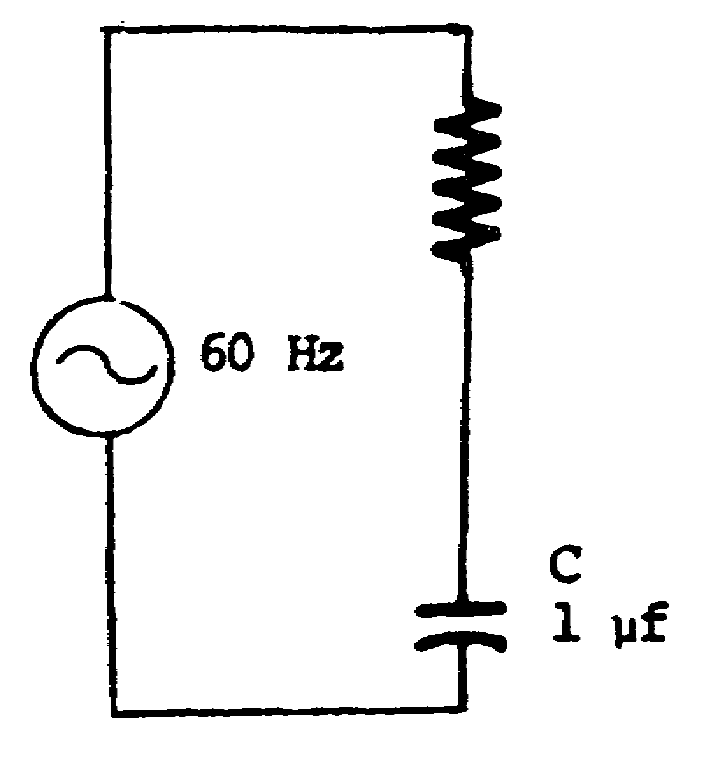

Xc = _______________________

Xc = 2.65 kΩ

6. State the phase relationship between current (I) and applied voltage (Ea) in a purely capacitive circuit.

The current leads the applied voltage by 90º.

7. Select the reference used when vectorially plotting the characteristics of a series RC circuit.

a. Voltage.
b. Power apparent.
c. Current.
d. Reactive power.

9

c.

8. Compute the capacitive reactance (Xc) in the circuit below.

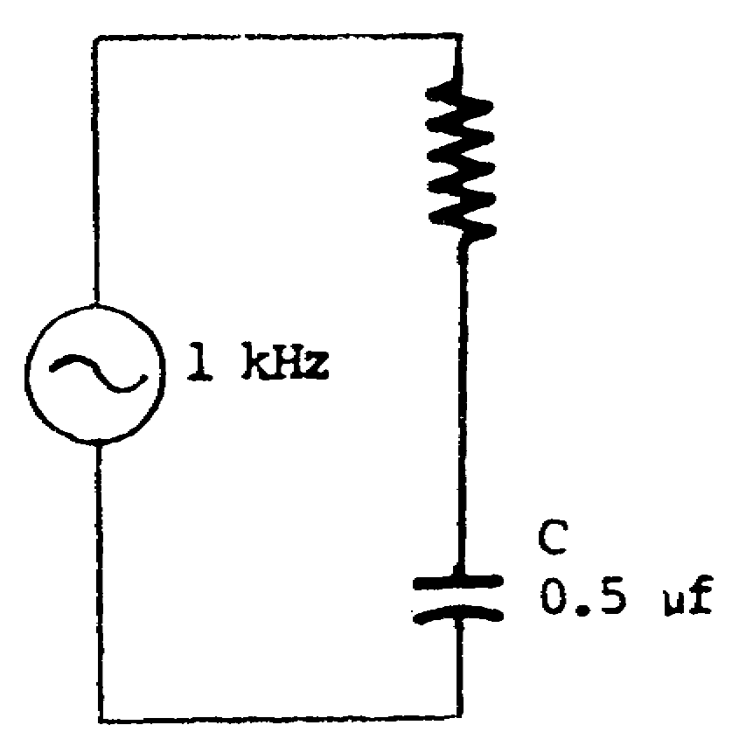

Xc = ___________________

Xc = 318.3 Ω

9. State the reference used when vectorially plotting the characteristics o f a series RC circuit.

Current.

10

10. According to Kitchhoff’s voltage law, the sum of the voltage drops across the components must equal the applied voltage. In the circuit shown in figure A below, the algebraic sum of ER and Ec does not equal Ea. This is because r.m.s. values of voltage are used instead of instantaneous values.

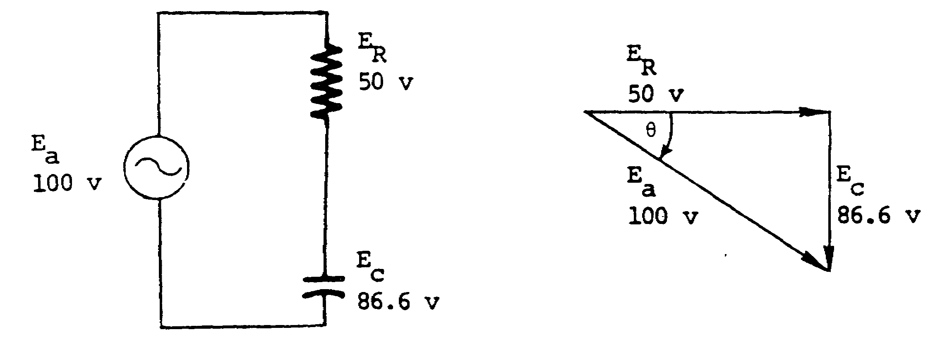
A B

Since ER and Ec are 90º out of phase, these voltages must be added vectorially to satisfy Kirchhoff's voltage law. This is shown in figure B above.

To solve for the applied voltage (Ea) and the phase angle (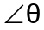) in a series RC circuit, plot the known vector quantities on the appropriate legs of a right triangle and solve for the unknown values. ER and Ec are plotted 90° apart in figure B. To solve for Ea and , any of the trigonometric functions that apply to the problem may be used; however, when using the slide rule, it is easier to convert from rectangular to polar coordinates.

Ea = 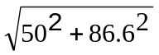

=  = 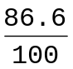 = .866 = -60º

11

10. (Continued)

Solve for Ea and in the circuit below.
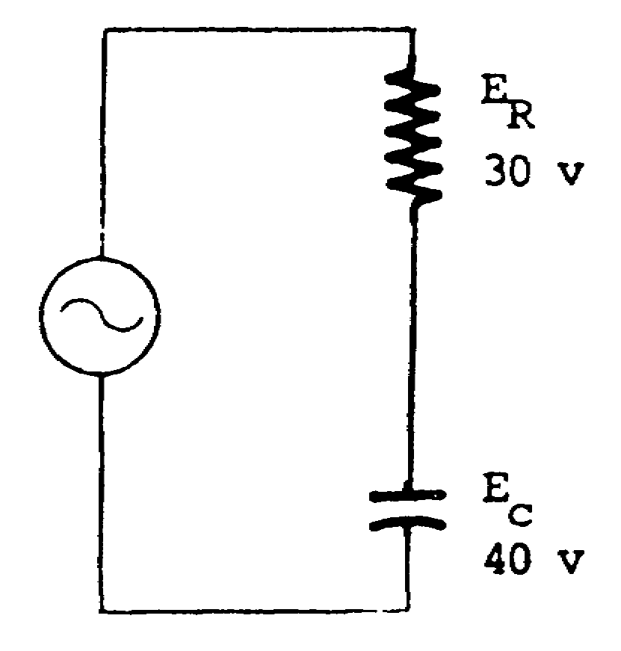

Use the Table of Natural Functions on page 33 when solving for sin, cos, or t an of  .
Ea = ________________

= ________________

Ea = 50 v
SOLUTION
= -53.1º

Ea = 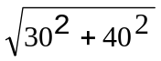

= 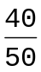 = .8 = -53.1º

11. Select the requirement necessary for using Kirchhoff's voltage law in a series PC circuit.

a. Voltages must be added directly.
b. Voltages must be added vectorially.
c. Voltages must be added algebraically.
d. Voltages must be subtracted algebraically.

12

b.

12. Impedance (Z) in a series RC circuit is calculated by vectorially adding Xc and R. Figure B below is the vectorial diagram for the circuit in figure A.
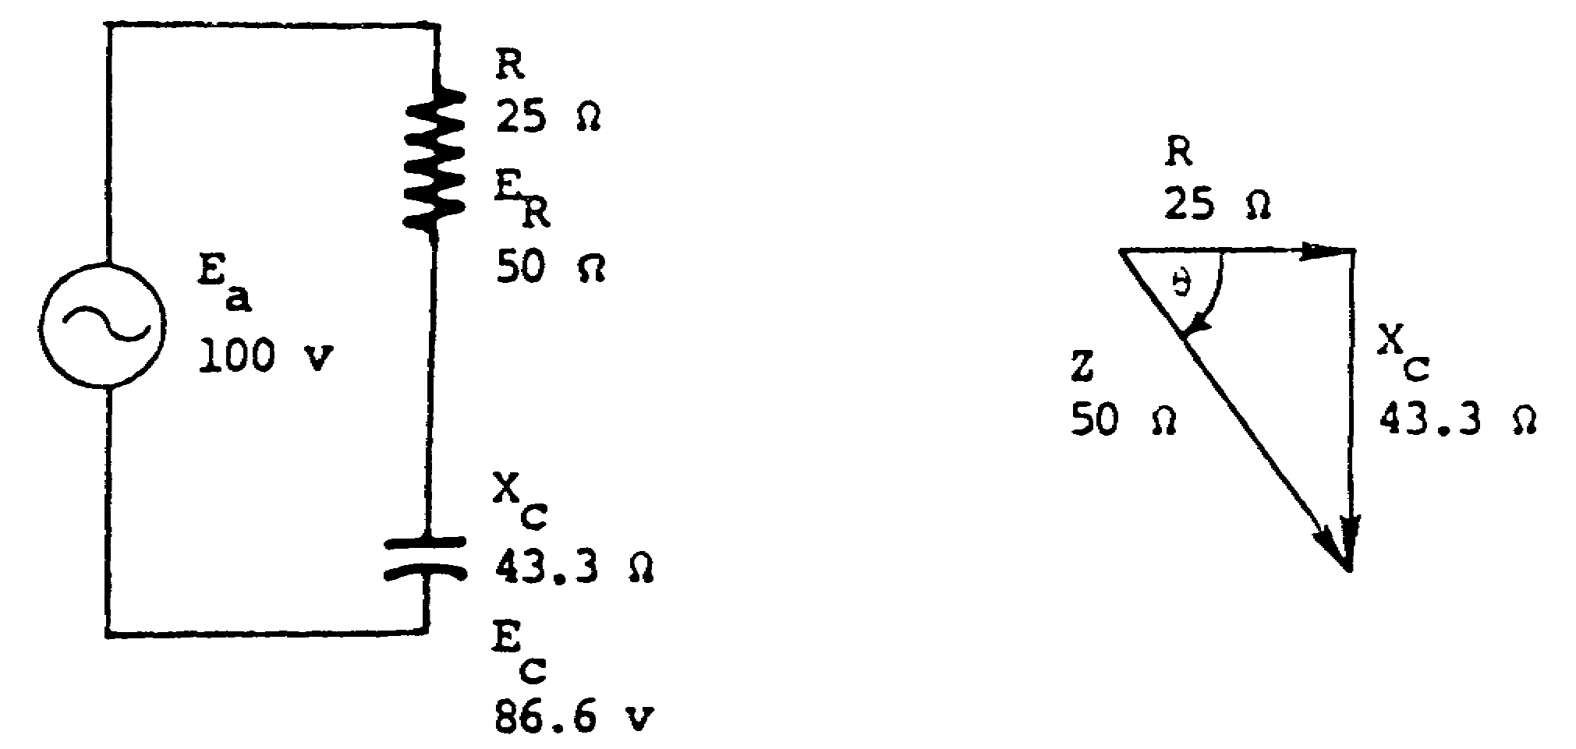
A B

Xc and R are plotted 90º out of phase with each other. The impedance vector, represented by the hypotenuse of the right triangle, and can be found by using any trigonometric function applicable to the problem or by rectangular-to-polar conversion, as shown below.
Z = 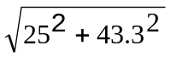
= 50v

= = 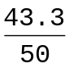 = .866 = -60º

As shown below, the angle of the impedance triangle is the same as the angle indicated for the applied voltage. In fact, the voltage triangle and the impedance triangle for the same circuit are similar triangles (all three angles equal).
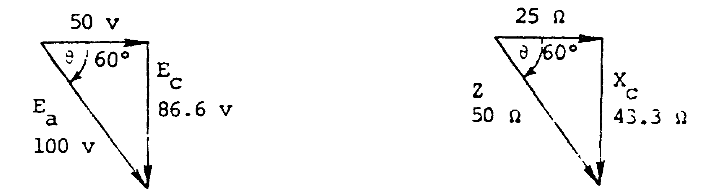

13

12. (Continued)

Solve for Z and in the circuit below.

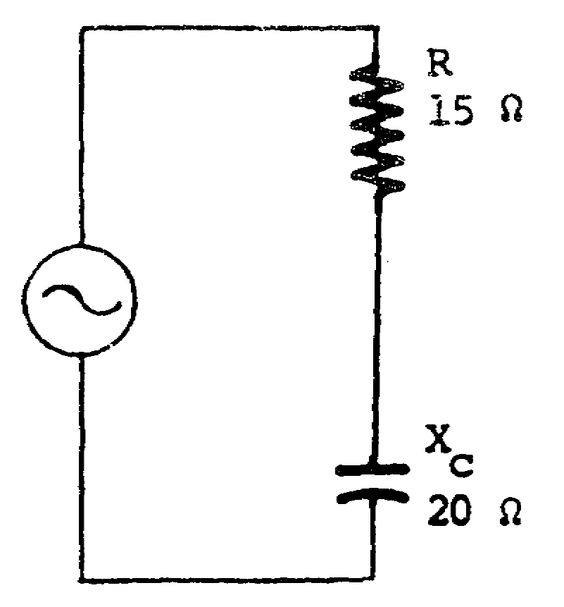

Z = _____________

= ___________

Z = 25 Ω SOLUTION

= 53.1º
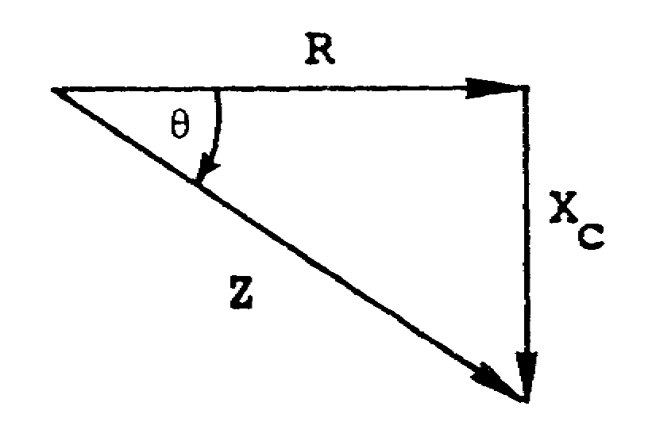

Use the Table of Natural Functions on page 33 when asked to solve for sin, cos, or tan of during the course of this lesson.

14

13. Solve for Ea and in the circuit below.
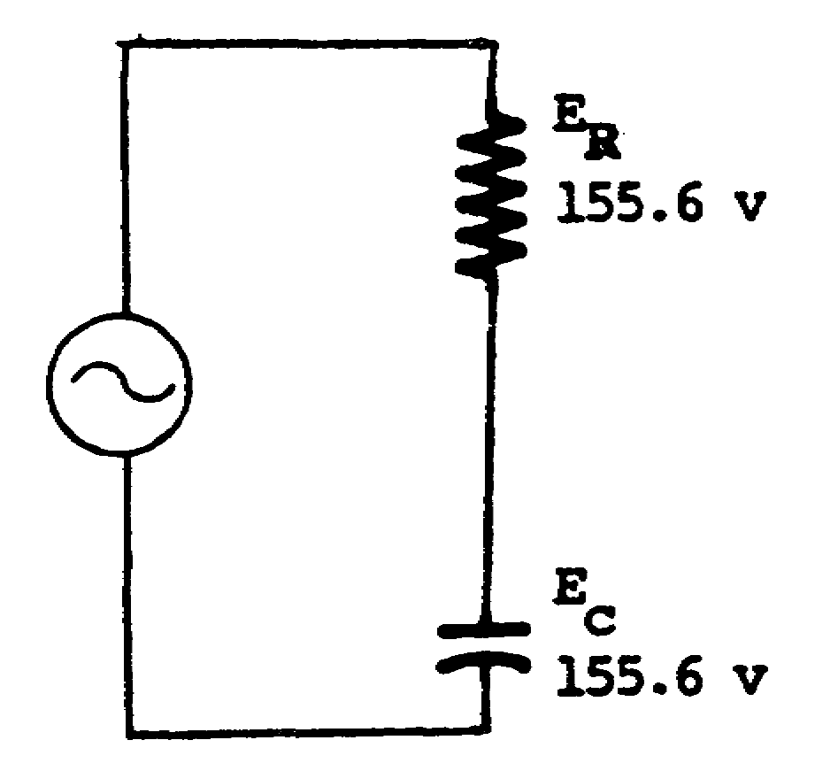

Ea = ____________

= ____________

Ea = 220 v = -45º

14. Select the requirement necessary for using Kirchhoff's voltage law in a series KC circuit.

a. Voltages must be subtracted vectorially.
b. Voltages must be added algebraically.
c. Voltages must be added vectorially.
d. Voltages must be added directly.

15

c.

15. As in any series circuit, current is the same through all the components of a series RC circuit. By using the proper values of voltage and opposition, Ohm's law can be used to find current in a series RC circuit. Three methods used to calculate current in a series RC circuit are shown below.

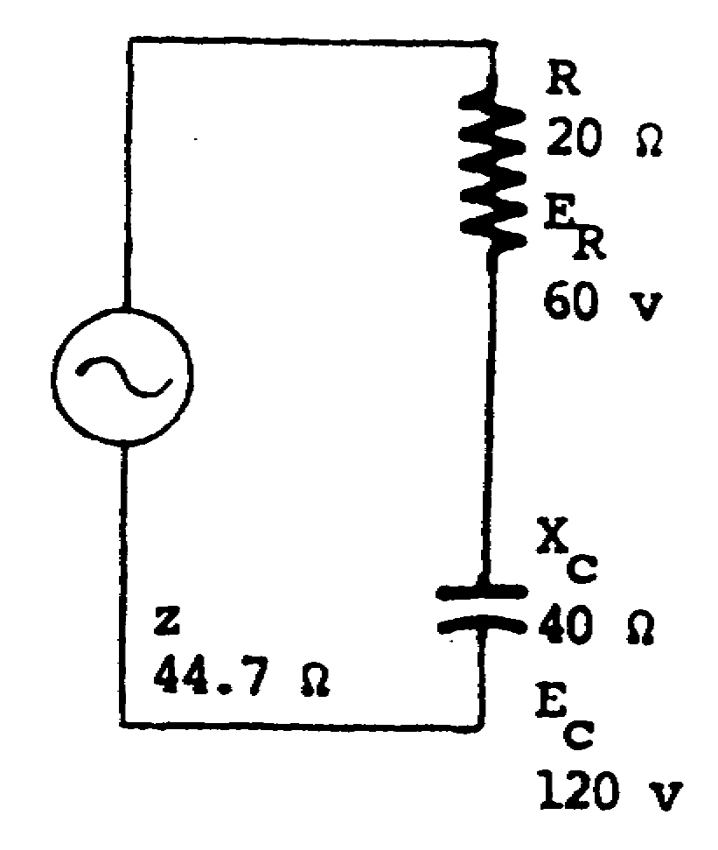

Method 1: I = 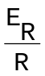 = 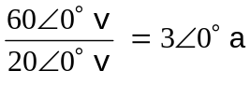

Method 2: I = 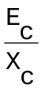 = 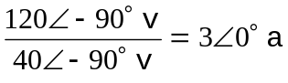

Method 3: I = 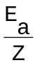 = 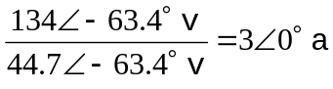

16

15. (Continued)

Solve for the current in the circuit below.

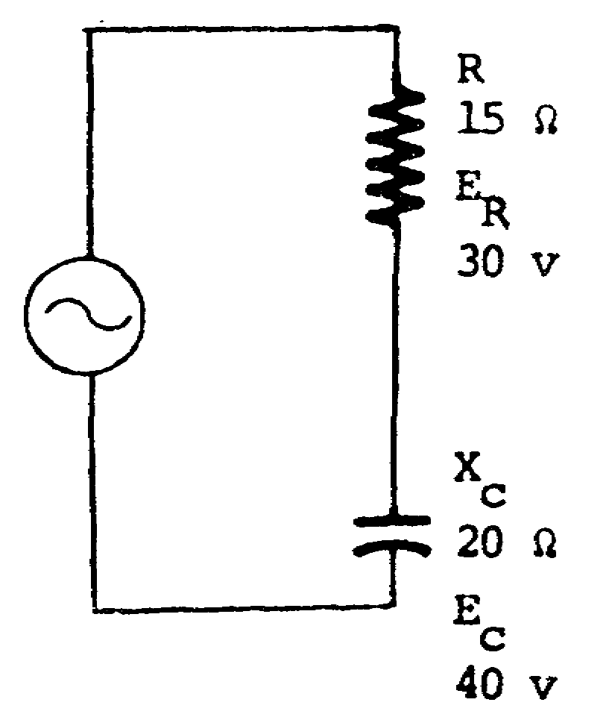

I = ___________

I = 2/0º a

17

16. Solve for Z and in the circuit below.

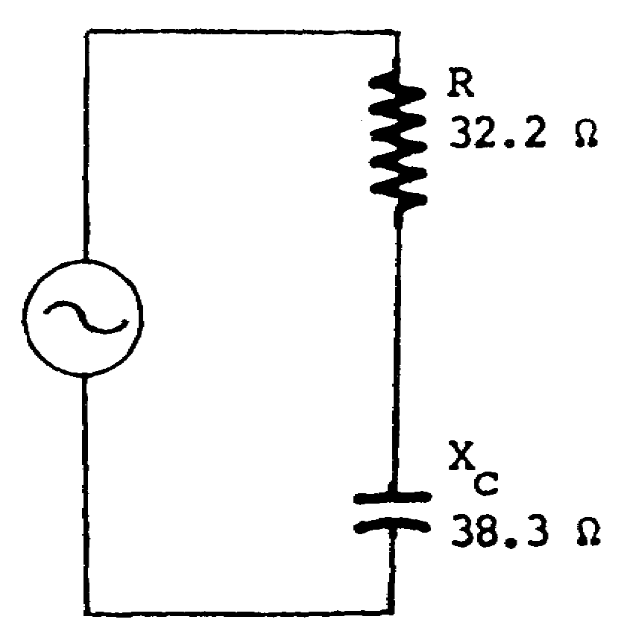

Z = _______________

= ______________

Z = 50.1 π = -49.8º

17. Solve for Ea and in the circuit below.
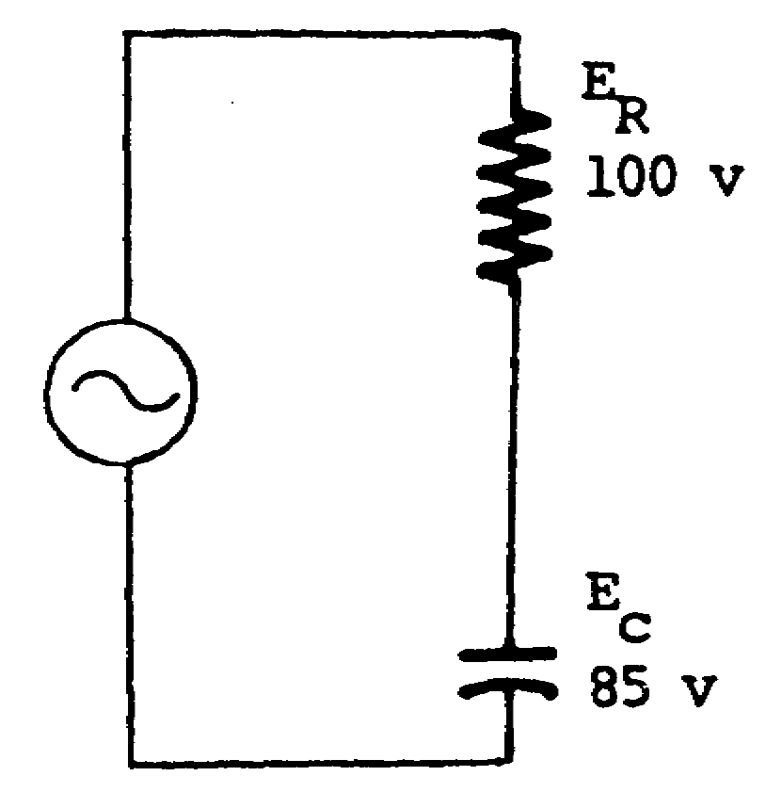

Ea = ________________

= _______________

Ea = 131.1 v = 40.4º

18

18. To prevent confusion when referring to POWER in a series RC circuit, three terms should be reviewed.
(1) APPARENT POWER (Pa) --the power the circuit appears to be using, equal to the product of the applied voltage and the circuit current: The unit of measure of apparent power is the volt-ampere (VA). Apparent power is also equal to the vector sum of true power and reactive power and can be represented by the hypotenuse of the right triangle used in the vector diagram.
(2) TRUE POWER (Pt) --the power expended by the resistive portion of the load: True power is in phase with the current; therefore, it is used as the reference for. The unit of measure is the watt. True power is calculated by using one of the following formulas.
Pt = I2R Pt = 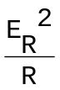

(3) REACTIVE POWER (Px)--the power used in charging a capacitor. The power is returned to the source upon discharge. Reactive power is calculated by using one of the following formulas.
Px = I2Xc Px = 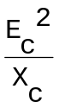

Reactive power is measured in volt-amperes-reactive, abbreviated vars, and is plotted 90° from Pt on a vector diagram. Pa, Pt, and Px are shown on the vectorial diagram below.
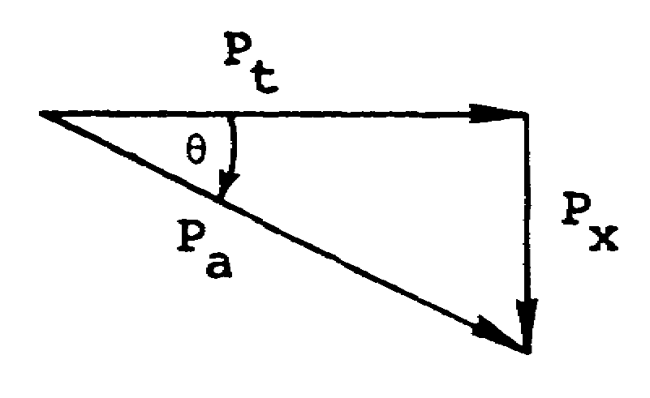

19

18. (Continued)

Solve for Pt, Px, and Pa in the circuit below.

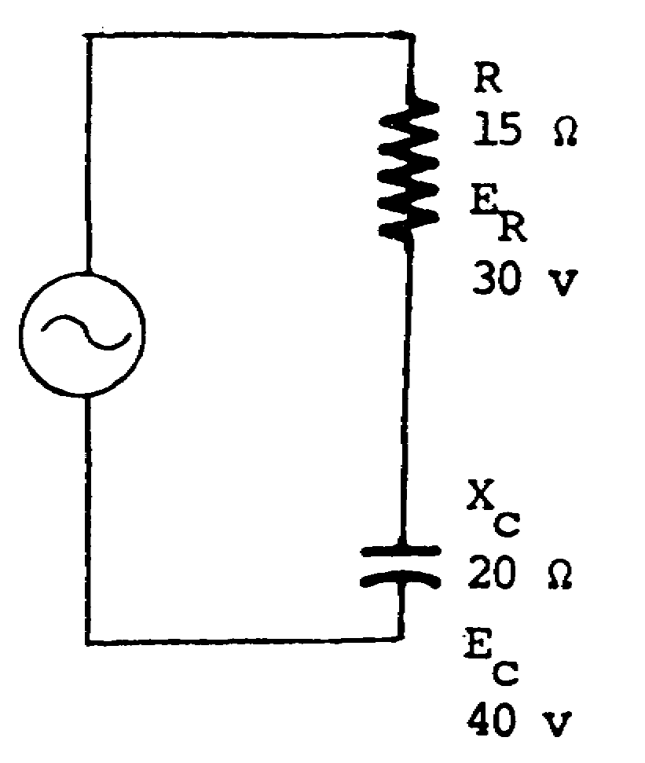

Pt = ________________

Px = ________________

Pa = ________________

SOLUTION
Pt = 60 watts
Px = 80 vars
Pa = 100 VA

Pt =

= 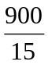

Pt = 60 watts

Px =

= 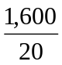

Px = 80 vars

20

18. (Solution- continued)

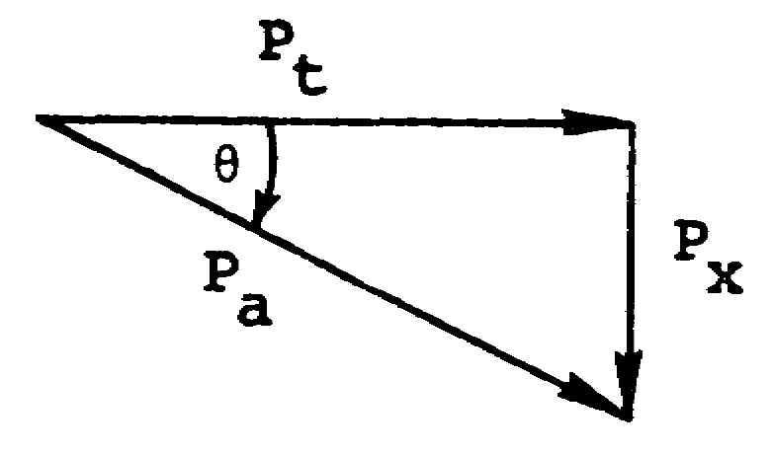

Pa = Pt - jPx

= 60 w - j80 vars

Pa = 100/-53.1° VA

NOTE: An alternate solution for Pa is to solve for current; then, multiply Ea times I.

19. Solve for the current in the circuit below.

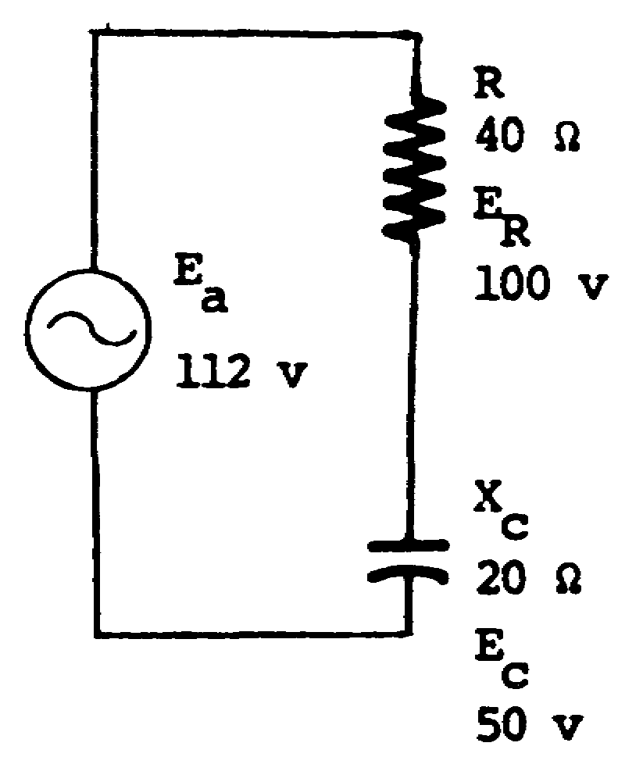

I = ___________________

21

I = 2.5/0º a

20. Solve for Z and in the circuit below.

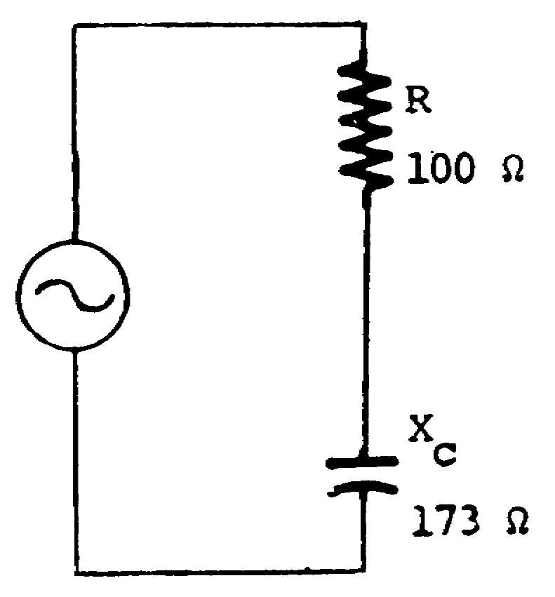

Z = _______________

= _______________

Z = 200 Ω 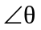 = -60º

22

21. Solve for Pt, Px, and P a in the circuit below.

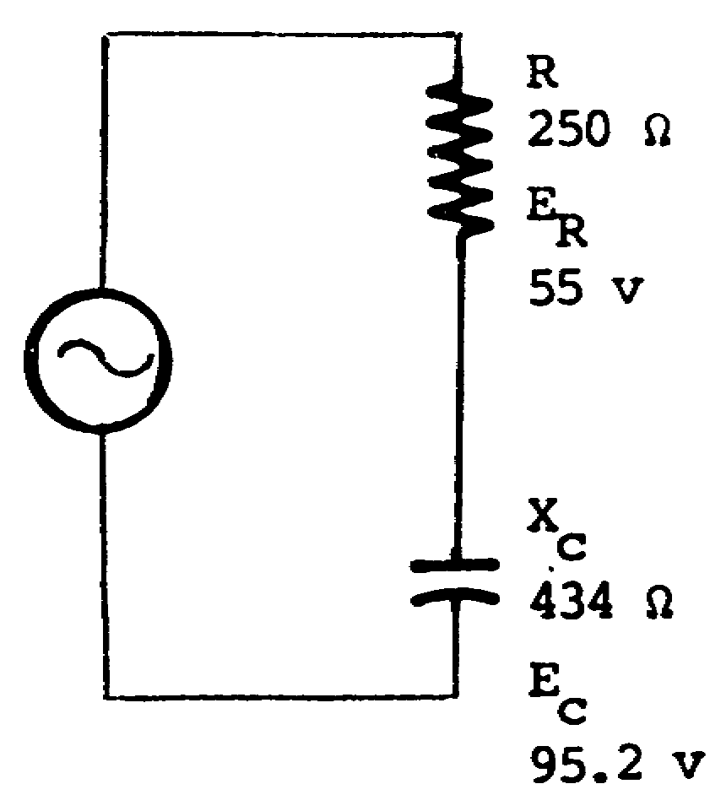

Pt = _____________

Px = _____________

Pa = _____________

Pt = 12.1 watts Px = 20.9 vars Pa = 24.2 VA

22. Solve for the current in the circuit below.

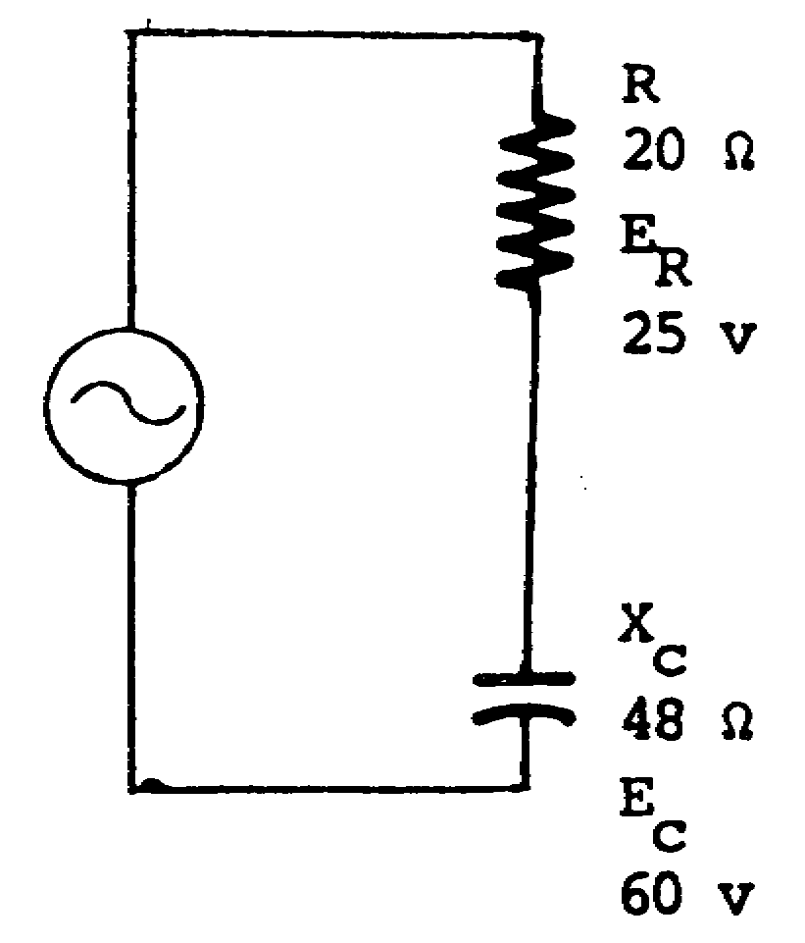

I = _______________

23

I = 1.25/0º a

23. Solve for Pt, Px, and Pa in the circuit below.

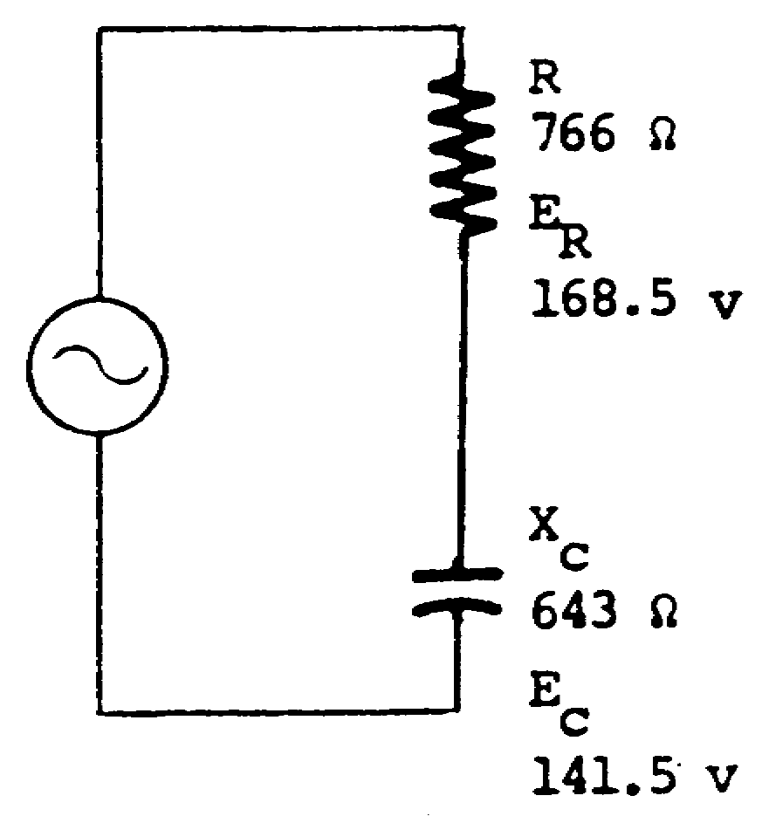

Pt = _____________

Px = _____________

Pa = _____________

Pt = 37.05 watts Px = 31.12 vars Pa = 48.4 VA

24

24. A series RC circuit always has a leading phase angle. The circuit phase angle is defined as the angular difference between Ea and I.
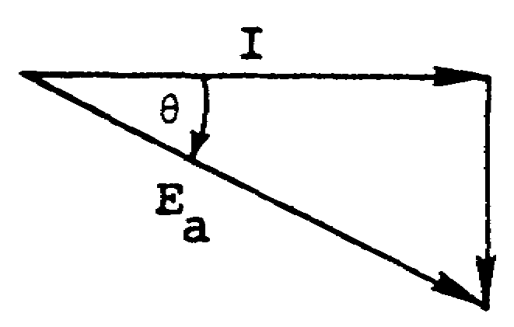

Since the circuit current leads Ea, a series RC circuit is said to have a leading phase angle. The phase angle can be found from any of the right triangles constructed to find Ea, Z, or Pa.

A series RC circuit has a _________________ phase angle, because (leading/lagging)

the current always______________ the applied voltage.
(leads/lags)

leading leads

25. No true power is expended in a purely capacitive a-c circuit. By definition, true power is the average power actually consumed by the circuit, the average being taken over one complete cycle of alternating current.

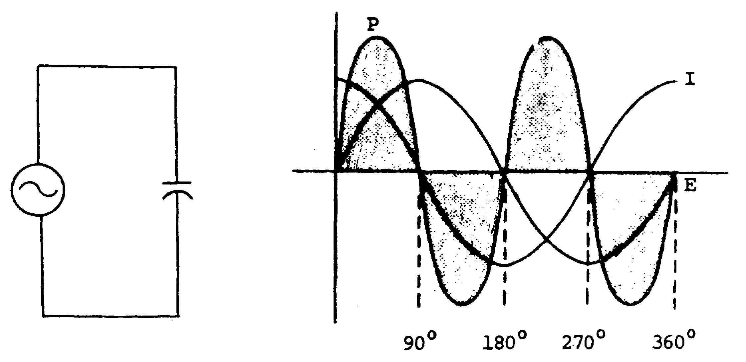

25

25. (Continued)

Referring to the diagram on page 25, notice that during the first 90°, current is drawn from the source, and power--the product of voltage and current--is positive during the interval. From 90° to 180º, the capacitor returns current to the source, and power--the product of voltage and current--is negative during this interval. This seemingly negative power is power returned to the source. The average power actually consumed by the circuit for the first 180º is zero. There is a similar alternation from 180º to 360°, and the average power consumed by a purely capacitive circuit for 360º is zero.

How much power is expended in a purely capacitive a-c circuit?

None.

26. Select the type of and the reason for the phase angle in a series RC circuit.

a. A series RC circuit has a lagging phase angle, because the current always lags the applied voltage.

b. A series RC circuit has a leading phase angle, because the applied voltage always leads the current.

c. A series IC circuit has a lagging phase angle, because the current always leads the applied voltage.

d. A series RC circuit has a leading phase angle, because the current always leads the applied voltage.

26

d.

27. The power factor (PF) of a circuit is the ratio of true power to apparent power. The formula is

PF = 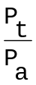

Since true power is represented by the adjacent side of a right triangle of a vectorial diagram and apparent power by the hypotenuse, PF is also equal to the cosine of the phase angle,

PF = cos

The power factor may be expressed as a decimal or a percentage and indicates the portion of apparent power that is actually expended in the circuit. The power factor is expressed as LEADING or LAGGING and indicates what Pt is doing in respect to Pa. In a series RC circuit, current leads the applied voltage; therefore, the POWER FACTOR is said to be LEADING.

In a series RC circuit, the power factor is__________________,
(leading/lagging)

because the Pt always __________________the Pa.
(leads/lags)

leading leads

27

28. Select the quantity of power expended in a purely capacitive a-c circuit.

a. Maximum.
b. Minimum.
c. None.
d. Varies according to the value of capacitance.

c.

29. Select the type of and the reason for the phase angle in a series RC circuit.

a. A series RC circuit has a leading phase angle, because the current always leads the applied voltage.

b. A series RC circuit has a lagging phase angle, because the current always lags the applied voltage.

c. A series IC circuit has a leading phase angle, because the current always lags the applied voltage.

d. A series RC circuit has a lagging phase angle, because the current always leads the applied voltage.

a.

28

30. The power factor can be useful in solving the power triangle of a series RC circuit.

Since PF =

and PF = cos

then cos =

Pt = cos x Pa

For example: The true power of a circuit that has a Pa of 100 VA and a phase angle of 60º would be computed as shown below. (The cosine of 60° is 0.5.)

Pt = cos x Pa

= 0.5 x 100 VA

Pt = 50 watts

What is the PF and the Pt of a series RC circuit that has a Pa of 100 VA and a phase angle of 45°?

PF = ____________

Pt = ____________

Pf = 0.707 leading Pt = 70.7 watts

29

31. Select the type of and the reason for the power factor in a series RC circuit.

a. A series RC circuit has a lagging power factor, because Pt lags Pa.

b. A series RC circuit has a leading power factor, because Pt leads Pa.

c. A series RC circuit has a leading power factor, because Pa leads Pt.

d. A series RC circuit has a lagging power factor, because Pa lags Pt.

b.

32. State the quantity of power expended in a purely capacitive a-c circuit.

None.

30

33. Solve for the PF and the Pt in a series RC circuit that has a Pa of 600 VA and a phase angle of 53.1°.

PF = _____________

Pt = _____________

PF = 0.6 leading Pt = 360 watts

34. Select the type of and the reason for the power factor in a series RC circuit.

a. A series RC circuit has a leading power factor, because Pt leads Pa.

b. A series RC circuit has a lagging power factor, because Pt lags Pa.

c. A series RC circuit has a lagging power factor, because Pa lags Pt.

d. A series RC circuit has a leading power factor, because Pa leads Pt.

31

a.

35. Solve for the PF and the Pt in a series RC circuit that has a Pa of 300 VA and a phase angle of 45°.

PF = ______________

Pt = ______________

PF = 0.707 leading Pt = 212 watts

32

TABLE OF NATURAL FUNCTIONS

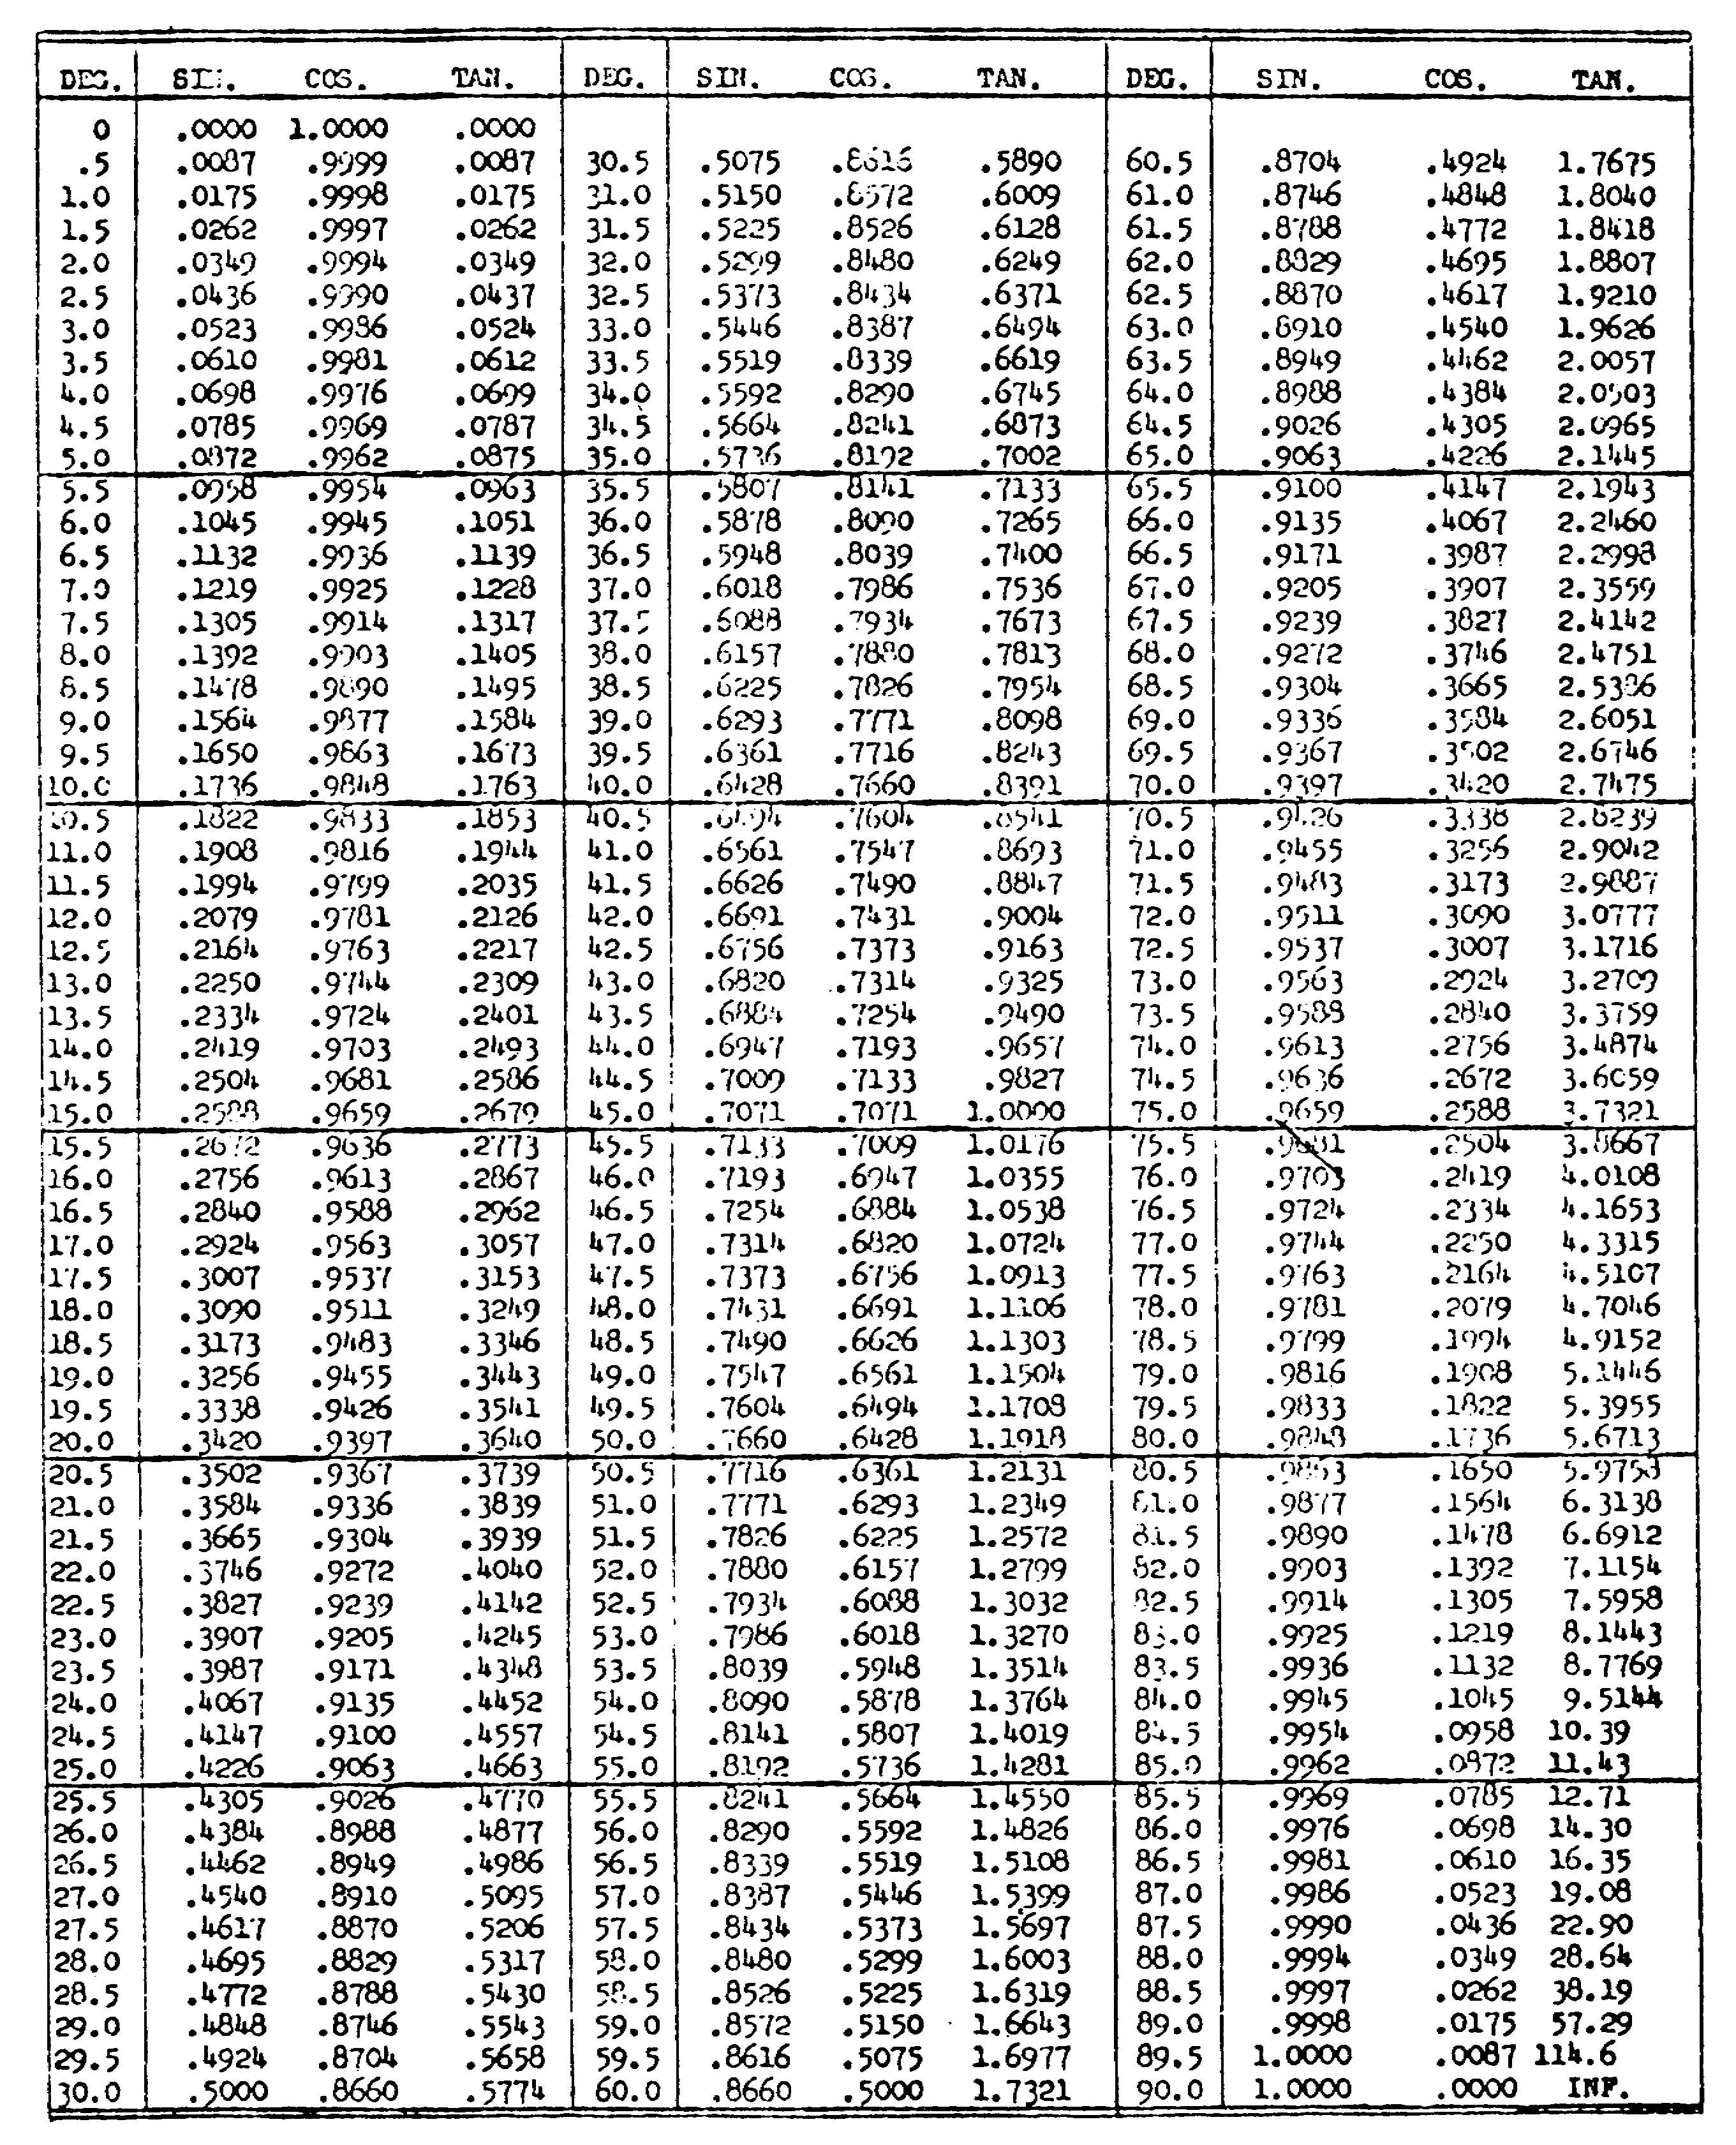

33

NOTES

34

36. We previously learned how to solve for total resistance in both series and parallel circuits. Total capacity of a circuit is found in a similar manner. However, the mathematical procedure is different in this way:
CAPACITORS IN SERIES combine in the same manner as resistors in parallel.
CAPACITORS IN PARALLEL combine in the same manner as resistors in series.
To solve for the total capacity of capacitors in SERIES, we use one of these formulas:

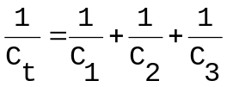

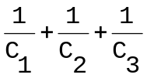 Ct = 1

Ct = 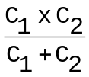

The total capacity of a SERIES circuit is always LESS than that of its smallest capacitor(like the Rt of resistors connected in parallel). Remember this important fact, as it will help to ensure that you use the right procedures Capacitors in series combine in the same manner as ___________ in ___________________.

35

resistors 37. Solve for Ct of the circuit in figure 3.
parallel

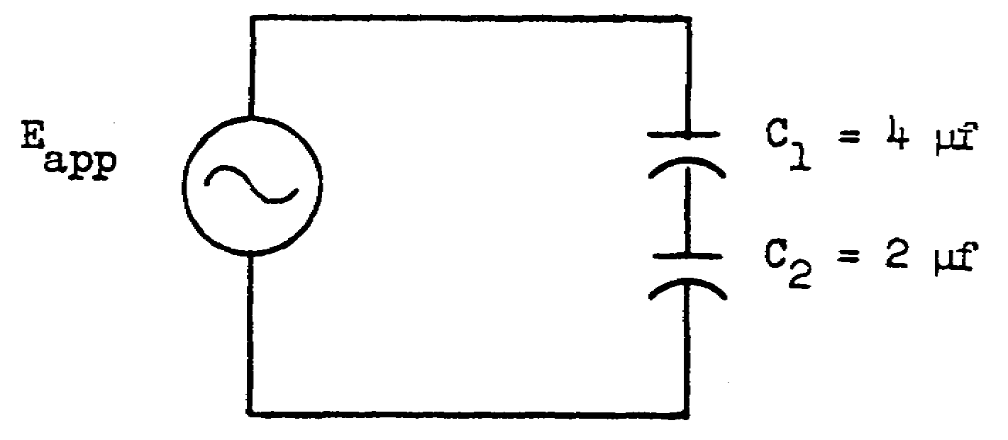
Figure 3

Ct = ___________µf

1.33 µf 38. List the two factors which determine capacitive

(Ct is small- reactance.
er than the
smallest
capacitor in 1._________________________
the circuit) .
2._________________________

frequency 39. Write the formula used to solve for capacitive

capacitance reactance.

36

XC = 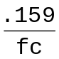
or

XC = 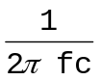

resistances
series
40. To solve for the total capacity of capacitors in parallel, capacitor values are added like resistors in series. to solve for the total capacity of capacitors connected in parallel, we use the formula Ct = C1 + C2 + C3. Thus, we merely add all the capacitances together. Capacitors in parallel are added like _________________ in _________________.

41. Solve for the Ct of the circuit in figure 4.
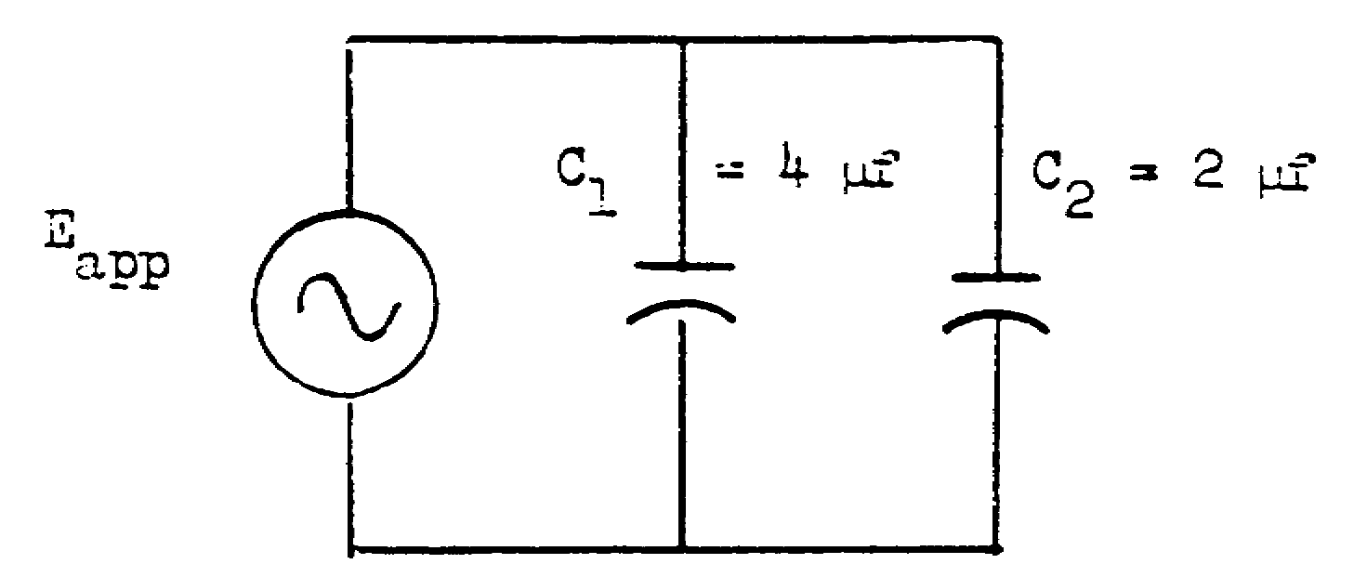
Figure 4

Ct = _____________µf

37

6 µf 42. Solve for Ct of the circuit in figure 5.

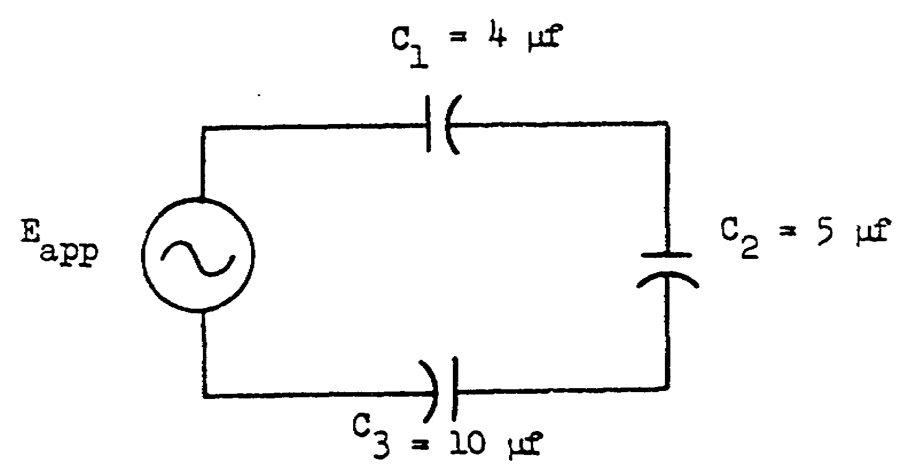

Figure 5 Ct = __________µf

1.8 µf 43. List the two factors which determine capacitive reactance.

1.________________________

2.________________________

38

frequency 44. To find XC, merely substitute the given values of
capacitance f and c in the formula, and mathematically solve.
Remember, do not misplace decimal points - TAKE YOUR TIME. Solve for the capacitive reactance of the circuit in figure 6.

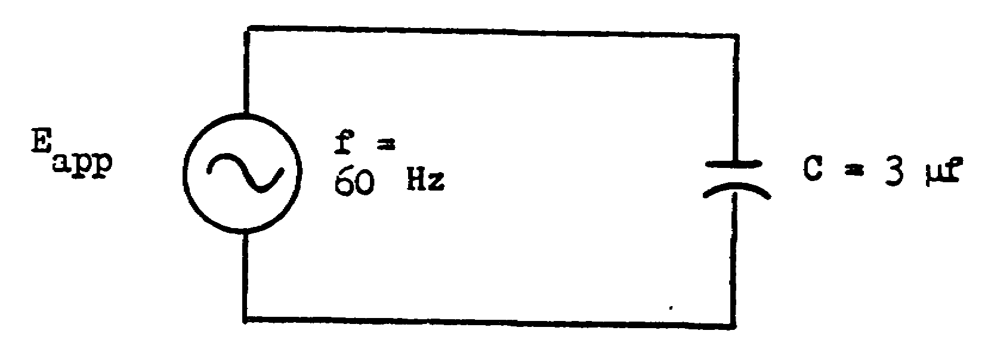

Figure 6 XC = ______

39

884Ω 45. Solve for Ct of the circuit in figure 7.

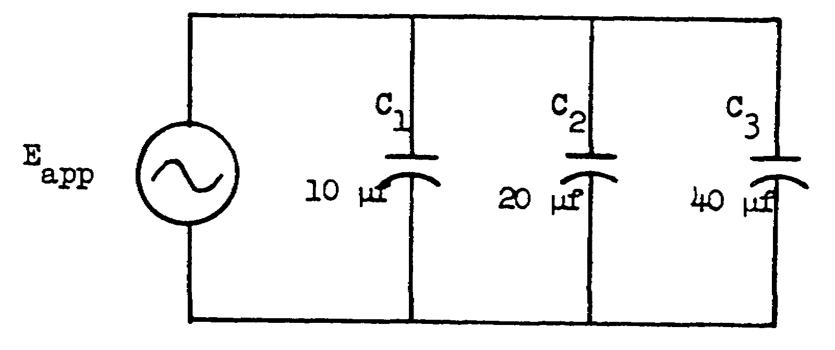

Figure 7 Ct = ___________µf

70 µf 46. The symbol for capacitive reactance is______, which is defined as the_________________________
________________________________________________
_______________________________________________.

40

XC 47. Solve for Ct of the circuit in figure 8.

opposition of
a capacitor to
ac
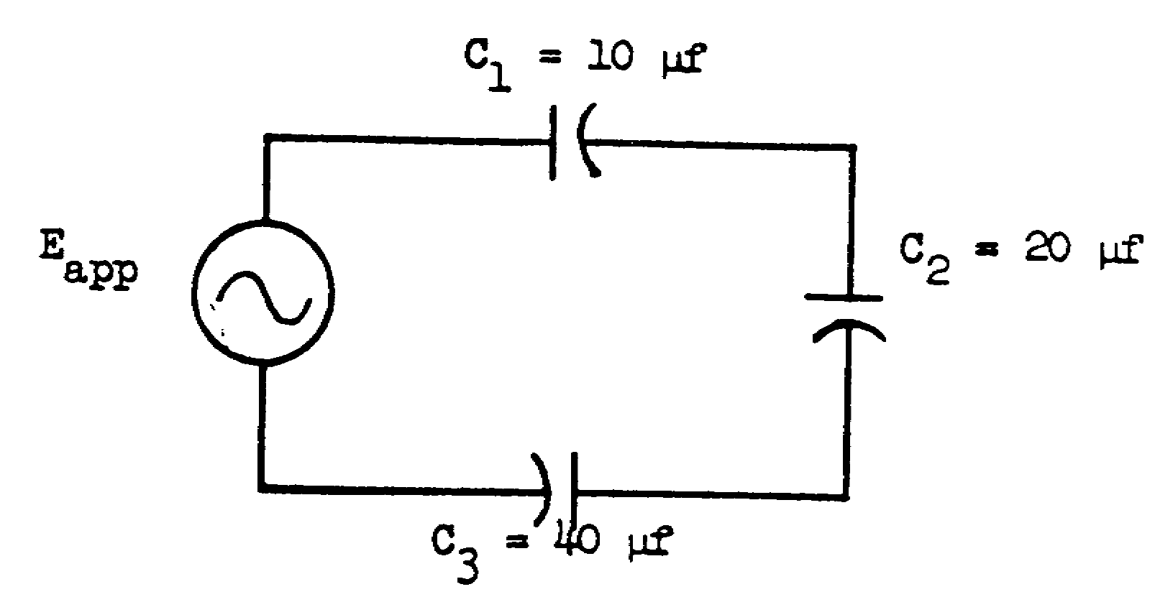

Figure 8 Ct = __________µf

41

Ct = 5.71 µf 48. Solve for XC of the circuit in figure 9.

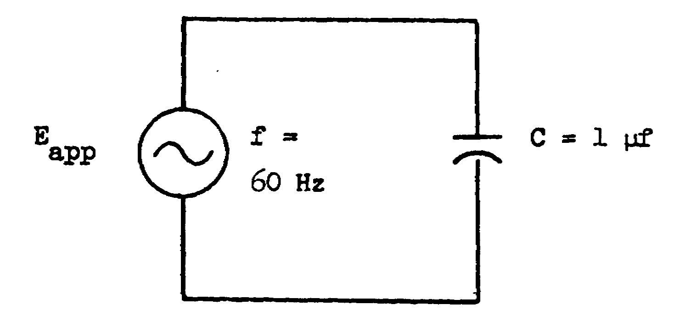

Figure 9 Xc = ____________

2650Ω 49. Solve for Ct of the circuit in figure 10.

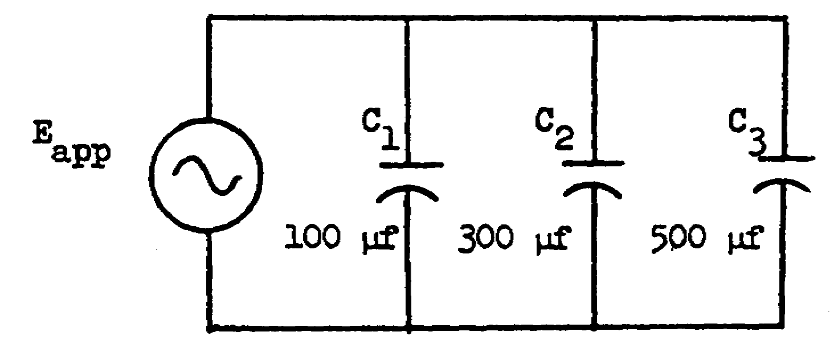

Figure 10 Ct = ___________

42

900 µf 50. Solve for XC in the circuit in figure 11.

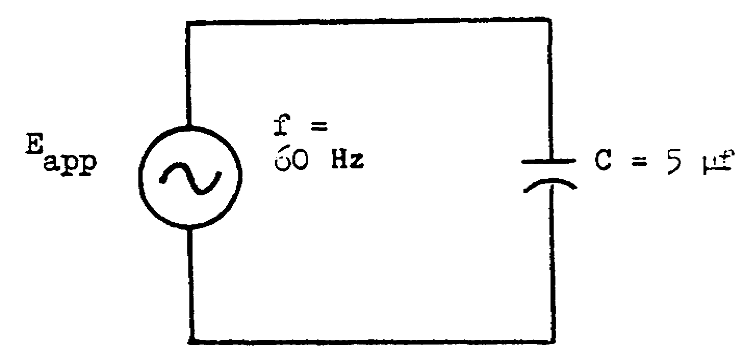

Figure 11

XC = _____________

530Ω 51. The symbol for capacitive reactance is _______, which is defined as the________________________ _______________________________________________ _______________________________________________.

43

XC 52. In a series circuit containing resistance and opposition of capacitance (such as in figure 12), the current a capacitor to ac (Iline) is the same at any point in the circuit.
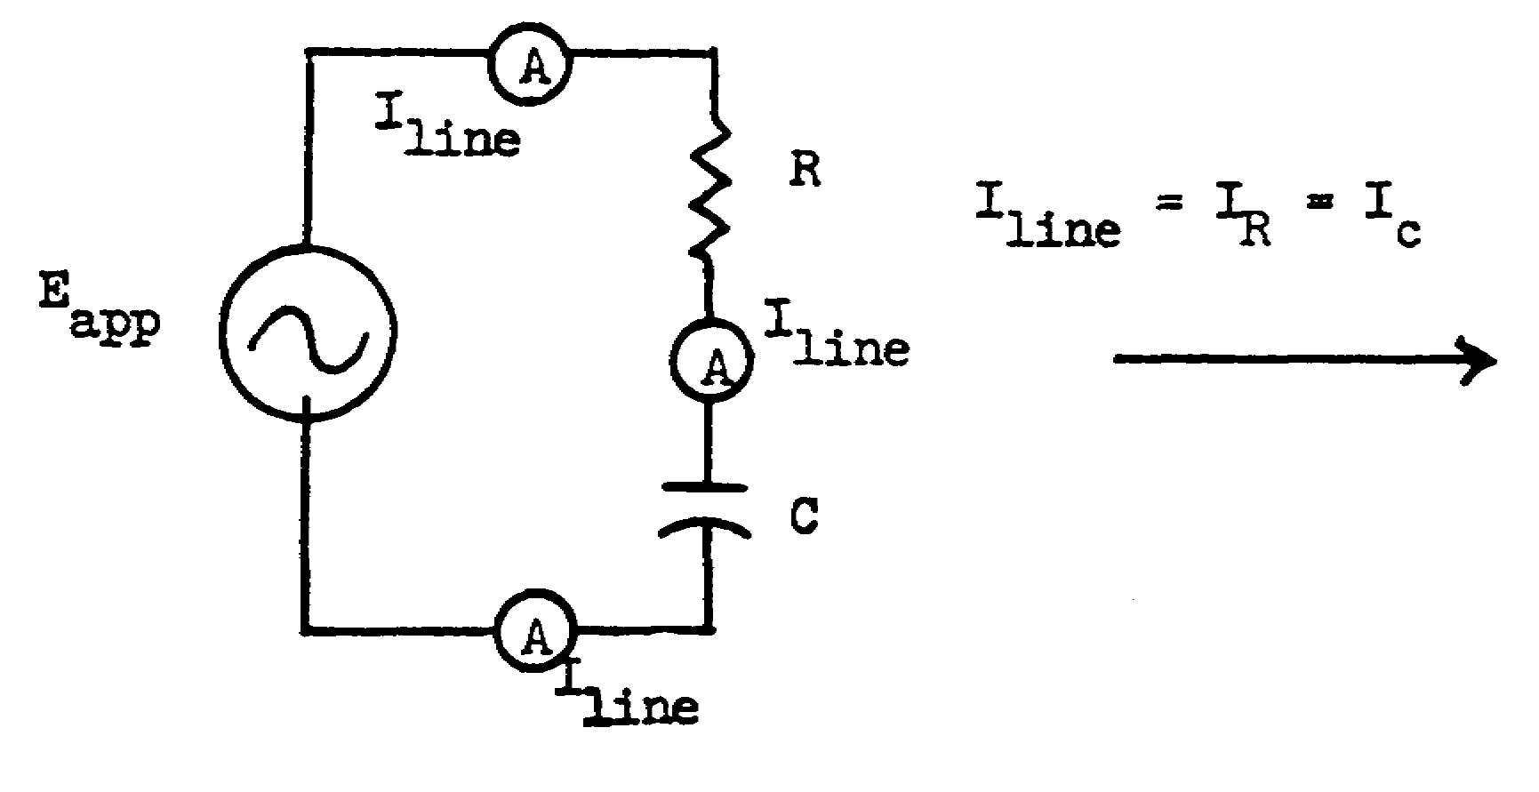
Figure 12

Since current is common throughout the circuit, CURRENT is used as a reference. Vectors can be used to represent the voltage relationship of E R and EC. Since the voltage across a resistor is always in phase with the current through it, the ER and Iline vectors are drawn on the same reference axis. Figure 13 illustrates the vectorial relationships in a series RC circuit.

Current Vector Voltage Vector Impedance
Diagram for Diagram for Vector
figure 12 figure 12 Diagram
for fig. 12
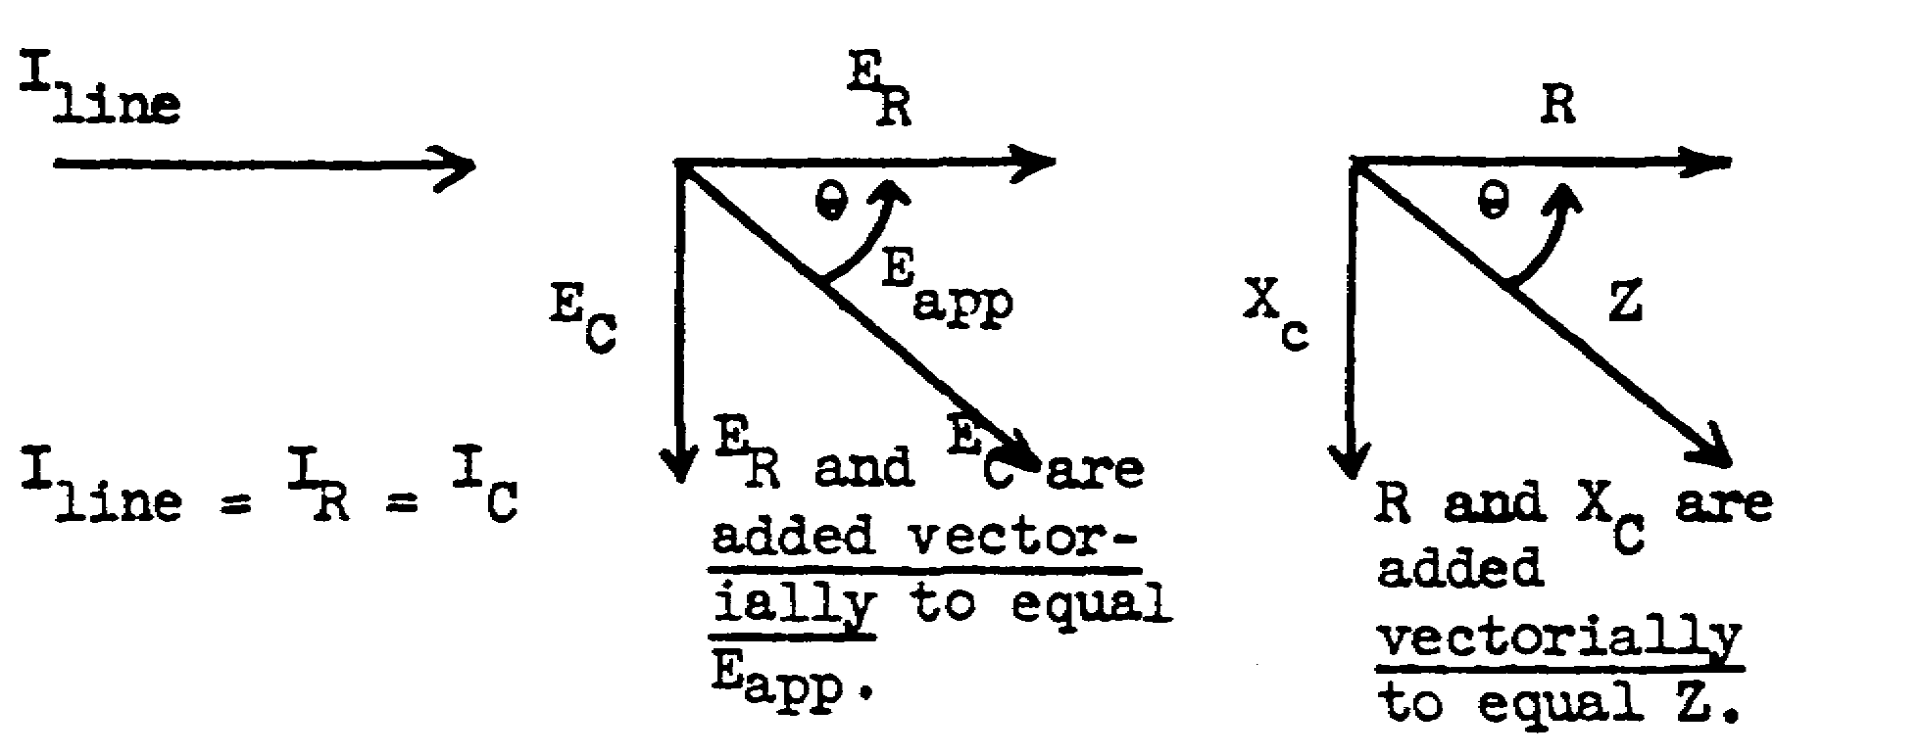

Figure 13

44

NO RESPONSE 53. The angle between ER and Eapp (or between R
NECESSARY and Z) is the phase angle () of the circuit. In the spaces at the bottom of the page, draw the 2 vector diagrams for the following circuit:

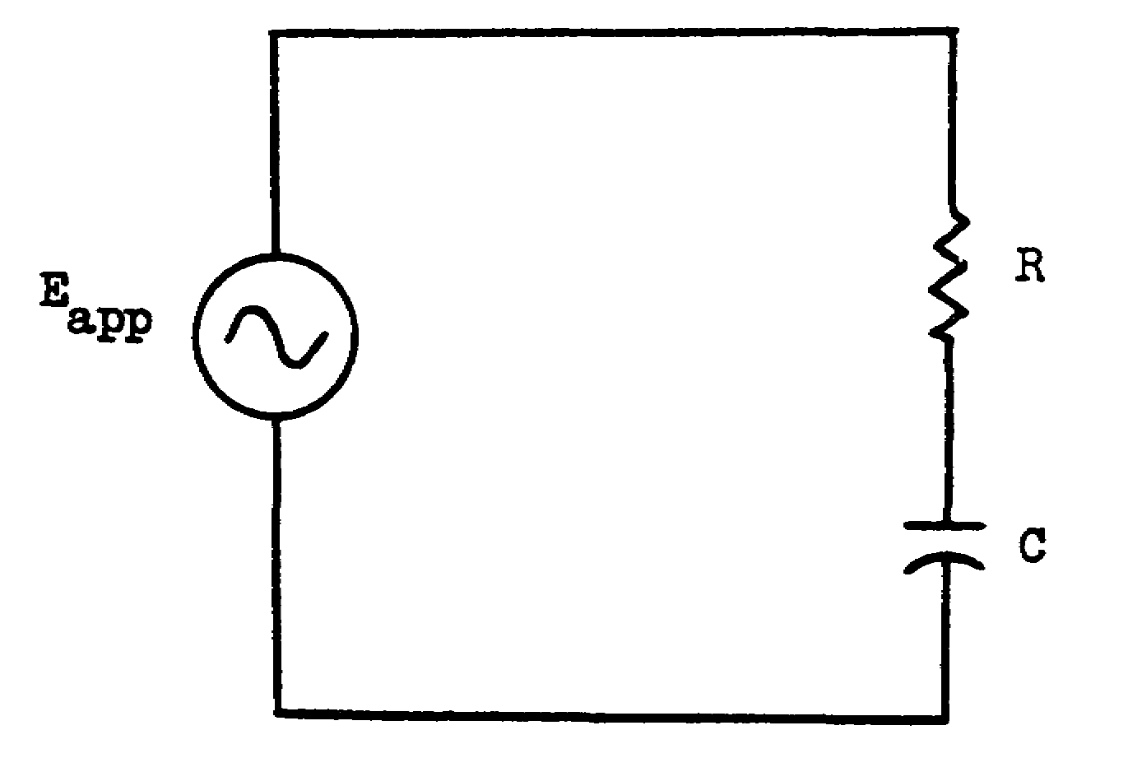

Voltage vector diagram Z (impedance) vector diagram

45

Voltage diagram 54. To solve for unknown values in a series RC circuit, certain steps must be followed. Referring to figure 14, we will go through the steps and find the values for: (1)
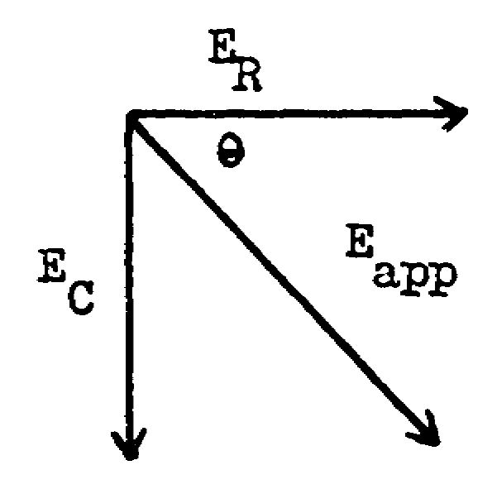
(2) Z
(3) Iline
(4) ER
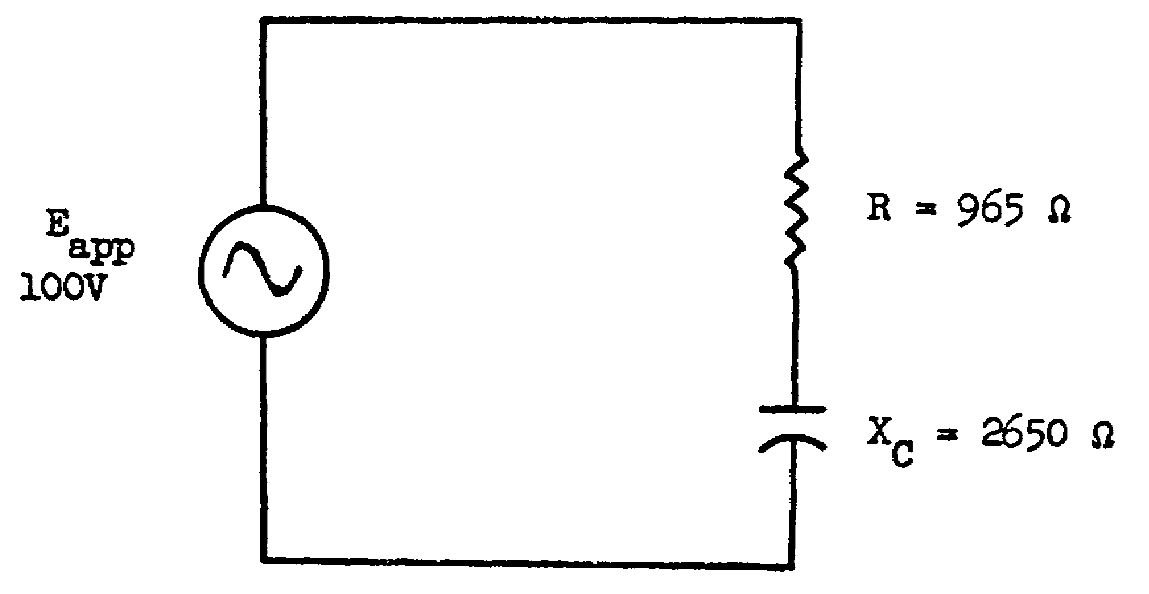
(5) EC

Impedance diagram
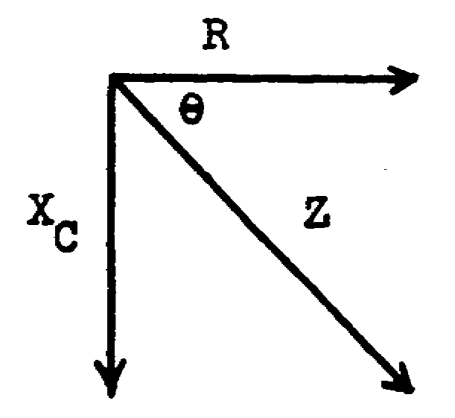

Figure 14

In the space below, draw the Z vector which represents the circuit in figure 14; make sure the vectors are in their proper relationships; and label each vector with the values from the circuit in figure 14.

46

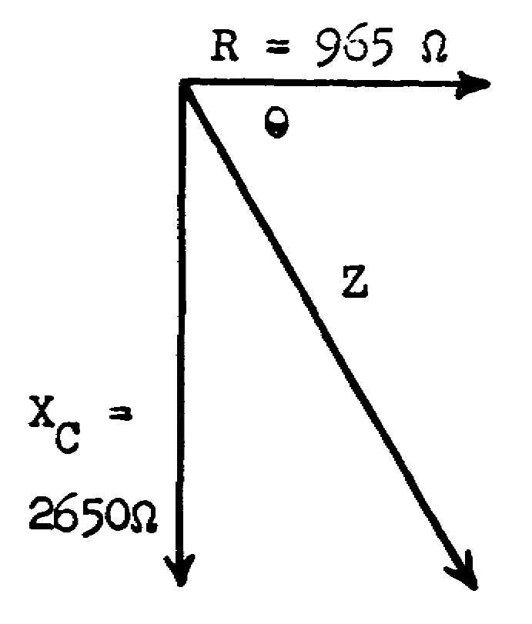
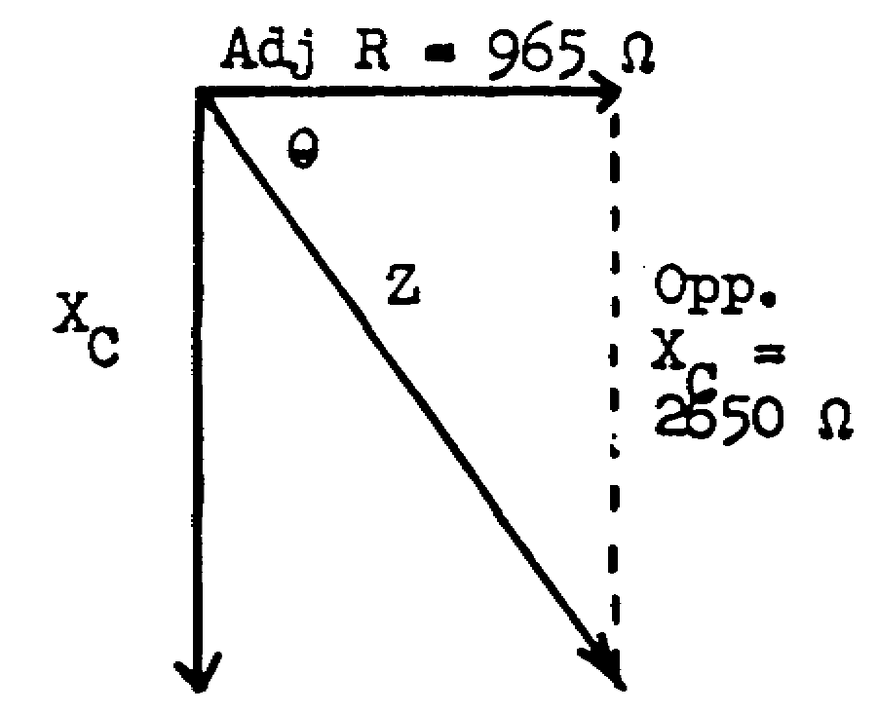
55. Since wre are given R and Xc, we can now find the hyp.(Z) of the triangle. To do this, we must first solve for the tan of .
tan = 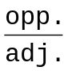.

NOTE:
The opposite
side of the
triangle is
XC and is
opposite .

tan = = 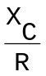 = 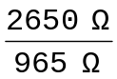

tan = ___________________

tan = 2.746 56. When tan = 2.746, = ____________________.

(Find the nearest degree, using the Table of Natural Functions on page 33.)

70° 57. At this point, we know 2 sides and of a triangle. By using the sine function (of 70º), we can now solve for the hyp. (Z) of the triangle.
According to the Trig Table, the sine of 70° is ___________________. Knowing that the
sin = 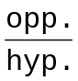; we transpose this formula to solve for hyp. (Z). Thus, the hyp. or
Z = 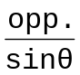 = 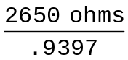 = ________________ohms.

47

.9397 58. We now know the values of E and Z. We can solve
Z = 2820 ohrms for Iline by merely substituting these values into Ohm's law formula:
I = or I =  or I = 
Iline = 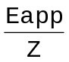
Iline = 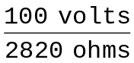
Iline = ___________

.0355 amp. 59. In a series circuit, Iline flows through XC;
or therefore, we can solve for EC by using Ohm's
35.5 ma law:
E = I x R
EC = Iline x XC = 035 amp. x 2650 ohms
EC = ______________volts.

92.75 volts 60. Iline flows throughl R in a series circuit; so again we use.Ohm's law and solve for ER.
E = I x R
ER = Iline x R = .035 amp. x 965 ohms
ER = ________________________volts.

48

33.8 volts 61. Now that we have solved the preceding problem, let's reviev the steps we wtent through and set them in your mind.
(1) Always draw and label the vector diagram of the circuit. This is to get the vectors and their values in their proper relationship.
(2) Solve for the tan :
tan = =
(3) Look at the Trig Table and find the degrees in (the phase angle). Write its value (in degrees)on the vector diagram.
(4) Use the sine function of to solve for the hyp.(Z) of the circuit:
sin =
transposing: hyp.= 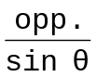 or Z = 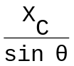
(5) Use Ohm's law to find Iline:
I =
thus, Iline = 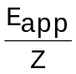
(6) Now solve for EC and ER by again using Ohm's law:
E = I x = R
thus, EC = Iline x XC
ER = Iline x R
ALWAYS USE THE ABOVE STEP-BY-STEP FROCEDURE.

49

No response 62. Let's work a similar problem with just a little less coaching.

Referring to figure 15, solve for: (1)
(2) Z
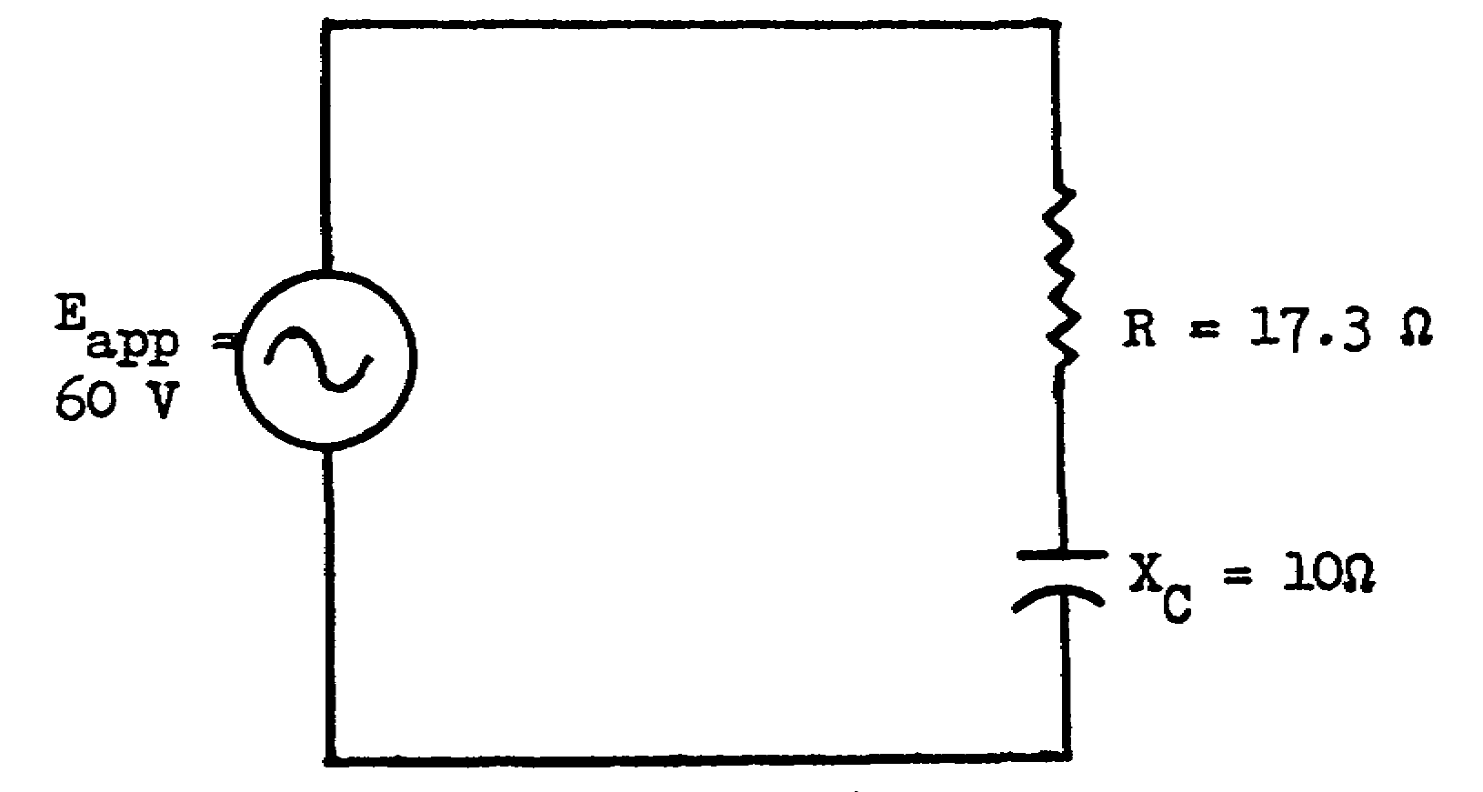
(3) I leads
or lags
(4) Iline
(5) ER
(6) EC

Figure 15

Draw and label the Z vector diagram for the circuit illustrated in figure 15.

50

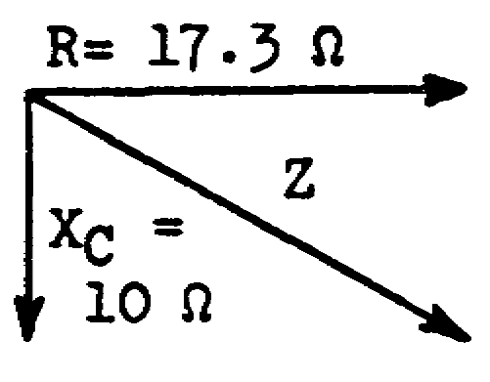
63. Solve for tan 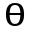.
tan = ___________________
= ___________________º

tan = .577 64. Use the sine function to solve for Z.
= 30º Note: Z = hyp.
sine = ; transposed, Z = =
Z = _____________________ohms

20 ohms 65. In a series RC circuit, the current __________
leads/lags
the voltage.

leads (current 66. Solve for Iline.
always leads
the voltage Iline = _______________
in a series
RC circuit)

3 amps. 67. Solve for ER.
ER =________________

51.9 volts 68. Solve for EC.
EC =________________

51

EC = 30 volts 69. Solve the following problem for the unknown values:
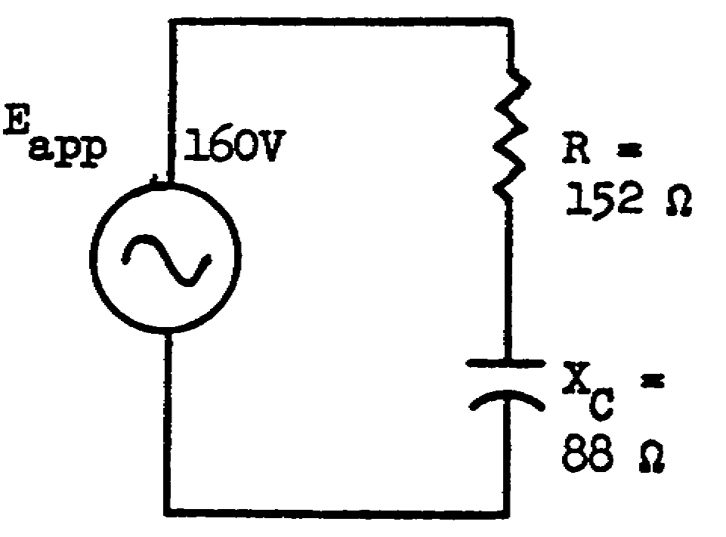
= ________________
Z = ________________
Iline_______________
I leads/lags________
ER = ________________
EC = ________________

52

= 30º 70. Solve the following problems for the unknown
Z = 176 ohms
Iline = .9 amp. values
I leads
ER = 136.8V =__________________
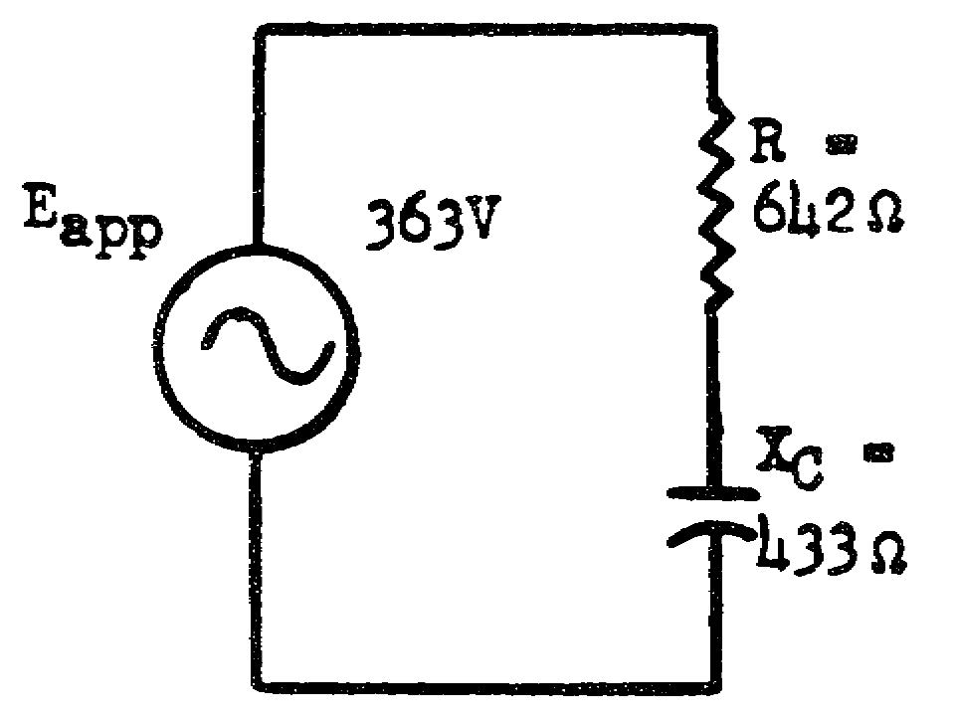
EC = 79.2V Z = __________________
Iline = ______________
I leads/lags__________
ER =__________________
EC = _________________

53

= 34º

Z = 774 ohms

Iline = . 47 amp.

I leads

ER = 301v

EC = 204v

54

71. Capacitors, although manufactured in many shapes and sizes, are divided into two basic classes:

(1) The VARIABLE CAPACITOR is usually constructed with two sets of plates--the stator (fixed) and the rotor (rotating). The rotor plates are allowed to rove freely between the stator plates so that the capacity can be varied from a small value when fully open to approximately ten times this value when fully meshed.

(2) The FIXED CAPACITOR has one set value of capacitance. There are several types of fixed capacitors. Sane of these types of fixed capacitors and their characteristics are listed below.

TYPE ADVANTAGES DISADVANTAGES USES

Paper Small, High loss, A-m receiver,
dielectric. low cost. short life. relatively
low voltage.

Mica Low loss, High cost, F-m and tv
dielectric. long life. small capacity receivers,
for physical relatively
size. high voltage.

Ceramic Low loss, High-frequency
dielectric. small, low coupling,
inductive oscillators.
effect, excel-
lent stability,
high voltage
rating.

Oil High voltage High cost, Extremely high
dielectric. rating, self- relatively large. voltage,
healing. transmitters.

Electro- Extremely large Polarity must Power supply,
lytic. values of be observed. cathode and
capacitance. screen bypass.

55

72. Any capacitor will break down if certain limits are exceeded. The maximum voltage that a capacitor can withstand is known as the working voltage rating (WVDC). Since the WVDC rating is the maximum voltage that the capacitor can withstand, a SAFETY FACTOR of 50 per cent should be used: WVDC should be 50 per cent higher than the highest voltage to be encountered.

Assume a circuit has a maximum applied voltage of 300 VDC. The minimum WVDC of a capacitor used in that circuit would be 450 WVDC when using a 50-percent safety factor.

300 Maximum applied voltage in the circuit

+150 50 per cent safety factor (50 per cent of 300)
450 WVDC rating

If the WVDC rating is known and you wish to know the maximum circuit voltage that can be applied safely, use a factor of 2/3 WVDC.

450 WVDC x 2/3 = 300 v maximum applied
circuit voltage
450 WVDC
-300 Maximum applied circuit voltage (2/3 of 450)
150 50 per cent safety factor (50 percent of 300)

A circuit has a maximum applied voltage of 200 VDC. What should be the minimum working voltage rating (WVDC) of a capacitor used in that circuit when considering a 50-per-cent safety factor?

56

300 WVDC 73 Match the three types of capacitors in column A to their uses as listed in column B.

A B

____(1) Ceramic a. Transmitters,
extremely high
____(2) Oil voltage.

____(3) Electrolytic b. Power supplies,
cathode and screen
bypass.

c. Oscillators, high-
frequency coupling.

(1) c. 74.

(2) a.

(3) b.

57

75. What should be the WVDC rating of a capacitor used in a circuit that has a maximum applied voltage of 500 VDC when considering a 50-per-cent safety factor?

750 WVDC SOLUTION:
500 VDC maximum
+250 50 per cent safety factor
750 WVDC

76. In any PARALLEL CIRCUIT, the voltage is the same across all branches.

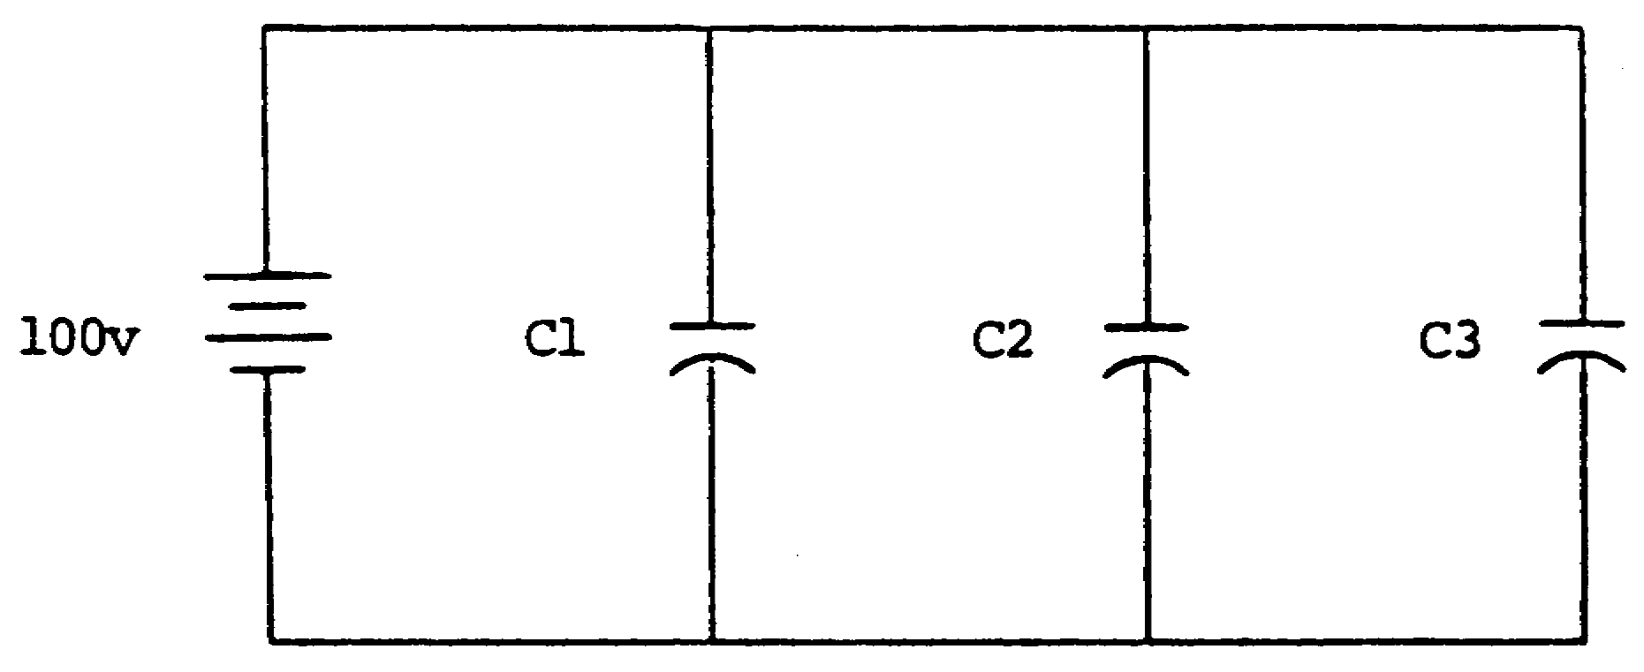

In the circuit above, the voltage across each of the capacitors is 100 volts: EC1 = 100 v; EC2 = 100 v; and EC3 = 100 v.
What is the value of EC3 in the circuit below?

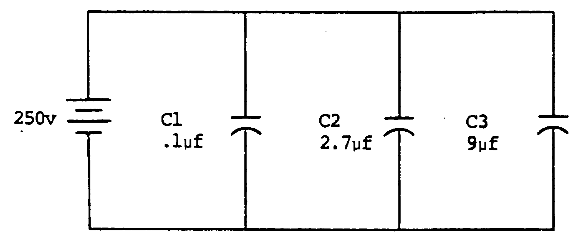

58

250 v 77.

78. What should be the minimum WVDC rating of a .3-picofarad capacitor in a circuit that has a maximum applied voltage of 250 VDC when considering a 50- per-cent safety factor?

59

375 WVDC 79. The total charge (Qt) in a parallel circuit is the sun of the individual charges,

Qt = Q1 + Q2 + Q3, etc.
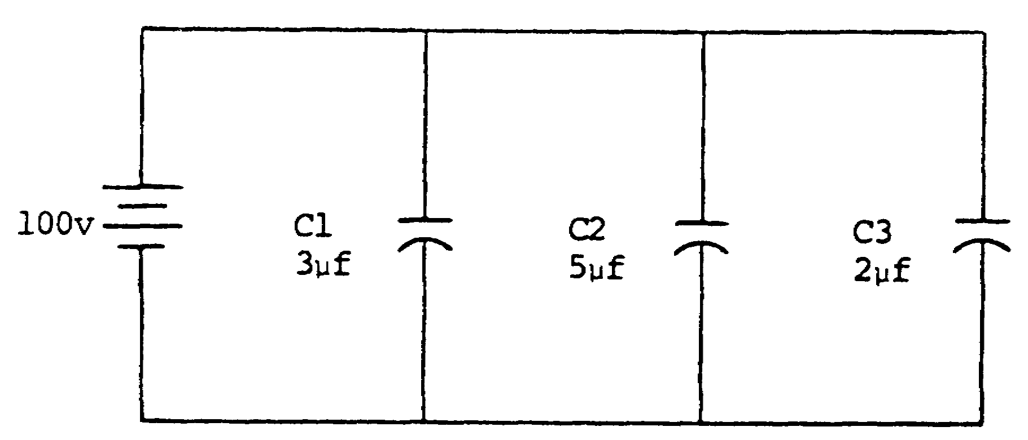

To solve for the total charge (Qt) in the circuit above, proceed as follows:

Use the formula Q = CE to find the individual charges.

Q1 = Cl x El Q2 = C2 x E2 Q3 = C3 x E3
= 3 µf x 100 v = 5 µf x 100 v = 2 µf x 100 v
= 300 µcoulombs = 500 µcoulombs = 200 µcoulombs

Qt = Q1 + Q2 + Q3
= 300 µcoulombs + 500 µcoulombs + 200 µcoulombs
= 1,000 µcoulombs
OR
Use the formula Ct = 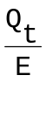 transposed Qt = Ct x E.
Ct = C1 + C2 + C3 E = 100 v Qt = Ct x E
= 3 µf + 5 µf + 2 µf (parallel circuit) = 10 µf x 100 v
= 10 µf = 1,000 µcoulombs

60

80.
Not all parallel circuits are as easy to calculate as the previous problems. Neither are they difficult if they are analyzed properly.

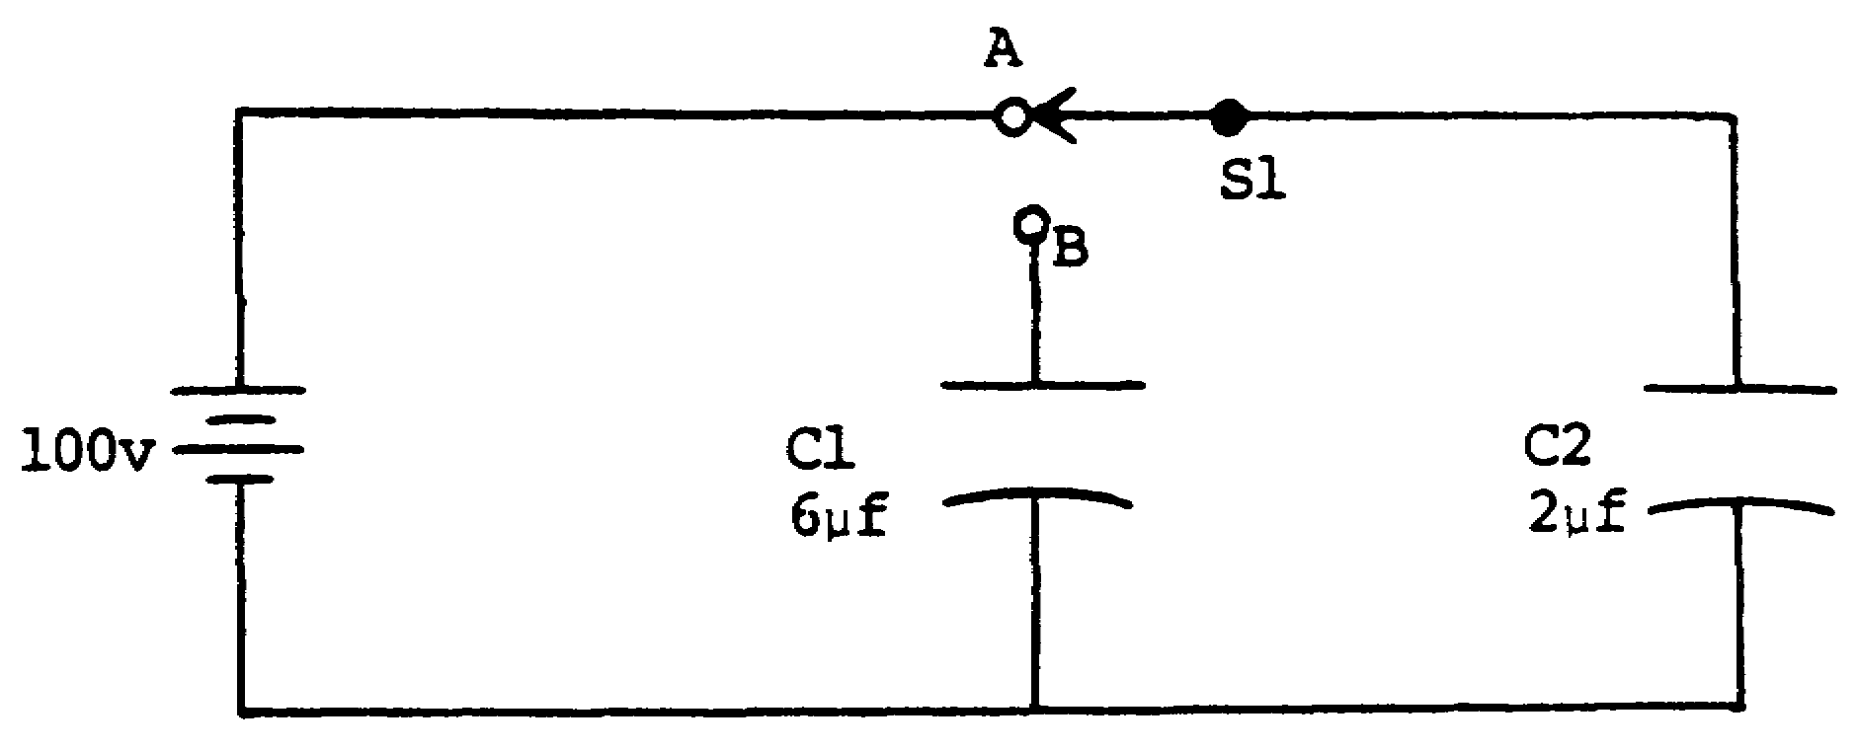

In the circuit above, assume switch S1 is placed in position A until C2 charges to 100 volts. Using the formula

C = ,

the Qt of the circuit at this time is 200 microcoulombs.
C =
Q = C x E
= 2 µf x 100 v
= 200 µcoulombs

61

80. (Continued)
Now, place switch S1 in position B and solve for EC1, EC2, Q1, Q2, and Ct.
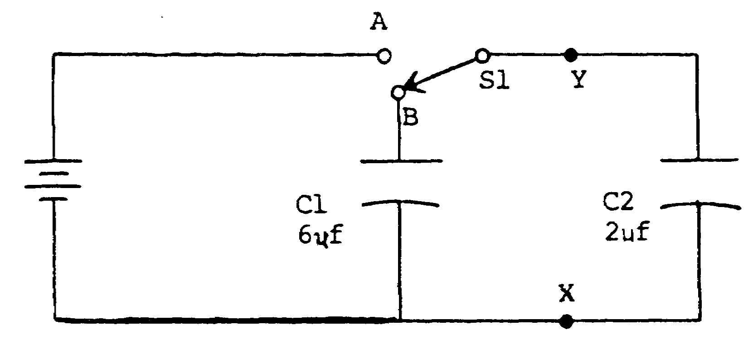
When switch S1 is placed to position B, the battery is removed from the circuit. The quantity of charge (Q) that was placed on C2 will remain as Qt. The total capacitance is calculated for a parallel circuit (point X to point Y):

Ct = C1 + C2
= 6 µf + 2 µf
= 8 µf

The Q remains the same as in position A: 200 µcoulombs. To find the new voltage, insert the known values in the formula.
Ct = 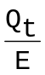
E = 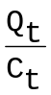
= 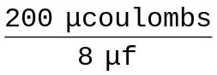
= 25 v

62

80. (Continued)

The voltage on each capacitor (parallel circuit) is now 25 volts.

To find the Q of each capacitor, use the individual capacitance values:

Q = C x E Q = C x E
Q1 = C1 x El Q2 = C2 x E2
= 6 µf x 25 v = 2 µf x 25 v
= 150 µcoulombs = 50 µcoulombs

Qt = Q1 + Q2 (parallel circuit)
= 150 µcoulombs + 50 µcoulombs
= 200 µcoulombs

Solve for Ct, EC, and Qt in the circuit below.

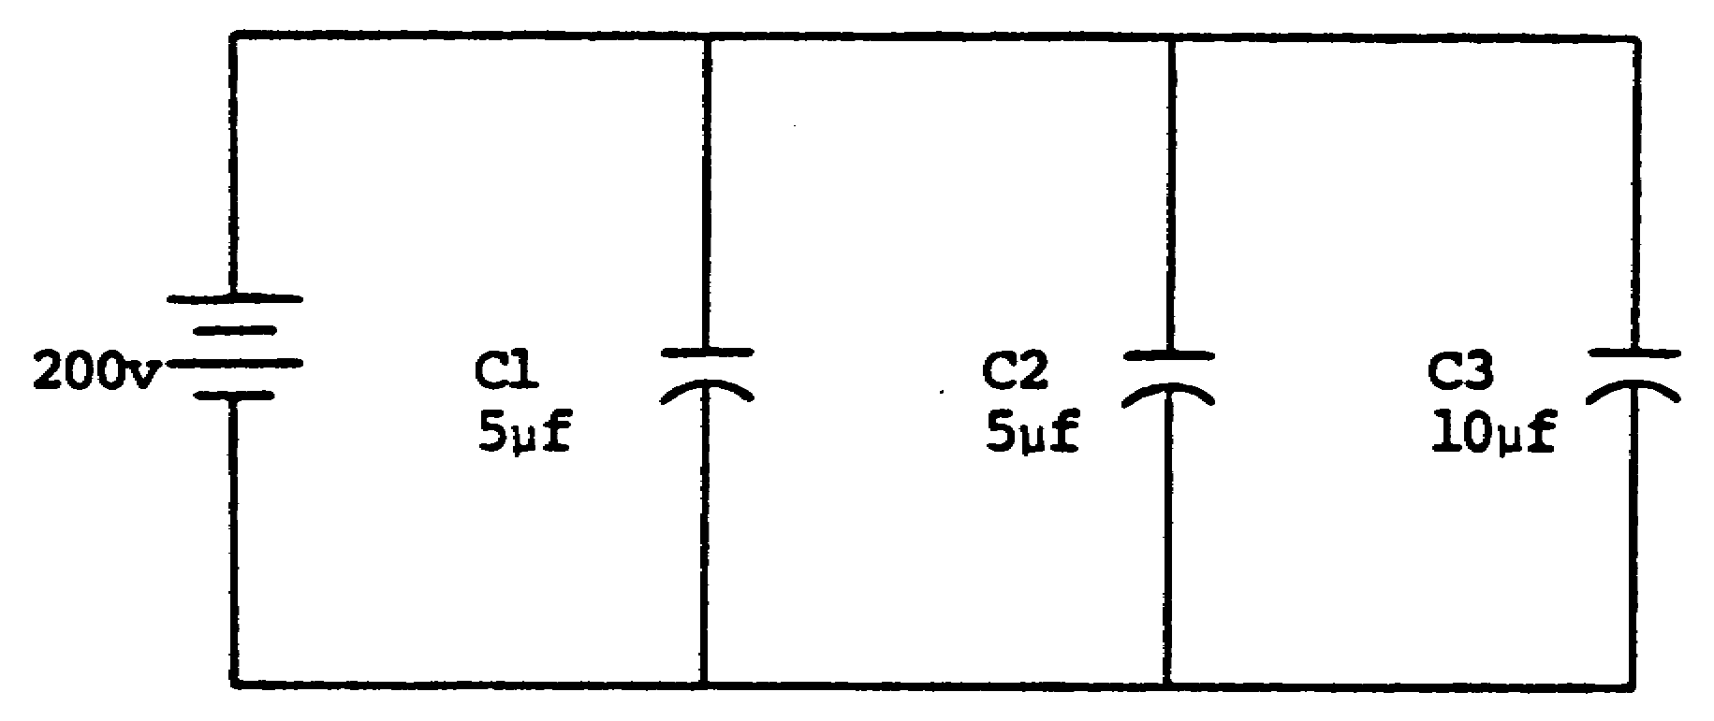

63

Ct = 20 µf 81. What are the values of EC1, EC2, and EC3 in the
EC = 200 v circuit below?
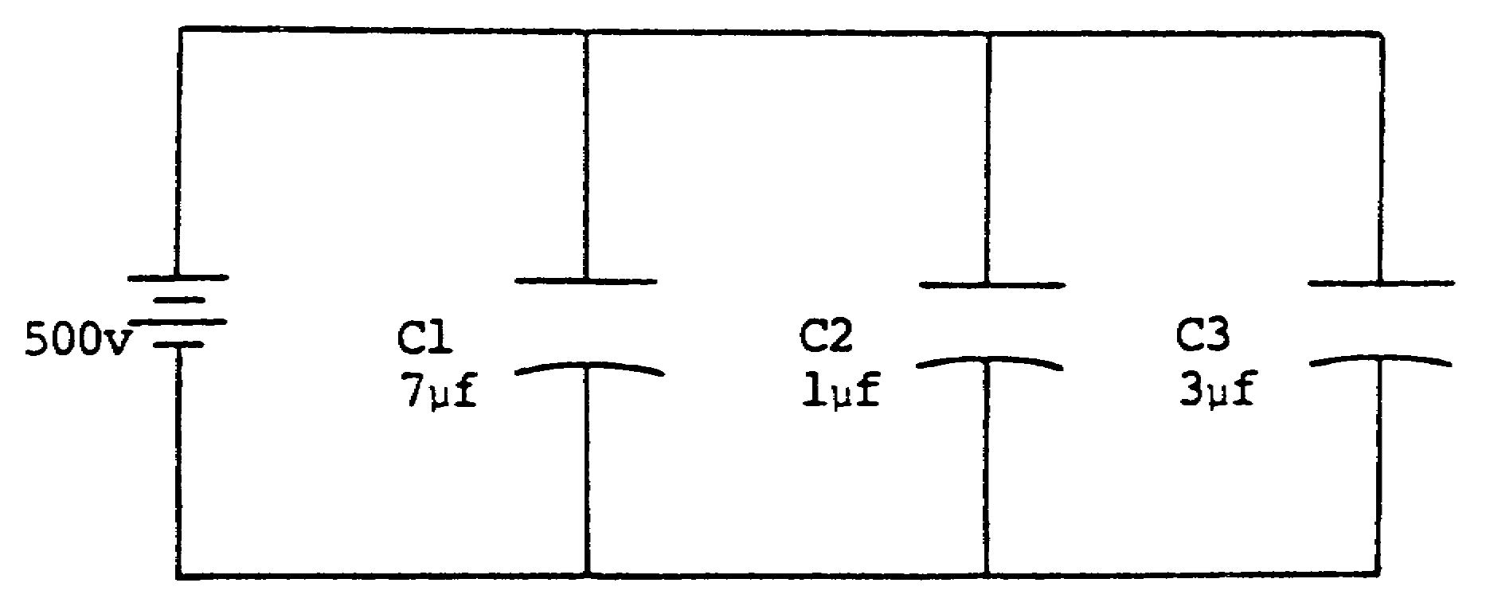
Qt = 4,000
µcoulombs

EC1 = 500 v SOLUTION: PARALLEL CIRCUIT
EC2 = 500 v The voltage is the same across all
EC3 = 500 v branches. With 500 volts applied,
500 volts is felt across each
branch.

64

82. Solve for the total capacitance (Ct) in the circuit below.

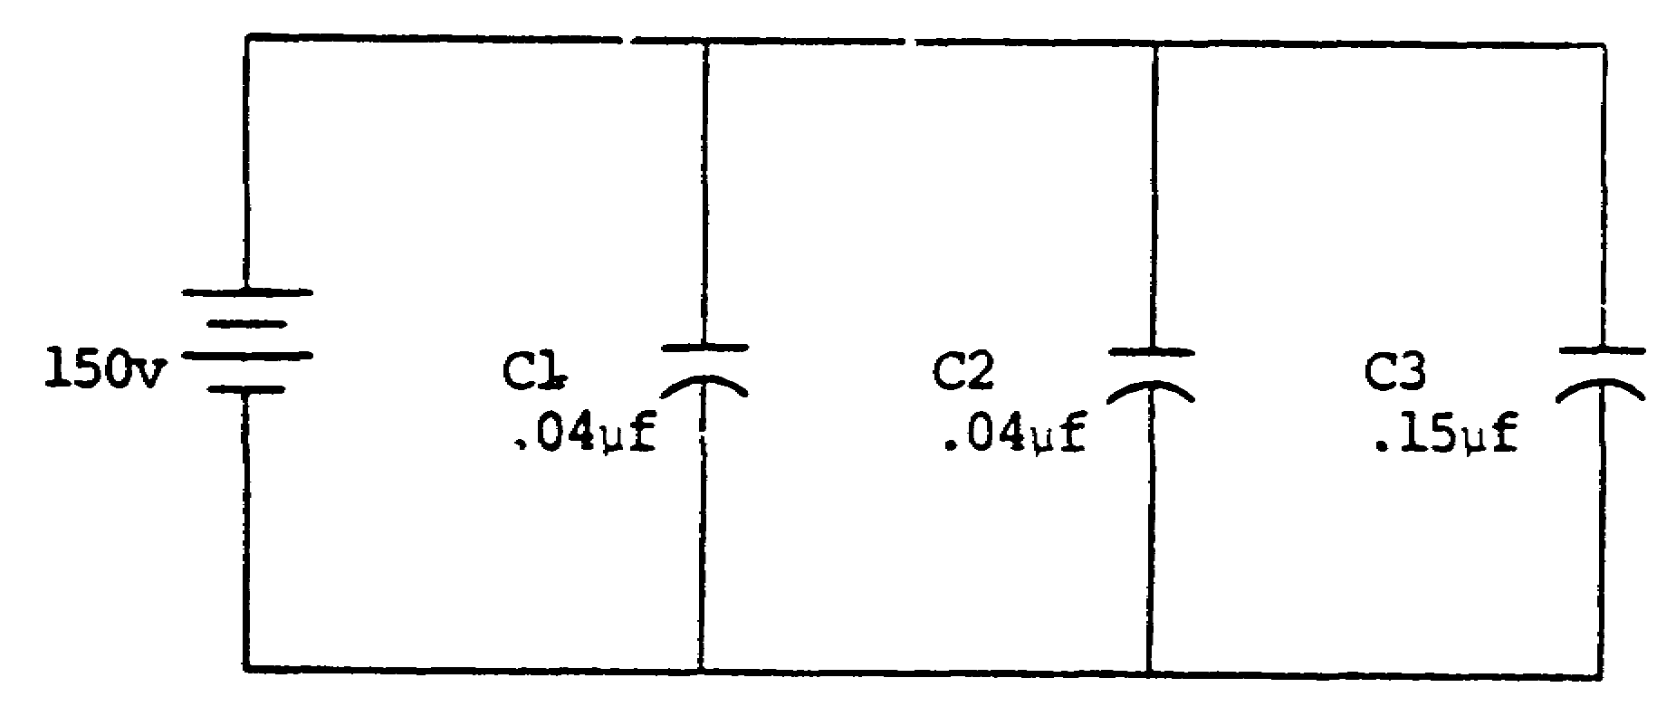

Ct = .23 µf 83. The total capacitance of capacitors in series is the reciprocal of the sum of the individual reciprocals of capacitances:

Ct = 1
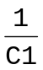 + 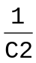 + 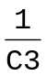, etc.

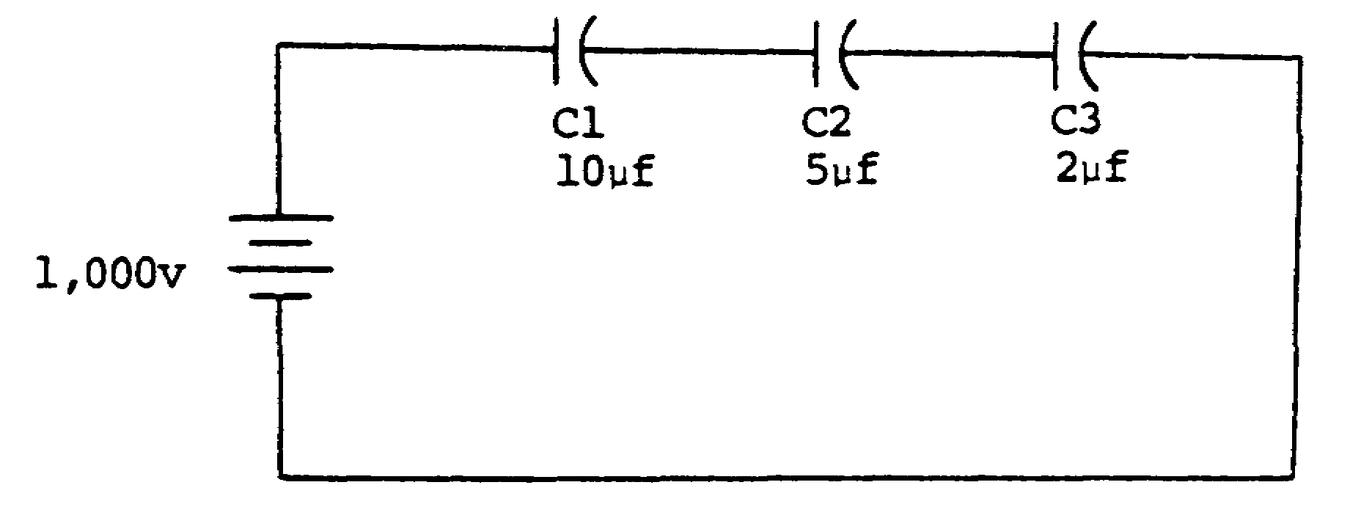

To calculate the total capacitance (Ct) in the circuit above, proceed as follows:

65

83. (Continued)

Ct = 1
+ +

= 1
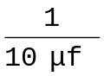 + 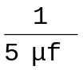+ 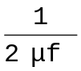

1
= .1 x 10+6 + .2 x 10+6 + .5 x 10+6

= 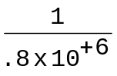

= 1.25 x 10-6
= 1.25 µf

What is Ct in a series circuit when C1 is 5 microfarads, C2 is 5 microfarads, and C3 is 10 microfarads?

66

Ct = 2 µf 84. What is the value of the total charge (Qt) in the circuit below?

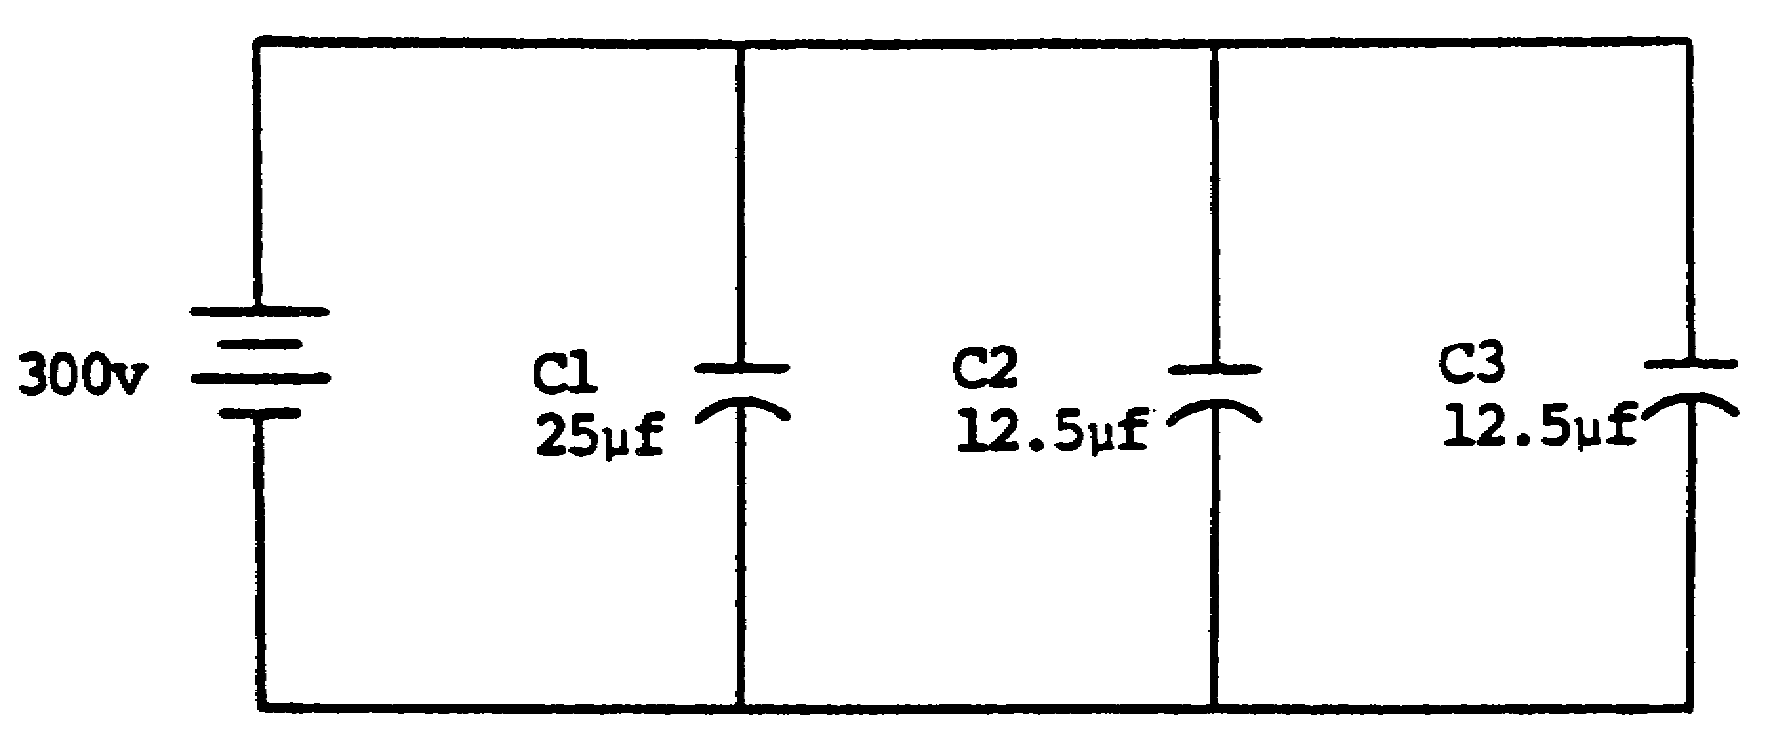

Qt = 15,000 SOLUTION: PARALLEL CIRCUIT
µcoulombs
Qt = Q1 + Q2 + Q3, etc.

Q1 = 25 µf x 300 v Q2 = 12.5 µf x 300 v Q3 = 12.5 µf x 300 v
= 7,500 µcoulombs = 3,750 µcoulombs = 3,750 µcoulombs
Qt = 7,500 + 3,750 + 3,750
= 15,000 µcoulombs
OR
Qt = Ct x E
= 50 µf x 300 v
= 15,000 µcoulombs

67

85. Solve for the values of EC1, EC2, and EC3 in the circuit below.
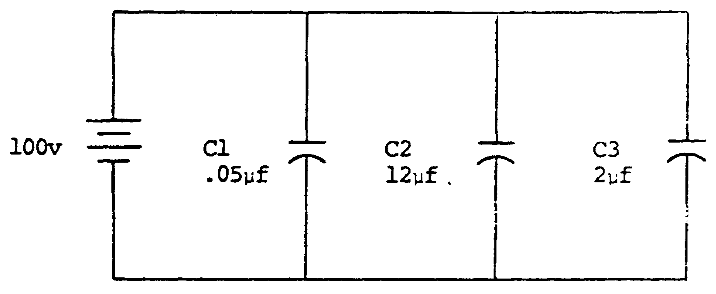

EC1 = 100 v 86. In any series circuit, the quantity of charge (Q)
EC2 = 100 v is the same on all capacitors. Ct MUST be used
EC3 = 100 v to calculate the value of Q in a series circuit.
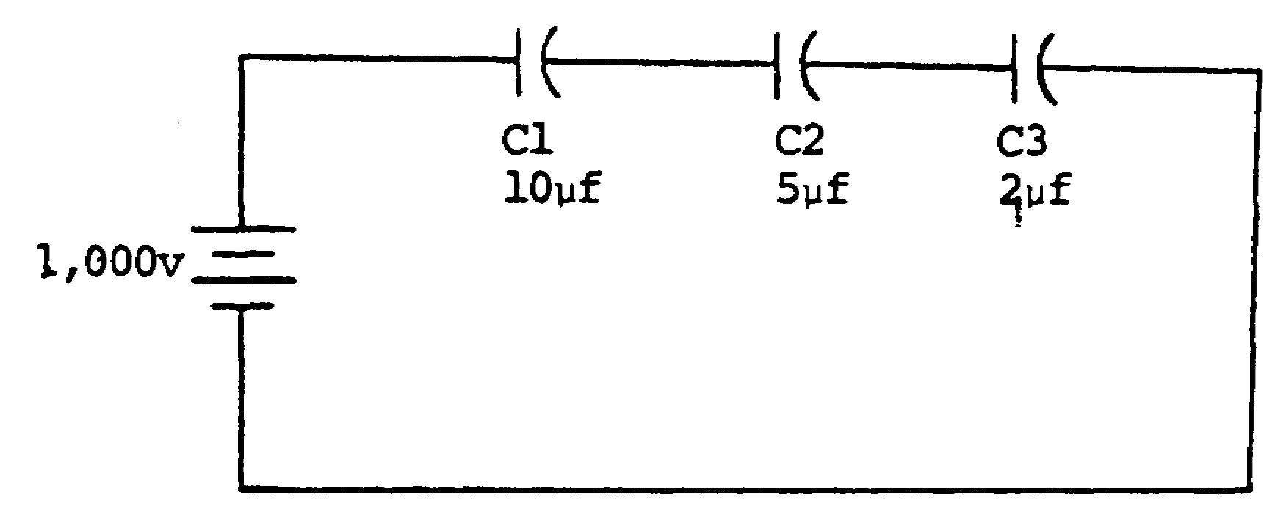

In the figure above, Q1, Q2, and Q3 are all 1,250 microcoulombs.
Q = Ct x Et
= 1.25 µf x 1,000 v
= 1,250 µcoulombs

68

86. (Continued)
This is true because the electrons on the right side of C3 displace an equal number of electrons to C2, and this action occurs across all components of the series circuit.

In a series circuit, the quantity of charge (Q) on each capacitor is_____________ _____________.

the same 87. What is the value of the total capacitance (Ct) in the circuit below?

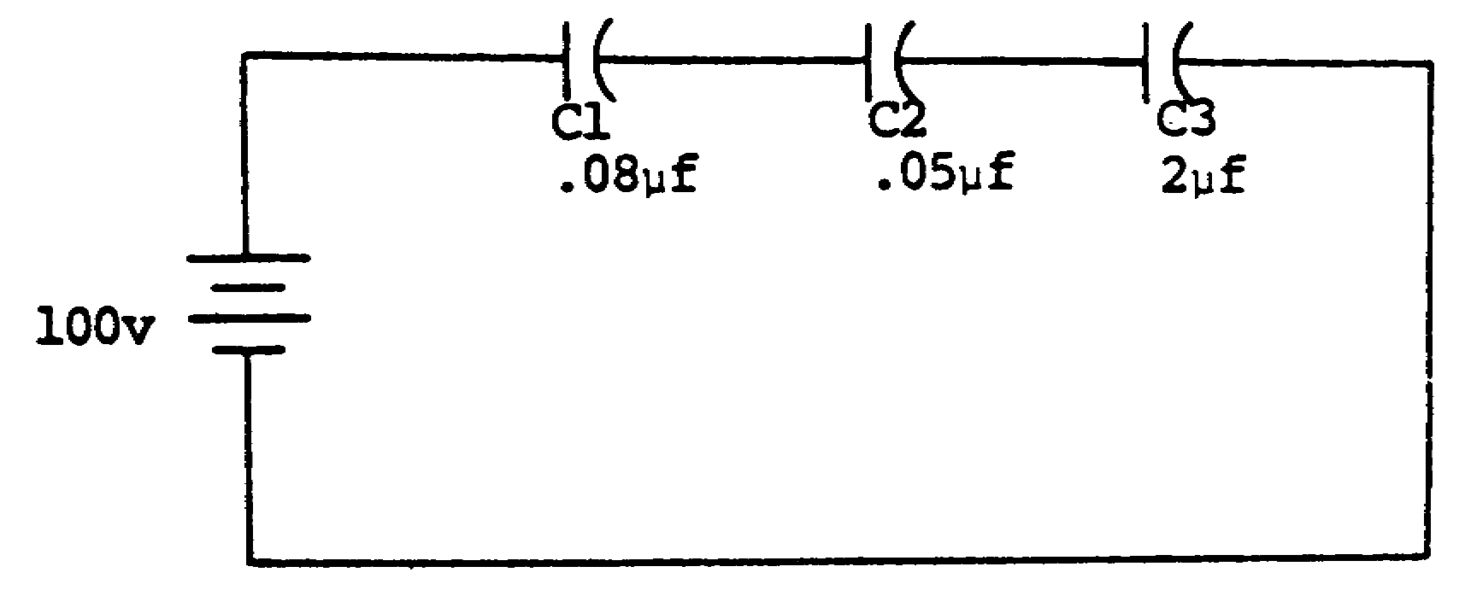

69

Ct = .03 µf SOLUTION: SERIES CIRCUIT
Ct = 1
+ + , etc.

1
= 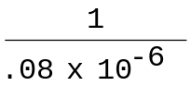 + 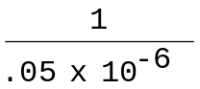 + 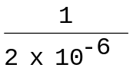

1
= 12.5 x 10+6 + 20 x 10+6 + .5 x 10+6

= 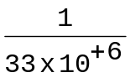
= .0303 x 10-6

88. Solve for the value of the total charge (Qt) in the circuit below.

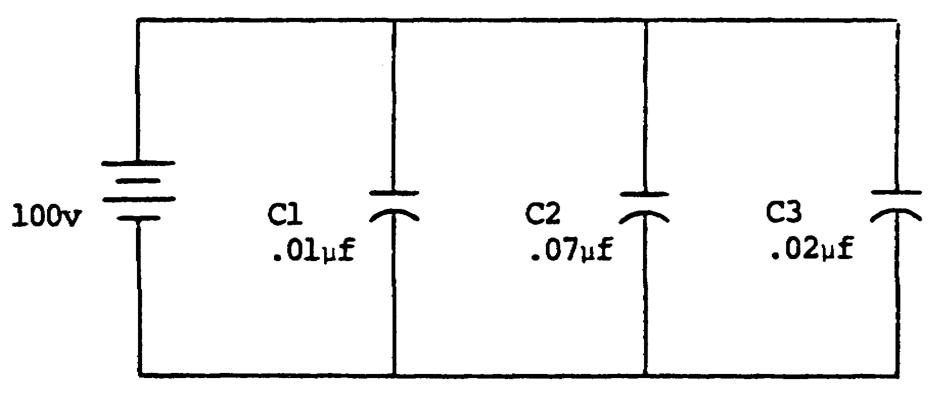

70

Qt = 10 89. In a series circuit, the voltages across the
µcoulombs capacitors normally differ, since voltage is
determined by the quantity of charge (Q) and the size
of the capacitor (C).
C =
E = 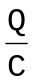
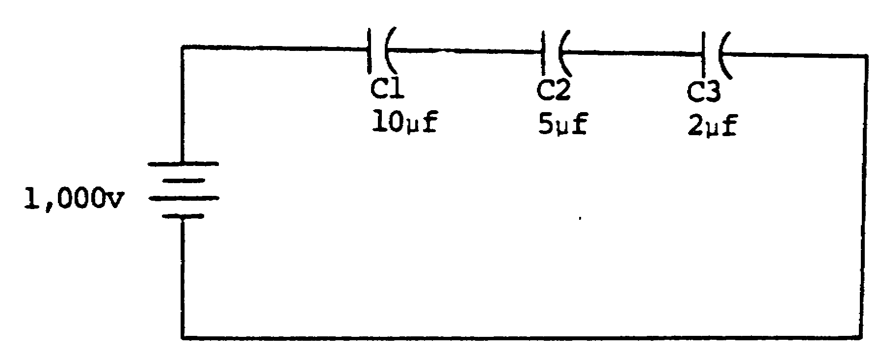

To calculate EC1, EC2, and EC3 in the circuit above, proceed as follows:

C =
E = (= 1,250 µcoulombs--series circuit)

EC1 = 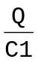 EC2 = 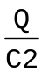 EC3 = 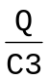
= 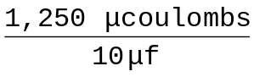 = 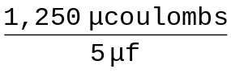 = 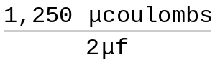
= 125 v = 250 v = 625 v

71

89. (Continued)

Kirchhoff's law: EA = + EC1 + EC2 + EC3
1,000 v = EC1 + EC2 + EC3
= 125 v + 250 v + 625 v
= 1,000 v

Note that the smallest capacitor assumed the largest value of voltage. This is always true in a series circuit. The smallest capacitor assumes the largest voltage, and the largest capacitor assumes the smallest voltage. In simple series circuits, the capacitor voltage can be found by using inverse ratio and proportion.

72

89. (Continued)
Solve for Ct, Q, EC1, and EC2 in the circuit below.

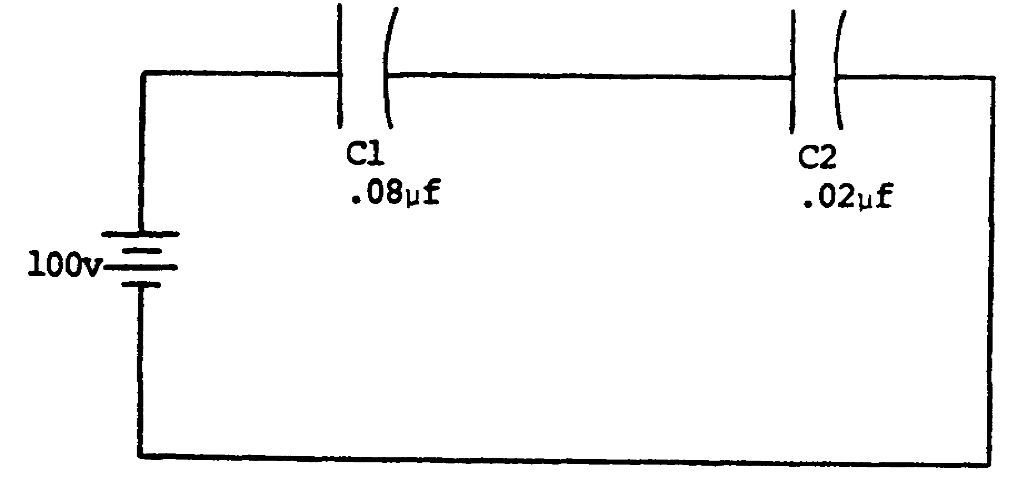

73

Ct = .016 µf 90. What is the value of the total charge (Qt) in the
Q = 1.6 circuit below?
µcoulombs
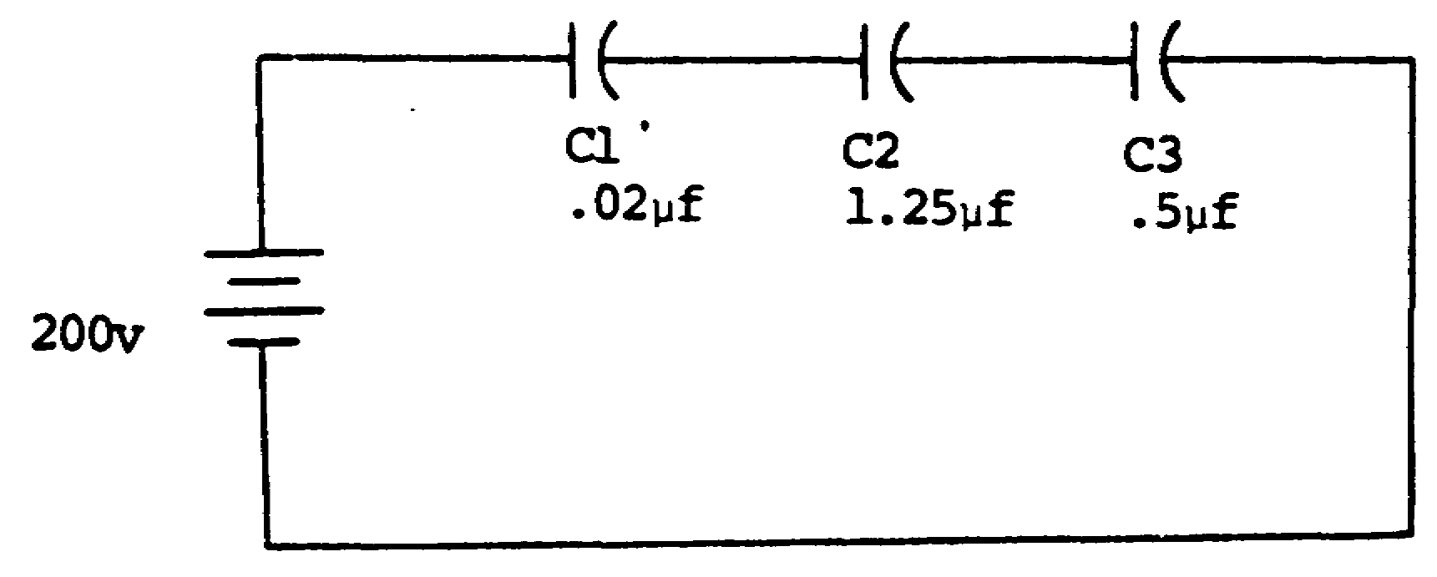
EC1 = 20 v
EC2 = 80 v

Qt = 3.78 SOLUTION: SERIES CIRCUIT
µcoulombs Ct MUST be used to find Qt.
Qt = Ct x E
Ct = 1
+ +
1
= 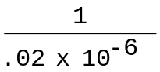 + 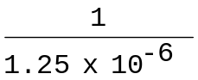 + 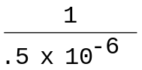

1
= 50 x 10+6 + .8 x 10+6 + 2 x 10+6
= 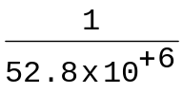
= 0.189 µf
Qt = .0189 µf x 200 v
= 3.78 µcoulombs

74

91. Solve for the total capacitance (Ct) in the circuit below.

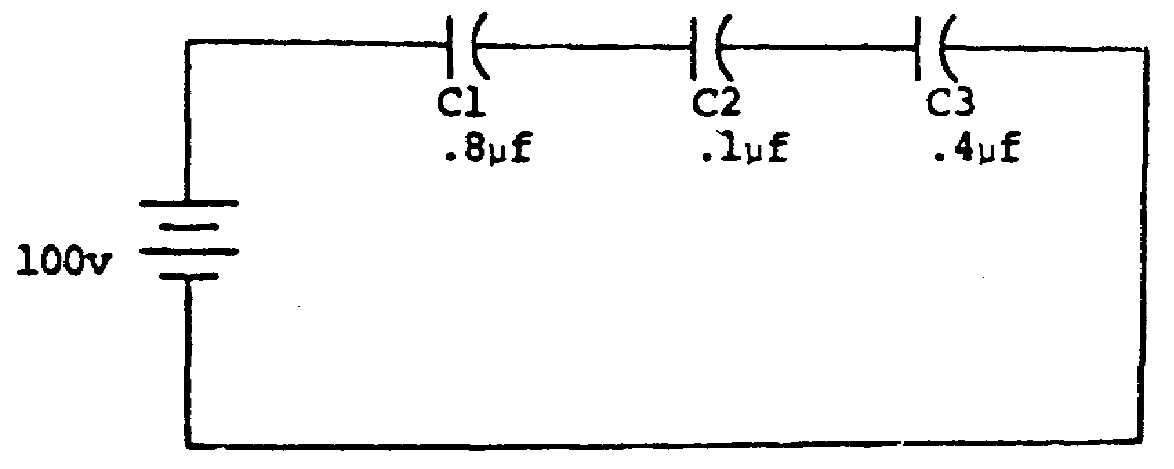

Ct = .0727 µf

75

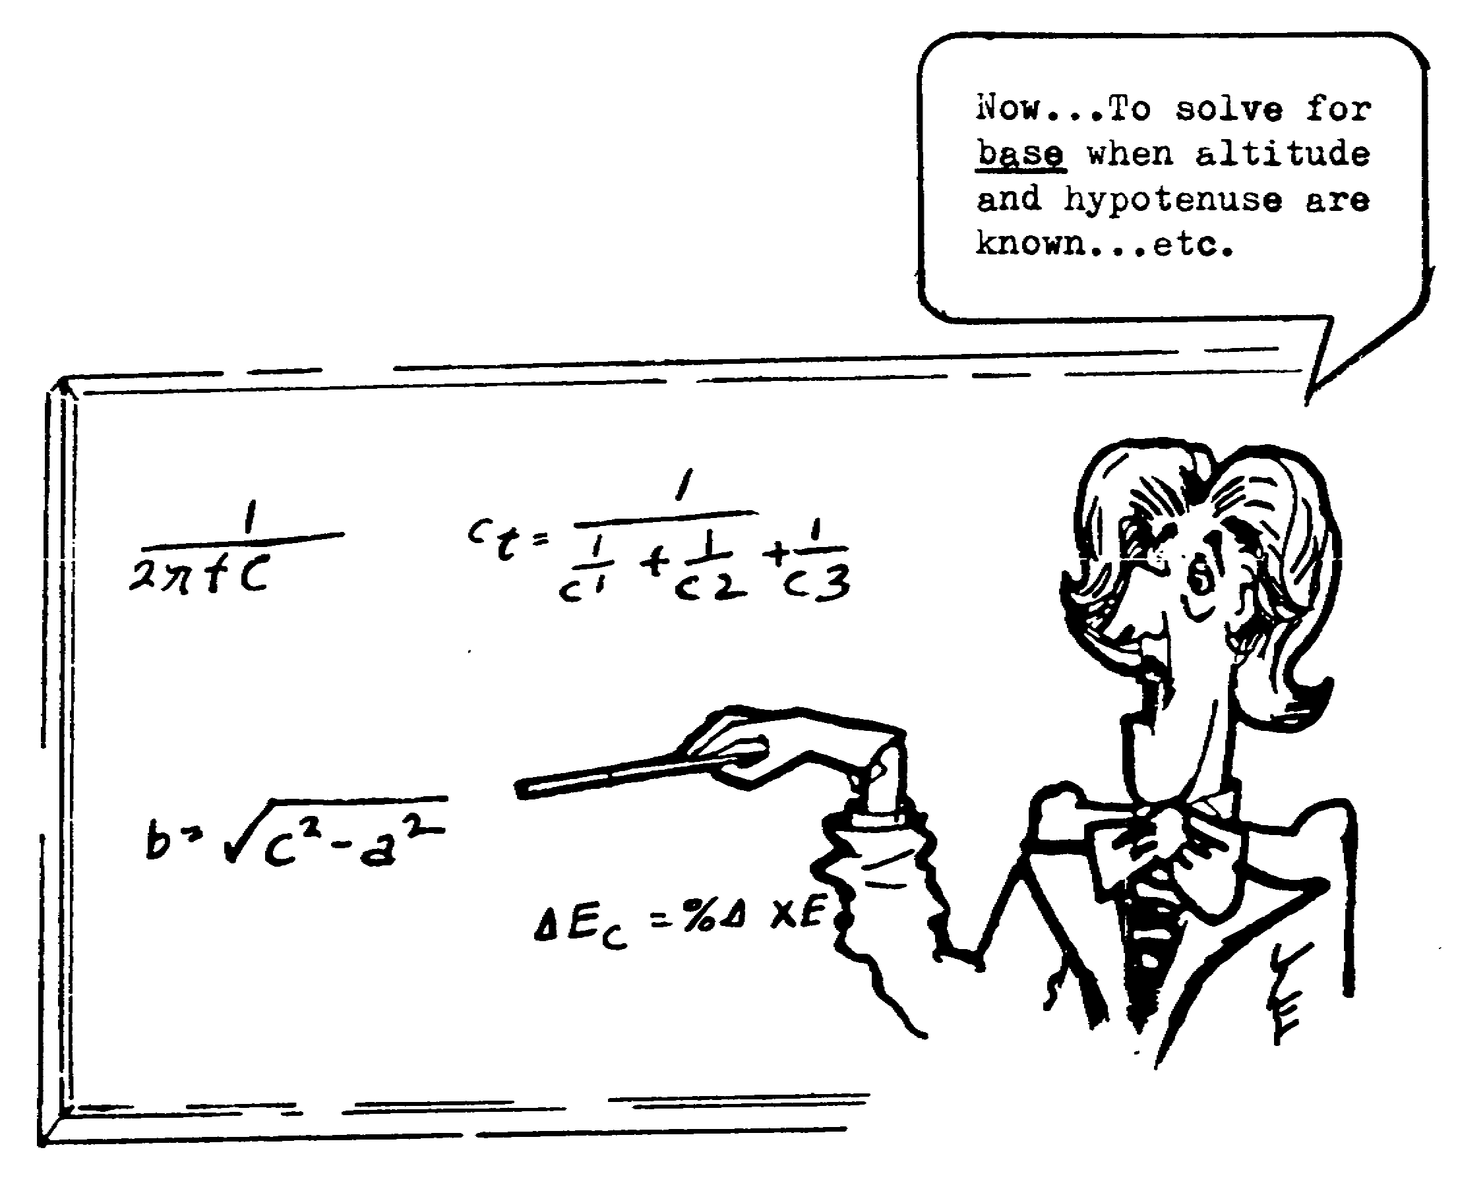

76

92. The maximum voltage that a capacitor can store is determined by the insulating material (dielectric).

Each dielectric material has a different DIELECTRIC STRENGTH. Dielectric strength is defined as the breakdown voltage per unit thickness.

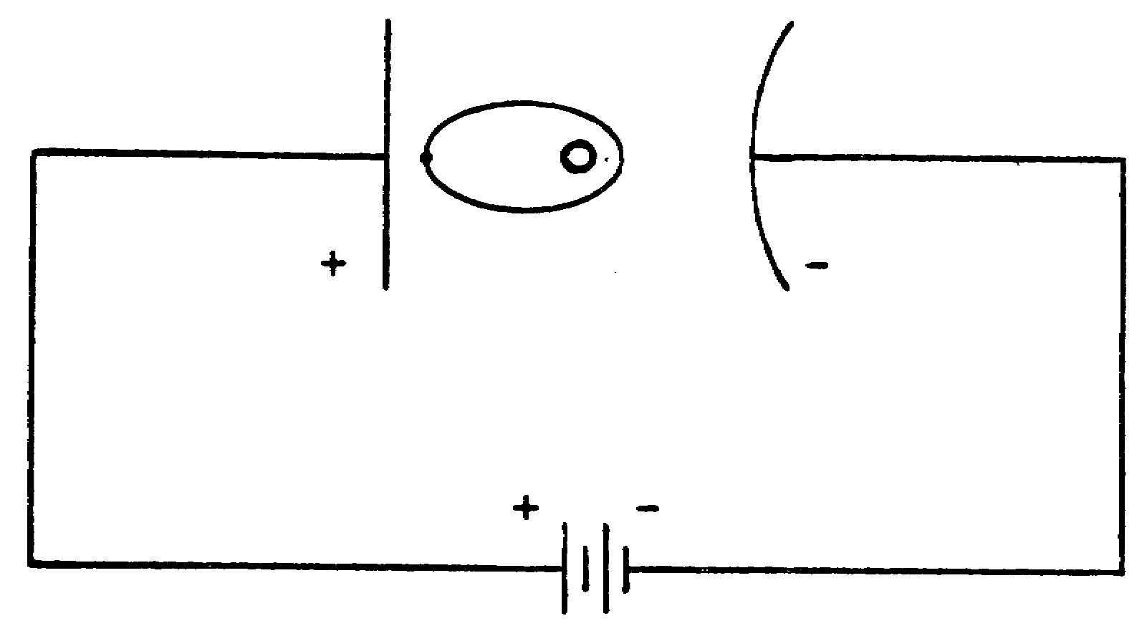

The circuit above illustrates an atom in a Dielectric material. The difference of potential between the plates causes the electron orbit to be distorted. If the source voltage is increased enough, the electron will break from its orbit, and current will flow through the dielectric. This conduction is known as dielectric breakdown. The voltage required to cause dielectric breakdown (breakdown voltage) is determined by the dielectric strength.

77

93.
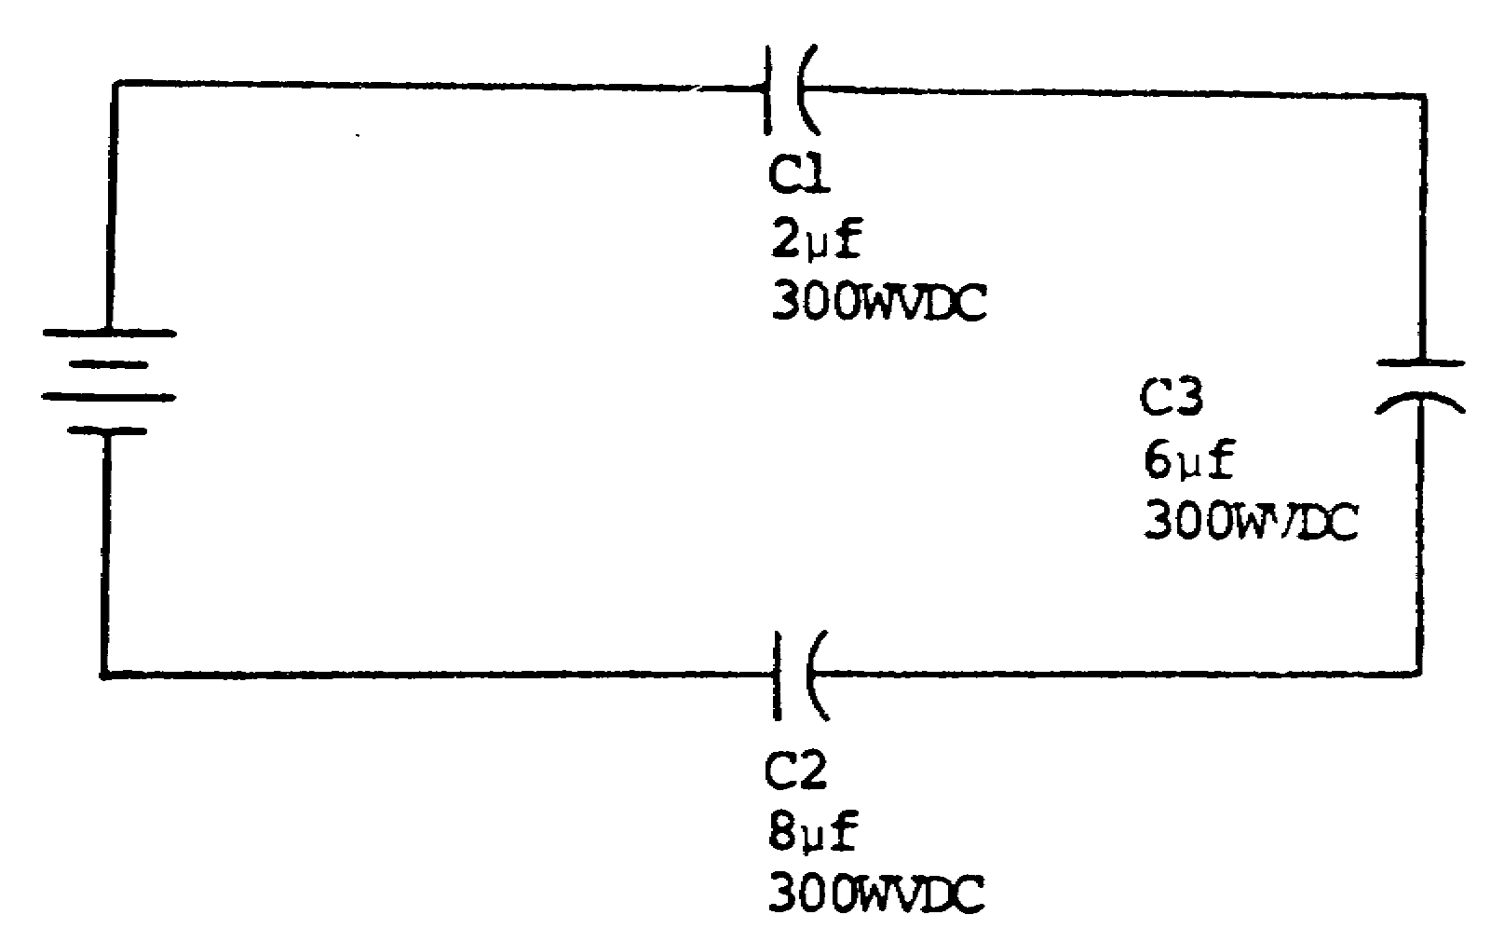
In the circuit above, the maximum voltage that can be safely applied to the circuit is found by an analysis of the circuit.
NOTE: a. In a series circuit, the voltage on each capacitor is usually different. Since Q is the same, the size of the capacitor determines the voltage.
b. The value of EC is inversely proportional to the value of capacitance. The smallest capacitance assures the largest voltage.
In the circuit above, capacitor C1 is the smallest capacitor; therefore, C1 will assume the largest voltage. With a rating of 300 WVDC, the maximum voltage that can be safely applied is 200 volts on C1.
EC1 = .667 x 300
EC1 = 200v
Student should reference frame 72 when solving the above problem.

78

93. (Continued)
Using ratio and proportion, C2 is four tines larger than Cl; therefore, the value of voltage on C2 will be one-fourth the value of the voltage on Cl.

EC2 = 1/4 EC1
= 1/4 x 200 v
= 50 v

C3 is three times larger than Cl; therefore, the value of voltage on C3 will be one-third the value of voltage on Cl.

EC3 = 1/3 EC1
= 1/3 x 200 v
= 66.67 v

The maximum voltage that can be applied to the circuit when considering a 50-per-cent safety factor is
Emax = EC1 + EC2 + EC3
= 200 v + 50 v + 66.67 v
= 316.67 v

79

93. (Continued)

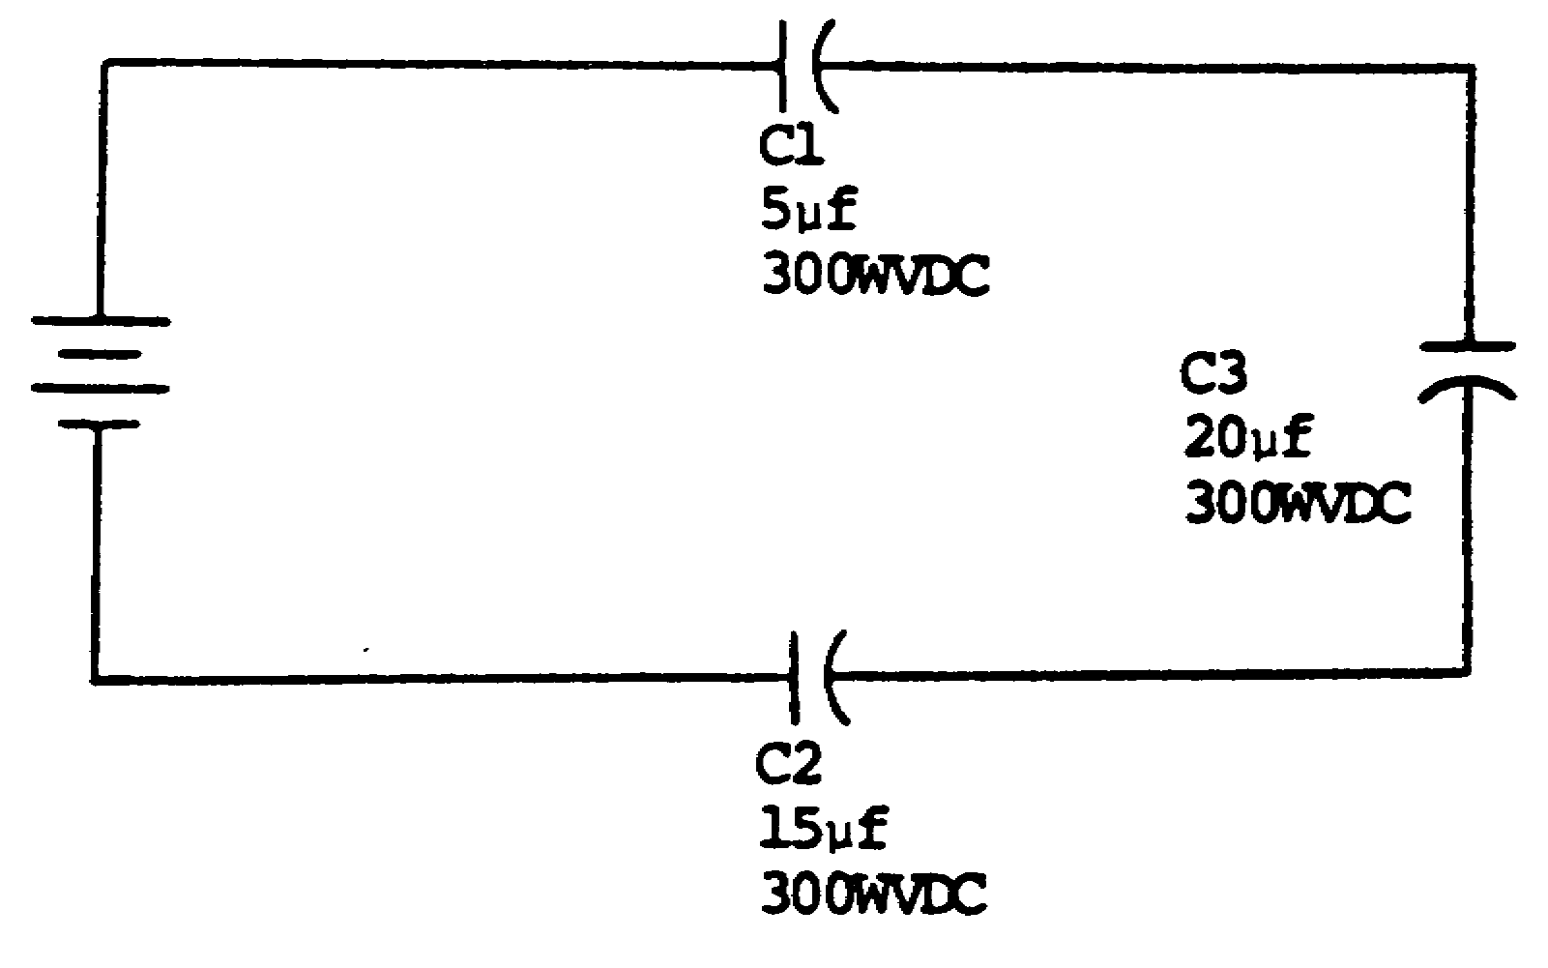

In the circuit above, what is the maximum voltage that can be applied to the circuit, considering the safety factor?

80

316.67v

81

94. What is the maximum voltage that can be applied to the circuit below, considering the safety factor?

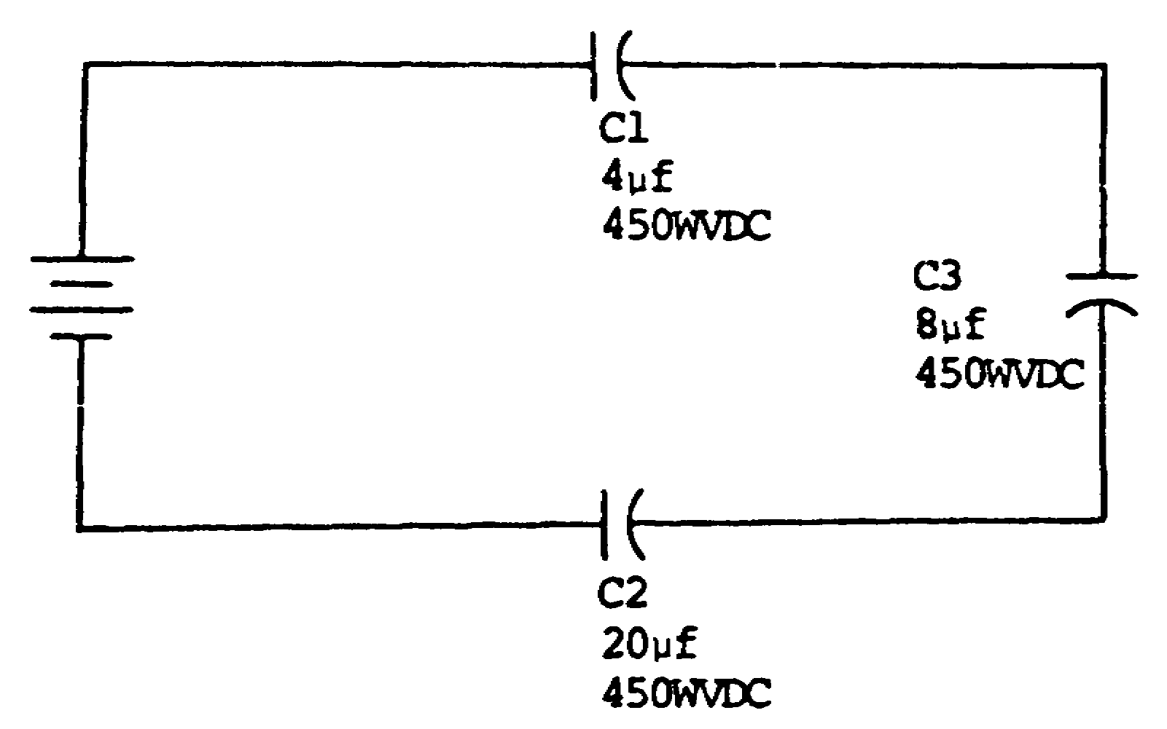

82

Emax = 510 v SOLUTION: Ratio and proportion.

C1 is the smallest capacitor; therefore, it will assume me the largest voltage. With a rating of 450 WVDC, the maximum voltage that can be applied to Cl is 300 volts when considering a 50-per-cent safety factor. EC1 = 300 v

C2 is five tines larger than C1; therefore, the value of voltage n C2 will be one-fifth the value of voltage an C1.

EC2 = 1/5 EC1
= 1/5 x 300 v
= 60 v

C3 is twice the value of Cl; therefore, the value of voltage on C3 will be one-half the value of voltage on C1.

EC3 = 1/2 EC1
= 1/2 x 300 v
= 150 v

Emax = EC1 + EC2 + EC3
= = 300 v + 60 v + 150 v
= 510 v

83

NOTES

84

95. What is the maximum voltage that can be applied to the circuit below, considering the safety factor?
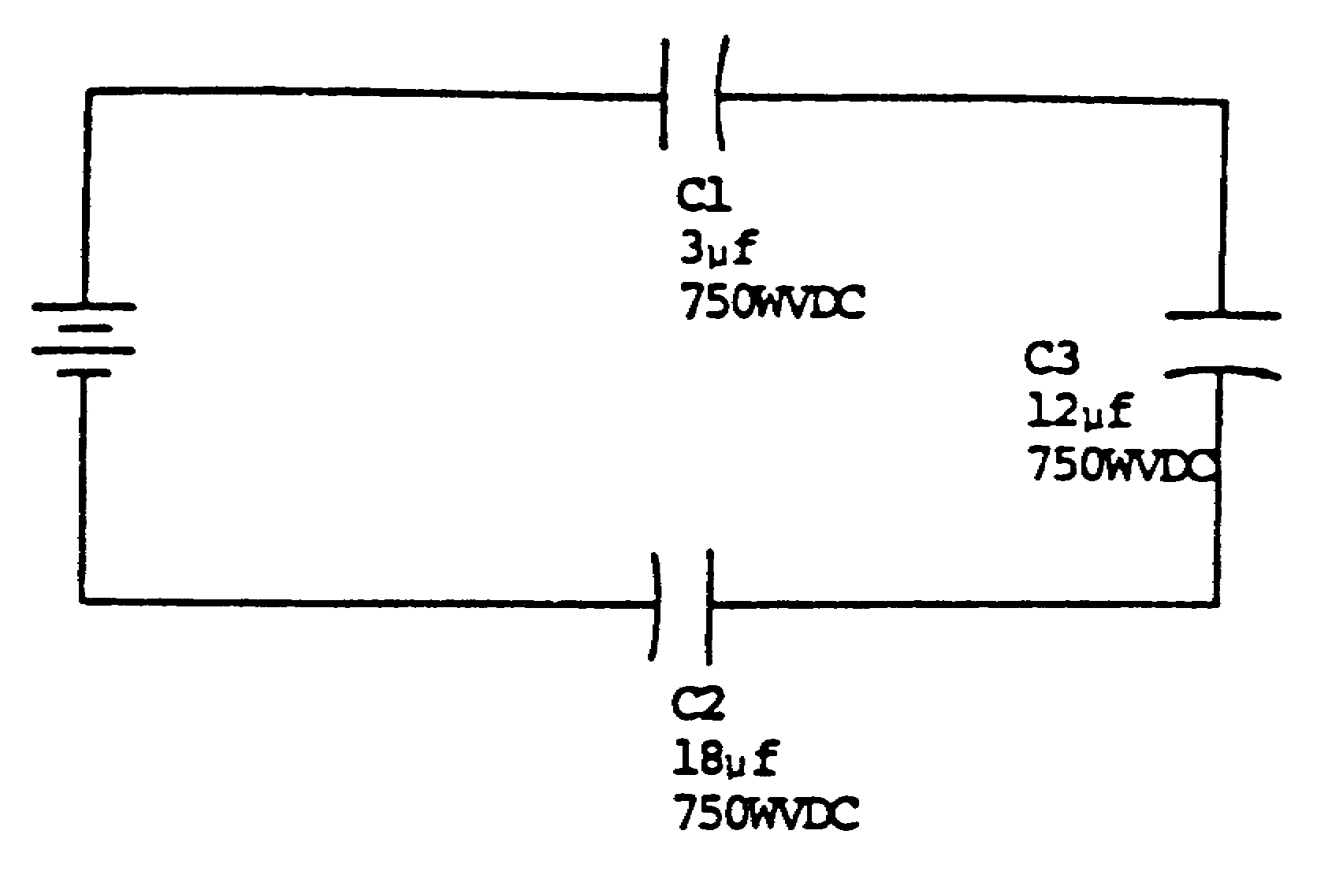

85

Emax = 708.3 v

86

LESSON 2

OBJECTIVE: The student will

1. select the statement applicable to the term "Time Constant".

2. select the statement which describes effective circuit voltage.

3. solve for effective circuit voltage in a series RC circuit.

4. solve for the change in capacitor voltage in a series RC circuit.

5. solve for the capacitor voltage' in a series RC circuit.

6. compute the resistor voltage for a series RC circuit.

7. compute RC time, Eeff, #TC, %Δ and EC for a series RC circuit.

TASK: Upon completion of this lesson you will be able to define the terms, and solve for problems in, time-constant and effective voltage.

CONDITIONS: You will have this booklet for self-paced study. All information required is contained herein.

STANDARDS: You will not be limited to the amount of time you may expend on this lesson or subcourse as a whole; however, you must conform to the minimum progress requirements set forth in chapter 3, DA Pam 351-20-18.

CREDIT HOURS: 2

87

INSTRUCTIONAL CONTENT

1. INTRODUCTION:

The sine wave is the basic waveform; however, many applications, such as radar, require nonsinusoidal waveforms (square waves, saw tooth waves etc). When these nonsinusoidal waveforms are applied to a resistive-capacitive circuit, a comparison of the capacitive reactance and resistance in the circuit becomes difficult. Since nonsinusoidal wave forms are composed of many different frequencies, an involved series of equations is required for analyzing RC networks. To simplify the analysis of RC circuits, a second method of analysis has been established. This method is to consider the output voltage changes with d-c voltages applied (the transients that take place in respect to time).

89

1. Capacitance is the property of a circuit that opposes any change of voltage in the circuit and stores energy in an electrostatic field.

A capacitor consists of two metal plates and a dielectric. When uncharged, both plates contain the same number of electrons. When charged, one plate contains more free electrons than the other plate. The difference in the number of electrons creates an electrostatic field between the plates.

The property of a circuit that opposes any change of voltage in the circuit and stores energy in an electrostatic field is_________________________.

capacitance 2. Two characteristics of a capacitor are
(1) it stores energy in an electrostatic field

(2) it opposes any change in voltage.

The capabilities of storing energy in an electrostatic field and of opposing any change in voltage are two characteristics of a____________________________.

91

capacitor 3. Select the definition of capacitance.

a. The property of a circuit that opposes any change of voltage in the circuit and stores energy in an electrostatic field.

b. A component constructed of two or more plates separated by a dielectric or an insulating material.

c. The measure of the ability of an insulating material to support an electrostatic field, as compared to air.

d. The maximum d-c voltage that can be safely applied across a capacitor without the danger of breaking down the dielectric.

a. 4. The charge (Q) that a capacitor is allowed to assume is determined by the value of the capacitance (C) and the strength of the voltage (E) applied. This relationship is shown by the formula

Q = CE

where Q = charge in coulombs
C = capacitance in farads
E = strength of field in volts

The charge that a capacitor can assume is determined by the value of the_________________ and the strength of the_______________________.

92

capacitance 5. The two characteristics of a capacitor are
voltage (1) it stores energy in an electrostatic field and

(2) it opposes any ____________________________
___________________________.

change in 6. Select the definition of capacitance.
voltage

a. The maximum d-c voltage that can be safely applied across a capacitor without the danger of braking down the dielectric.

b. The property of a circuit that opposes any change of voltage in the circuit stores energy in an electrostatic field.

c. A component constructed of two or more plates separated by a dielectric or an insulating material.

d. The measure of the ability of an insulating material to support an electrostatic field, as compared to air.

b. 7. The standard measurement for the rate of current flow is the ampere. Current flow (I) equals 1 ampere when electrons pass any given point at the rate of 1 coulomb (Q) per second (T). The amount of current flow may be determined by the formula
I =
When electrons pass any given point in an electrical circuit at the rate of 1 coulomb per second, current flow equals _________ ampere/s.
(2/4/1)

93

1 8. The basic formula that expresses the relationship of charge in coulombs, capacitance in farads, and strength of field in volts is___________________.

Q = CE 9. List two characteristics of a capacitor.
(1)
(2)

10. One coulomb (Q) is the quantity of electrons transferred when one ampere (I) flows for one second (T). When the current flow and the time are known, the quantity of electrons in the charge may be found by using the formula
A capacitor stores energy in an electro-static field.

A capacitor opposes any change in voltage.

Q = IT

The RC time formula may be derived from the two formulas for determining the value of a charge.
Since Q = CE (1)

and Q = IT (2)

then CE = IT (3)

By transposing formula (3),

T = 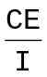 (4)

94

10. (Continued)

Ohm's law states that R = ; therefore,

substituting R for in T = ,

T = RC

"T" represents the RC time of the circuit, which is the product of resistance (in ohms) and capacitance (in farads).

A definite relationship exists between circuit components and the charge or discharge time of the capacitor. The amount of time required for a capacitor to change its charge is determined by the values of resistance and capacitance in the circuit (RC time).

The formula T = RC expresses the relationship of resistance, capacitance, and___________________.

95

time 11. Select the definition of an ampere.
a. An electric meter designed to measure current.

b. The energy required to move one electron between two points in an electrical circuit.

c. Electrons passing any given point in an electrical circuit at the rate of 1 coulomb per second.

d. The energy required to move two coulombs of electrons.

c. 12. State the basic formula that expresses the relationship of capacitance, charge, and voltage.

Q = CE 13. The RC time of a series circuit is simply the product of resistance (in ohms) and capacitance (in farads). The resultant time is generally stated in microseconds.

To solve for the RC time of a circuit with a capacitance of 10 microfarads and a resistance of 100 ohms:
T = RC
= 100 Ω x 10 uf
= 1 x 102 x 10 x 10-6
= 10 x 10-4
= 1,000 x 10-6
T = 1,000 usec

96

13. (Continued)
Determine the RC time for the problem shown below.
C = 2 uf
R = 10 Ω
T = ____________________

20 usec 14. The basic formula that expresses the relationship of resistance, capacitance, and time is_________.

T = RC 15. Select the definition of an ampere.

a. The energy required to move one electron between two points in an electrical circuit.

b. Electrons passing any given point in an electrical circuit at the rate of 1 coulomb per second.

c. The energy required to rove two coulombs of electrons.

d. An electric meter designed to measure current.

b. 16. The term "TIME CONSTANT" is defined as the time required for an exponential quantity to change by an amount equal to 63 percent of the change that can occur (63 percent is normally used for simplicity and ease of explanation).

In an RC circuit, time in seconds is directly proportional to the product of resistance and capacitance. The 63 percent is a constant, and regardless

97

16. (Continued)

Of the values of R and C, one time constant equals a 63 percent change.

In an RC circuit, one time constant (RCT) is the required to change the voltage across a capacitor
by 63 percent of the change that can occur.

The time required to change the voltage across a capacitor by 63 percent of the change that can occur is ______ ____________ _______________.

one time 17. Compute the RC time for the following problems.
constant
a. C = 0.003 uf b. C = 0.02 uf

R = 1 MΩ R = 10 kΩ

T = _________ T = _________

a. 3,000 usec 18. State the basic formula that expresses the
b. 200 usec relationship of resistance, capacitance, and time.

T = RC

98

19.
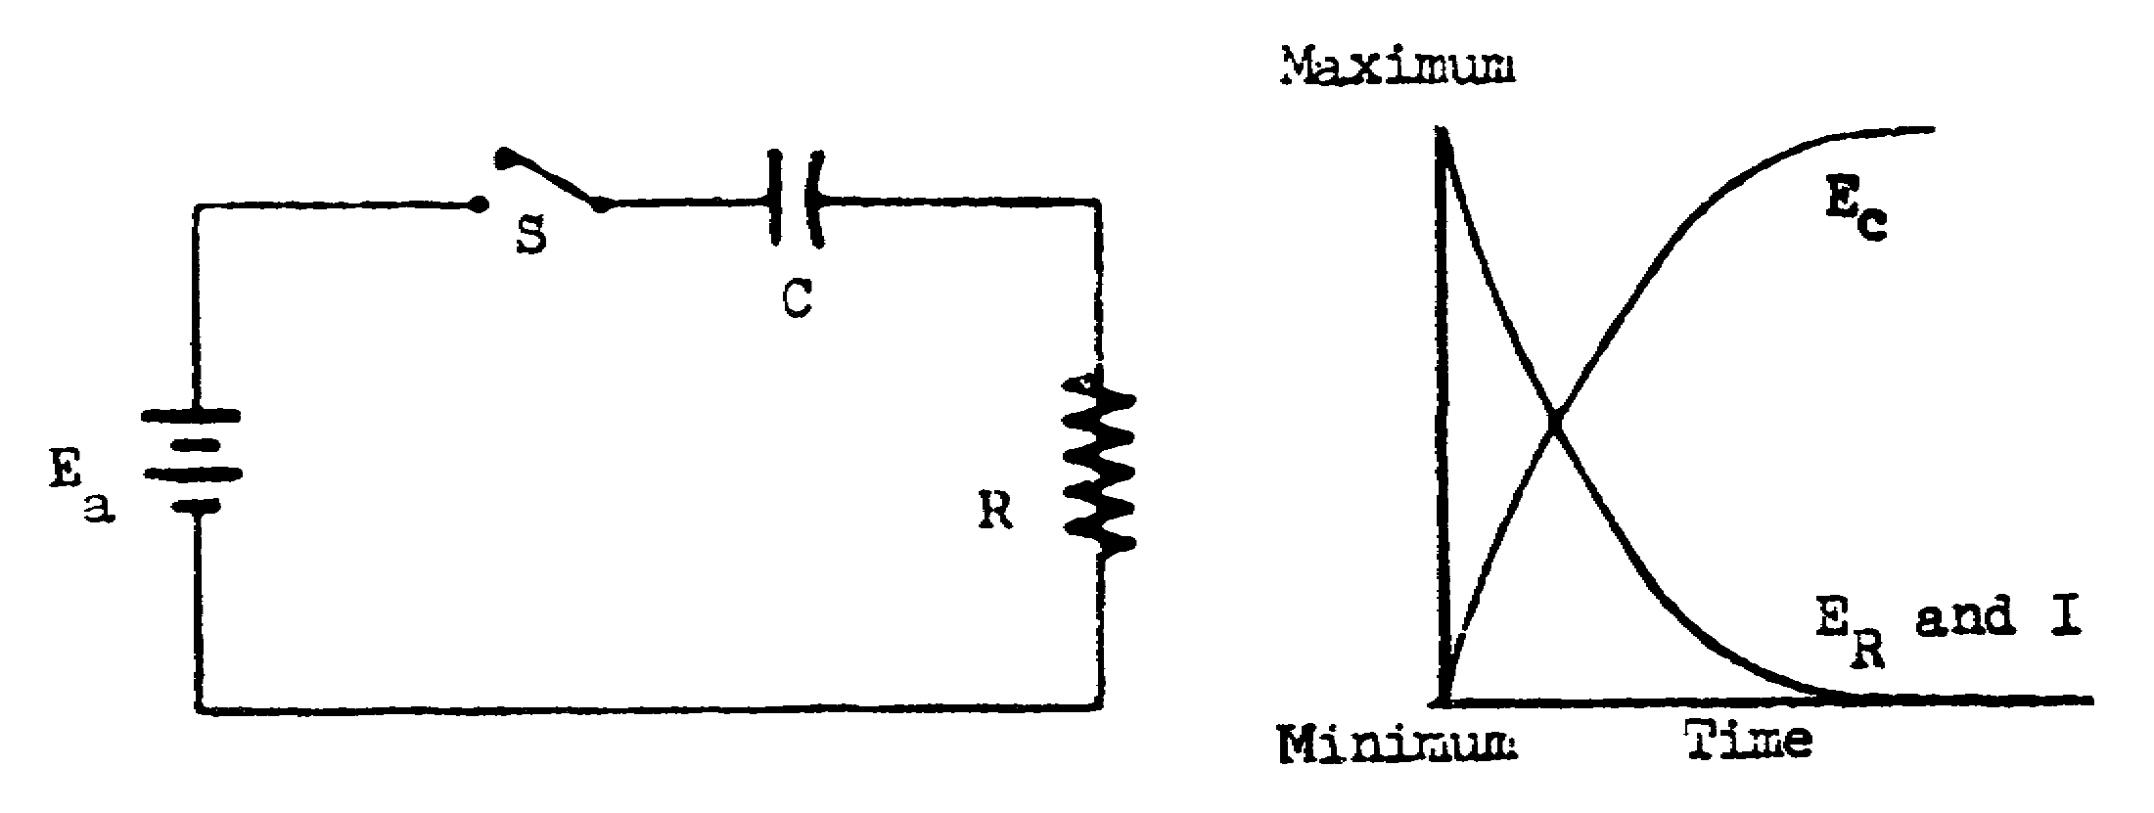

In the circuit above, the first instant that switch S is closed, all the voltage is developed across the resistor. No voltage appears across the capacitor during the first instant, because a capacitor cannot change its charge instantaneously. Maximum current passing through the resistance of the circuit develops a voltage equal to the applied voltage. As time passes, a charge will accumulate on the capacitor and cause the voltage to increase across the capacitor. Kirchhoff's law states that the algebraic sum of all changes in potential occurring around the circuit is equal to zero; therefore, as the capacitor voltage increases, the resistor voltage decreases. This action will continue until the capacitor charges to a value equal to Eapp; then, current ceases to flow.

The universal time constant chart is a graph of this voltage. Time is plotted on the X-axis and percentage of change (%Δ) on the Y-axis.

The universal time constant chart is a graph of voltage and current changes in an IC circuit. This chart is universal because it can be used to compute the time required to change the voltage or current regardless of the values of resistance or capacitance.

99

19. (Continued)

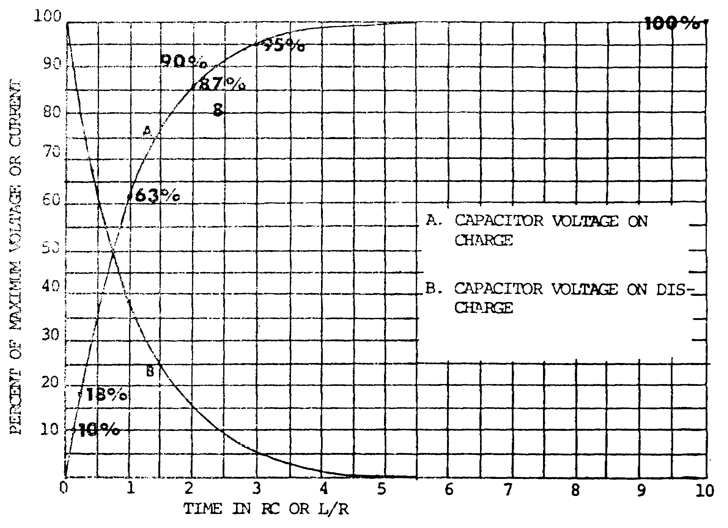

The RC time constants are illustrated on the chart shown above.

In 0.05 RC time constant, voltage changes by 5 percent.
In 0.1 RC time constant, voltage changes by 10 percent.
In 0.2 RC tine constant, voltage changes by 18 percent.
In 1 RC time constant, voltage changes by 63 percent.
In 2 RC time constants, voltage changes by 87 percent.
In 2.3 RC tine constants, voltage changes by 90 percent.
In 3 RC time constants, voltage changes by 95 percent.
In 10 RC time constants, voltage changes by 100 percent.

Below 0.1 RC time constant, the change in voltage is considered to be a linear change. For example, in 0.05 RC time constant, voltage changes by 5 percent.

In 2 RC time constants, there will be a/an__________ percent voltage change.

100

87. 20. Select the definition of a time constant.

a. The time required for an exponential quantity to change by an amount equal to 63 percent of the change that can occur.

b. A conversion from a period of time to RC time, utilizing the universal time constant chart.

c. When current flow results in a voltage being developed across the total resistance.

d. The time required to change the voltage across a capacitor by 31 percent of the change that can occur.

a. 21. Compute the RC time for each of the problems below.

a. C = 0.02 uf b. C = 100 pf

R = 200 kΩ R = 10 MΩ

T = __________ T = __________

a. 4,000 usec 22. Theoretically, a capacitor never becomes
b. 1,000 usec completely charged. However, for practical purposes, a capacitor is considered to be completely charged (100 per-cent) at the end of 10 time constants. On the universal time constant chart, you will note that at

101

22. (Continued)
10 time constants the capacitor is at 99.99 percent of the applied voltage.

A capacitor can change its charge approximately 100 percent in ___________ time constants.

10 23. Match each time constant value in column A to its percentage of change in column B. (Use the chart on page 100.)

A B

____(1) 2 a. 20 percent
____(2) 1 b. 87 percent
____(3) 2.3 c. 100 percent
____(4) 0.1 d. 10 percent
____(5) 10 e. 63 percent
____(6) 0.2 f. 90 percent
____(7) 3 g. 50 percent
____(8) 0.05 h. 95 percent
i. 5 percent
j. 18 percent

(1) b. 24. Select the definition of a time constant.
(2) e.
(2) e. a. The time required to change the voltage
(3) f. across a capacitor by 31 percent of the
(4) d. change that can occur.
(5) c.
(6) j. b. When current flow results in a voltage
(7) h. being developed across the total resistance.
(8) i.
c. A conversion from a period of time to PC
tire, utilizing the universal time constant
chart.

d. The time required for an exponential quantity
to change by an amount equal to 63 percent of
the chancre that can occur.

102

d. 25. To compute the number of time constants contained in a specified pulse width, the formula
#TC = 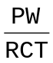 is used.
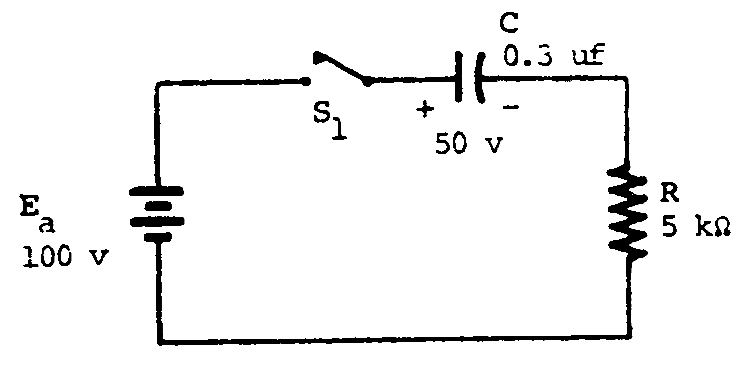

Pulse width (PW) is the time that switch S1 remains closed. In the circuit above, assume switch S1 is closed for 3,000 microseconds (PW = 3,000 microseconds). The number of time constants in 3,000 microseconds is calculated by using the time constant formula, as follows:

#TC =

PW
= 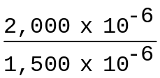
RC time of
circuit
#TC = 2

NOTE: Convert the #TC to percentage of change (%Δ) by referring to the universal time constant chart on page 100.

103

25. (Continued)
Calculate the number of time constants (#TC) for the circuit shown below (PW = 4,000 microseconds).

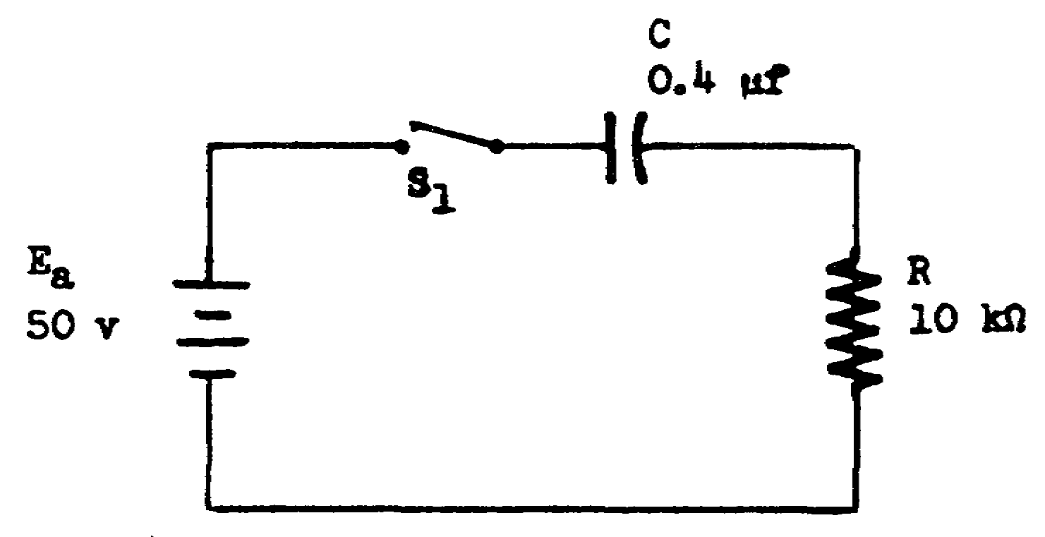

#TC = _________________________________

104

1 26. In 10 time constants, a capacitor can change its charge by _________________.

100 percent 27. Match each time constant value in column A to its percentage of change in column B. (Use the chart on page 100.

A B

____(1) 0.1 a. 90 percent
____(2) 0.2 b. 100 percent
____(3) 1 c. 63 percent
____(4) 2 d. 50 percent
____(5) 2.3 e. 87 percent
____(6) 3 f. 95 percent
____(7) 10 g. 5 percent
____(8) 0.05 h. 18 percent
i. 20 percent
j. 10 percent

105

(1) j. 28. Calculate the number of time constants (#TC) for
(2) h. the circuit shown below (PW = 250 microseconds).
(3) c.
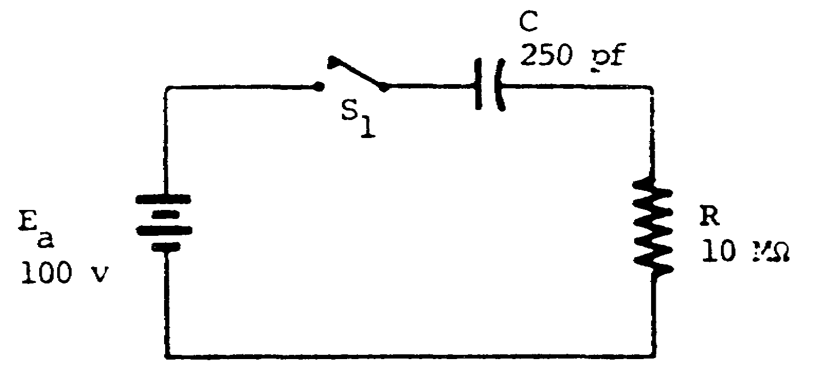
(4) e.
(5) a.
(6) f.
(7) b.
(8) g.

#TC =_________________

0.1 29. State the number of time constants required to fully charge a capacitor.

Ten. 30. The voltage that causes current to flow in a circuit is called effective circuit voltage (Eeff).

Effective circuit voltage (Eeff) is equal to the
algebraic sum of the applied voltage and the

106

30. (Continued)
capacitor voltage. Stated as a formula

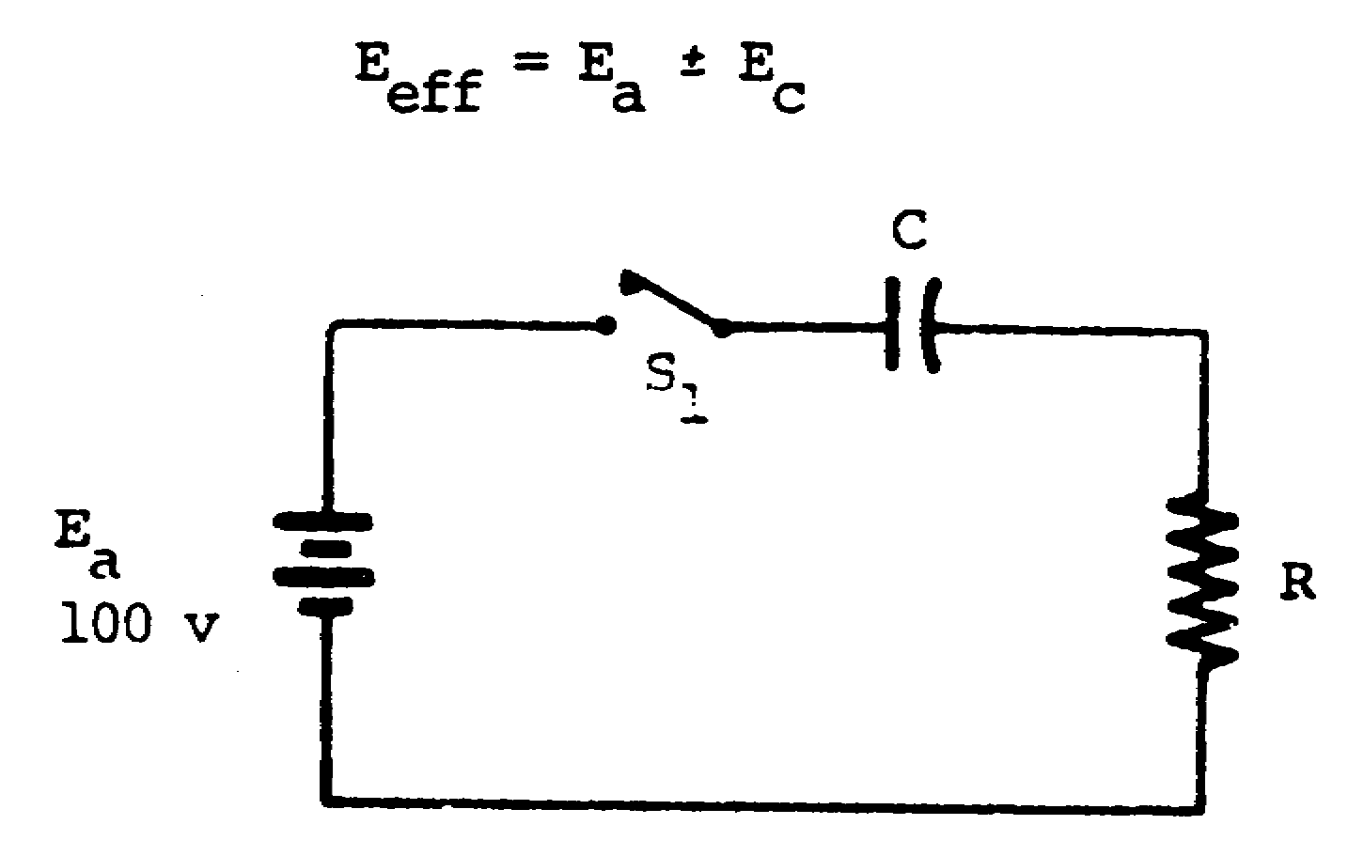

In the circuit above, assume the capacitor has a zero charge. AT THE FIRST INSTANT SWITCH S1 IS CLOSED, THE VALUE OF THE VOLTAGE ACTUALLY CAUSING CURRENT TO FLOW (Eeff) IS CALCULATED AS FOLLOWS:

Eeff = Ea ± Ec

Eeff = 100 v ± Ec

Since the capacitor has a zero charge,
Eeff = 100 v ± 0

Eeff = 100 v

The ALGEBRAIC sum of Ea and Ec MUST be used to compute Eeff, since the polarity of Ec is not always aiding Ea.

107

30. (Continued)

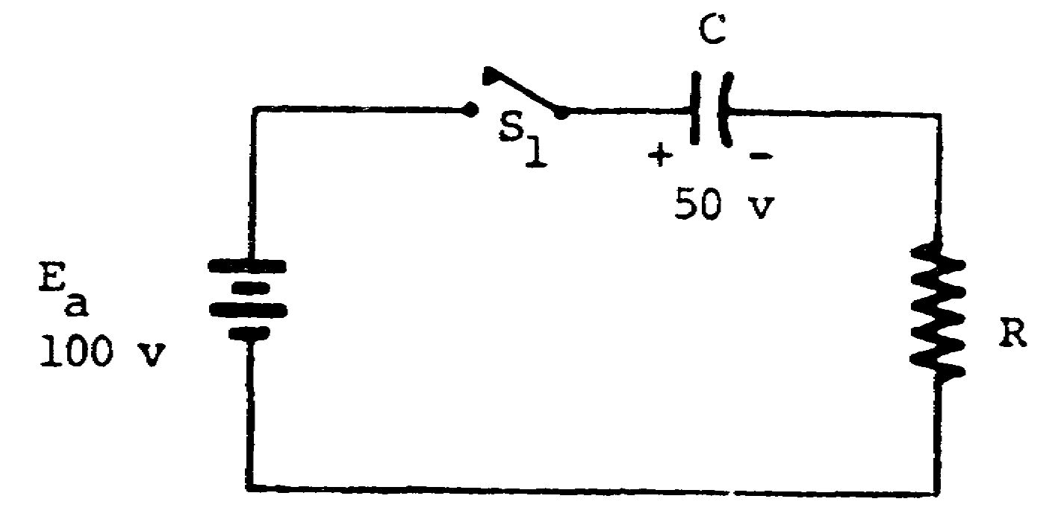

In the circuit above, assume switch S1 is closed long enough to charge the capacitor to 50 volts and then opened. The capacitor has a 50-volt charge, and no current is flowing. Now, close the switch and calculate the value of the voltage that is actually causing current to flow.

Eeff = Ea ± Ec

Eeff = 100 v ± Ec

From the polarity indicated on the capacitor as compared to the polarity of the battery, it is evident that Ec opposes Ea; therefore,

Eeff = 100 v - Ec

= 100 v - 50 v

Eeff = 50 v

108

30. (Continued)

NOTE: In a series RC circuit, the effective circuit voltage is developed across the resistance.

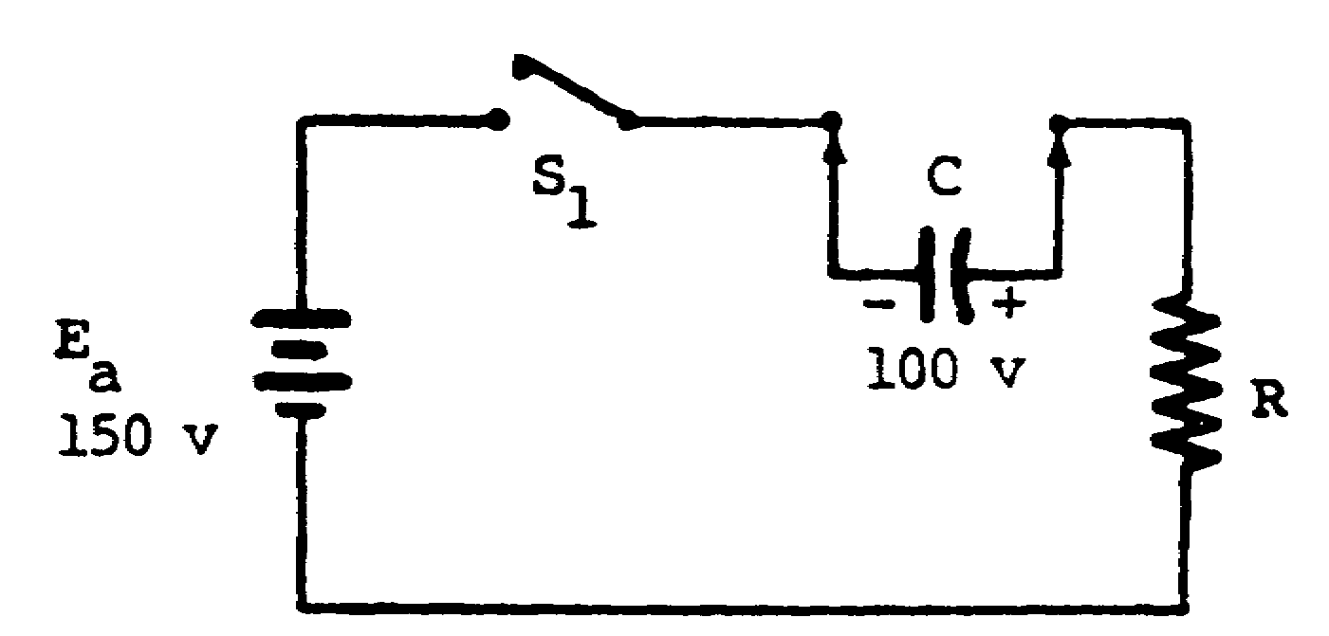

In the circuit above, assume that the capacitor has been previously charged to 100 volts by an external source.

If the capacitor is connected to the circuit with the polarities as shown, the capacitor voltage will aid the battery; therefore,

Eeff = Ea + Ec

Since the capacitor voltage is aiding the battery, Ea is added to Ec.

Eeff = 150 v + Ec
= 150 v + 100 v
Eeff = 250 v

109

30. (Continued)
The voltage actually causing current to flow in the circuit is 250 volts.

The algebraic sum of the applied voltage and the capacitor voltage is the ______________________ ____________________voltage.

effective 31. Select two statements that describe effective
circuit
circuit voltage.

a. The algebraic sum of the applied voltage and the capacitor voltage.

b. The voltage that causes current to flow in a circuit.

c. The effective value of an alternating current.

d. The ratio of the induced emf across a capacitor to current.

e. The vectorial sum of the applied voltage and the resistor voltage.

a. 32. Calculate the number of time constants contained
b. in the pulse widths given below.

a. PW = 2,500 usec b. PW = 5,000 usec
RCT = 2,500 usec RCT = 10,000 usec
#TC = __________ #TC = ___________

110

a. 1 33. A change in capacitor voltage (ΔEc) is calculated
b. 0.5 by multiplying the effective circuit voltage (Eeff) by the percentage of change (%Δ) allowed as derived from the number of time constants,
ΔEc = %Δ x Eeff.
In the circuit below, using a pulse width of 3,000 microseconds, calculate the change in capacitor voltage (ΔEc).
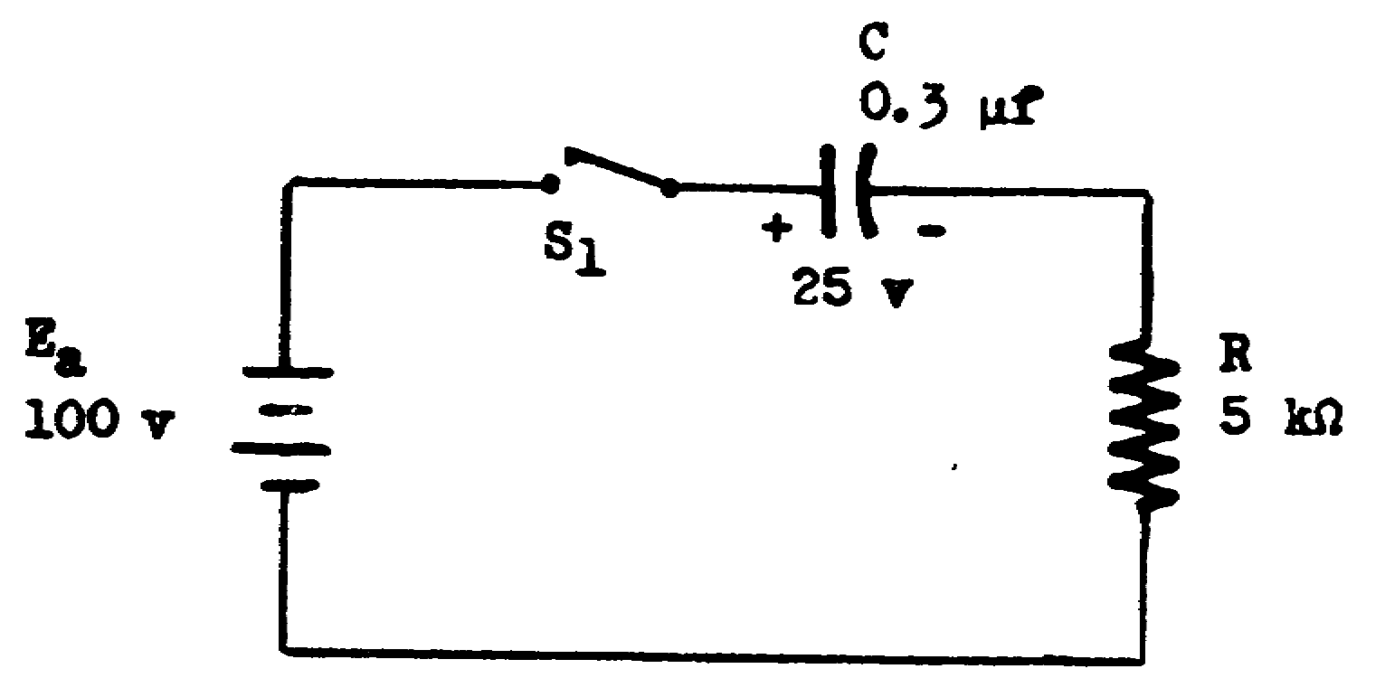

The capacitor has previously been charged to 25 volts; therefore,
Eeff = Ea ± Ec
= 100 - 25 v
= Eeff = 75 v
Compute #TC.
#TC =
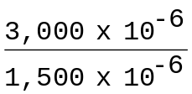
#TC = 2
The universal time constant chart shows that the percentage of change (%Δ) for 2 TC is 87 percent.

111

33. (Continued)
Compute ΔEc.

ΔEc = %Δ x Eeff

0.87 x 75 v

ΔEc = 65.25 v

The charge on the capacitor is changed (ΔEc) by 65.25 volts in two tine constants. Notice that when the switch is closed, the capacitor continues to charge. Therefore, after the change takes place, the new value of Ec is 90.25 volts. This is computed by algebraically adding the original value of Ec (25) to ΔEc (65.25 v).

Calculate ΔEc in the circuit shown below after the switch has been closed for 4,000 microseconds.
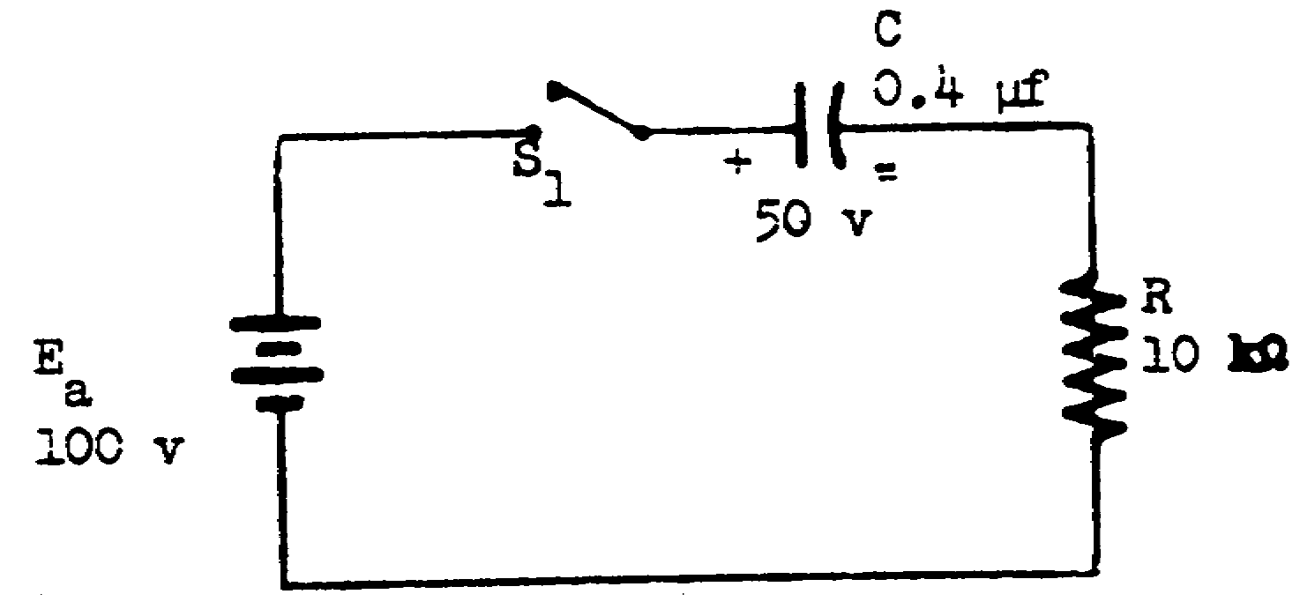

ΔEc _______________________

112

31.5 v 34. Calculate the effective circuit voltage in each of the circuits below.
a.
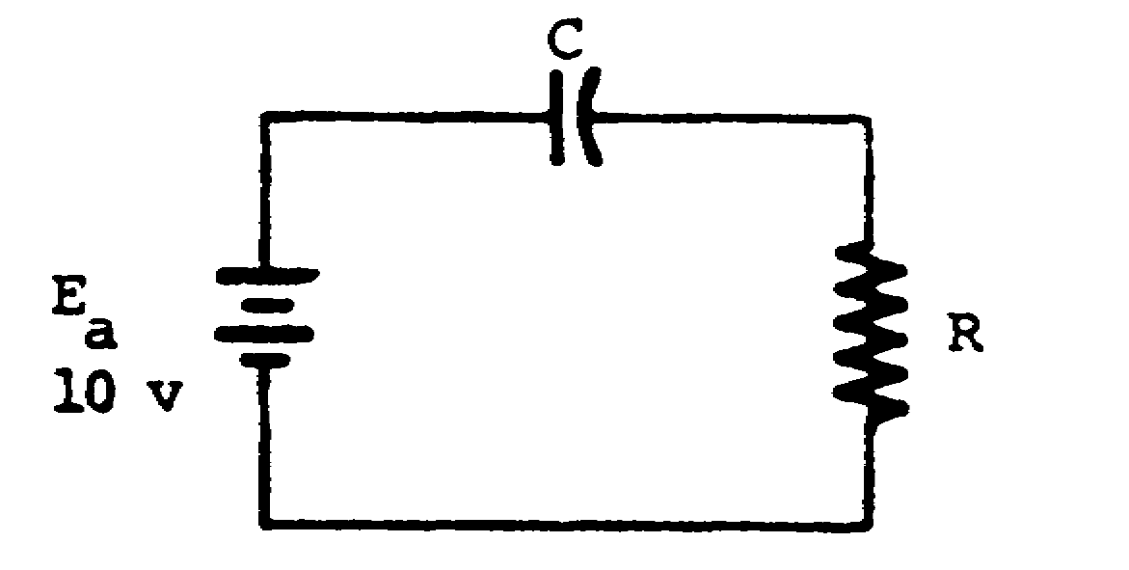

Eeff = _________________

b.
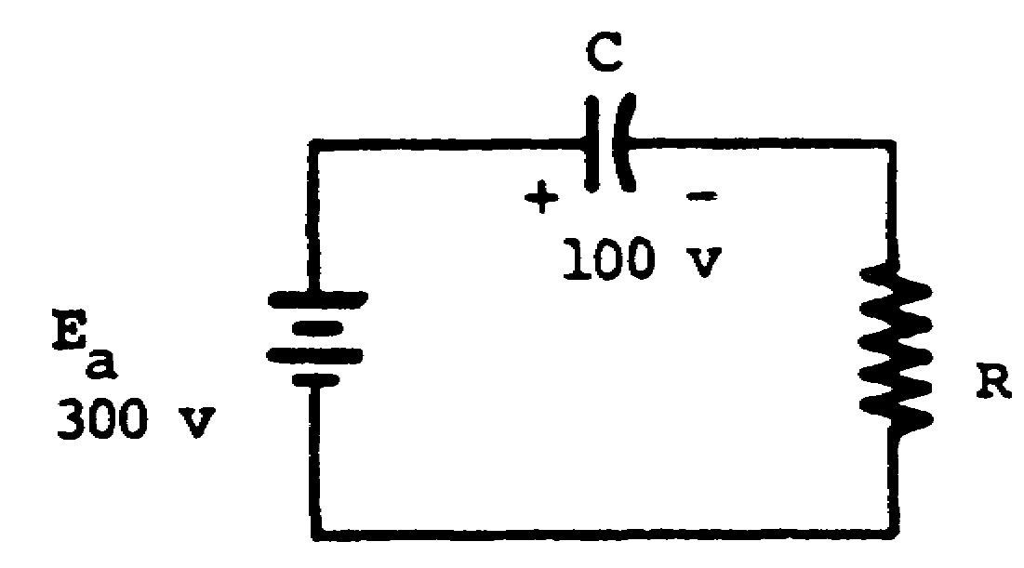

Eeff = __________________

113

a. 10 v 35. Select two statements that describe effective
b. 200 v circuit voltage.

a. The ratio of the induced emf across a capacitor to current.

b. The vectorial sum of the applied voltage and the resistor voltage.

c. The algebraic sum of the applied voltage and the capacitor voltage.

d. The voltage that causes current to flow in a circuit.

e. The effective value of an alternating current.

c. 36. The capacitor in the following circuit has been
d. previously charged to 200 volts.

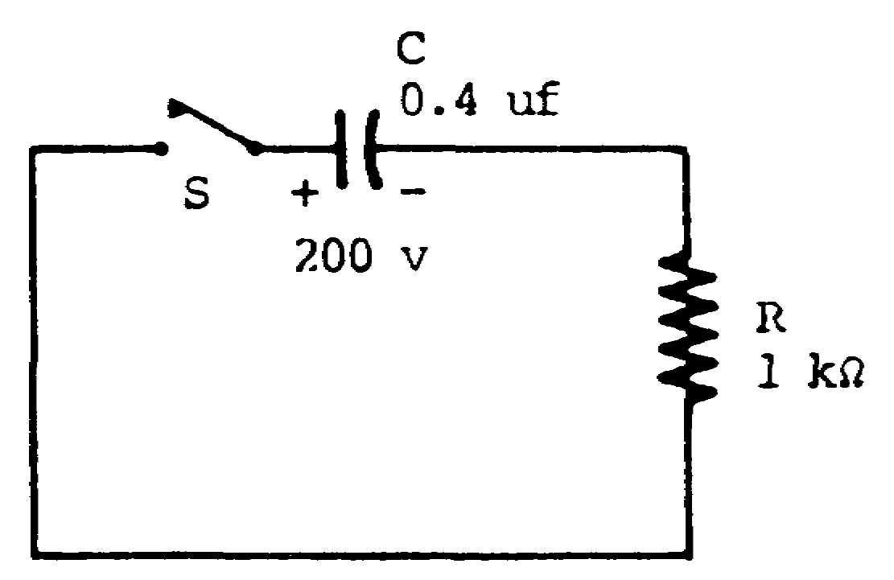

Since there is not an external potential applied, the capacitor will discharge if the switch is closed. In this example, Ec has became Eeff, since it is the voltage that causes current to flow.

114

36. (Continued)

Calculating for values of RC time, #TC, percentage of change, Eeff, and ΔEc is the same as for previous circuits. If the switch is left closed for 10 time constants, the capacitor will discharge to zero (100-percent change).

To calculate RC time, #TC, percentage of change, Eeff, and ΔEc for the circuit shown below, use the following procedure (PW = 40 microseconds).
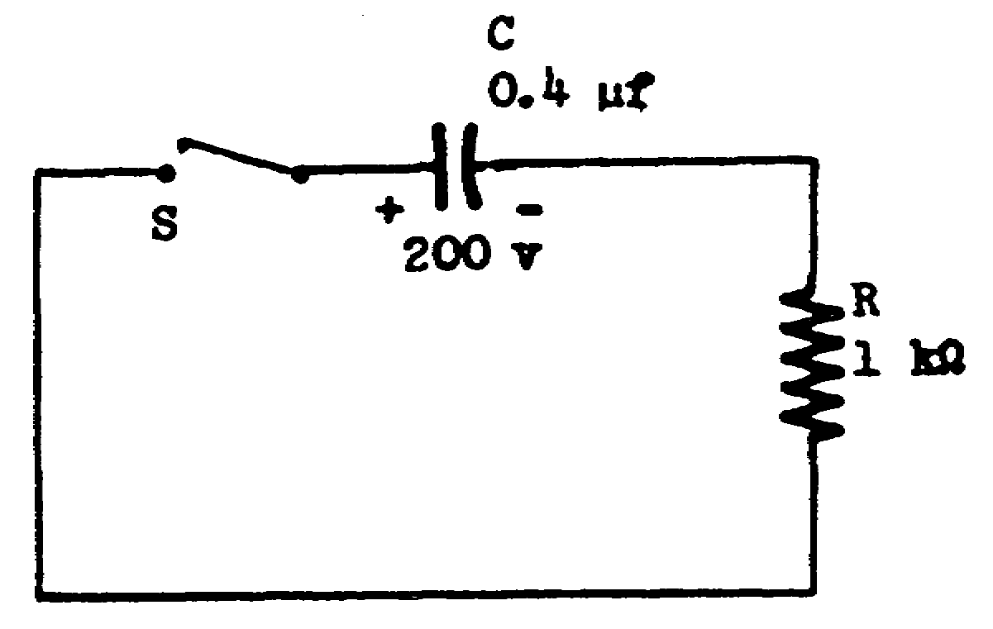

Calculate RC time.
T = RC
= 1 x 103 x 0.4 x 10-6
= 0.4 x 10-3
= 400 x 10-6
T = 400 usec

Calculate #TC.
#TC =
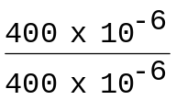
#TC = 0.1

115

36. (Continued)

Calculate percentage of change by utilizing the universal tire constant chart. (See page 100)

0.1 TC = 10%Δ

Calculate Eeff (at the first instant).

Eeff = Ea ± Ec

= 0 ± 200 v

Eeff = 200 v

Calculate ΔEc.

ΔEc = %Δ x Eeff
= 10% x 200 v
= 0.10 x 200 v
ΔEc = 20 v

Calculate the new value of Ec.

Ec = original value of Ec ± ΔEc
= 200 v - 20 v
Ec = 180 v

NOTE: Since the capacitor discharges when the switch is closed, ΔEc is subtracted from the voltage that was originally on the capacitor.

116

36. (Continued)

Calculate Ec in the circuit shown below after the switch has been closed for 120 microseconds.

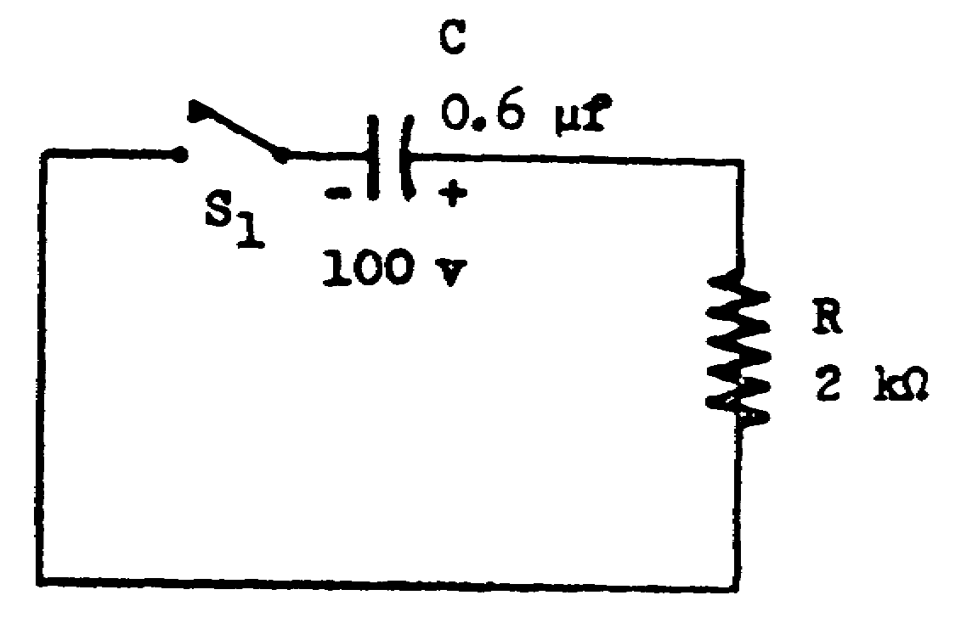

Ec = _________________________

117

90 v 37. Calculate the change in capacitor voltage (ΔEc) in the circuit shown below after the switch has been closed for 1,000 microseconds.

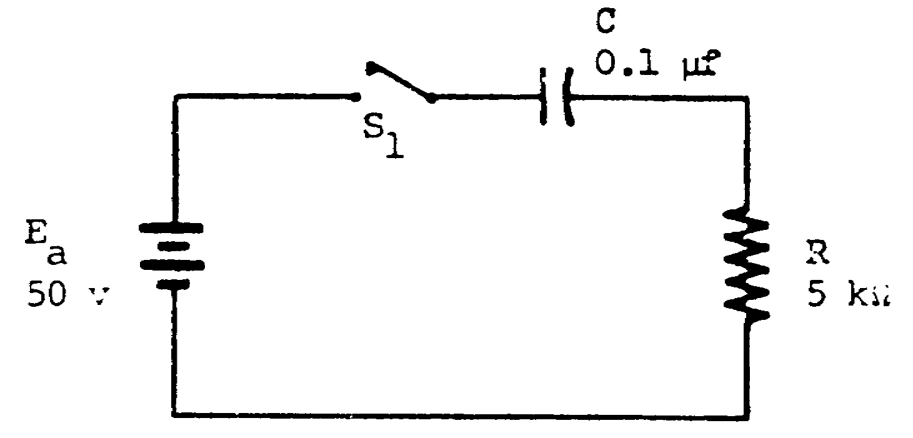

ΔEc = __________________

118

43.5 v 38. Calculate the effective circuit voltage in each of the circuits below.

a.

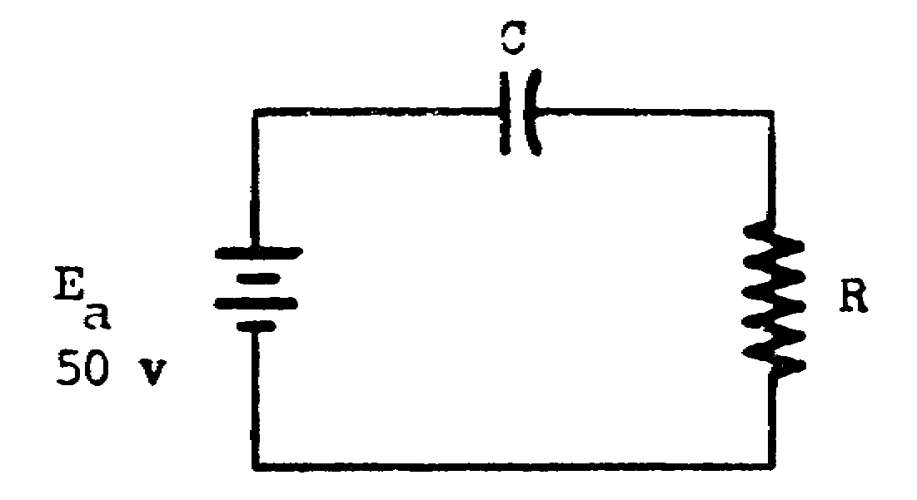

Eeff = __________________

b.

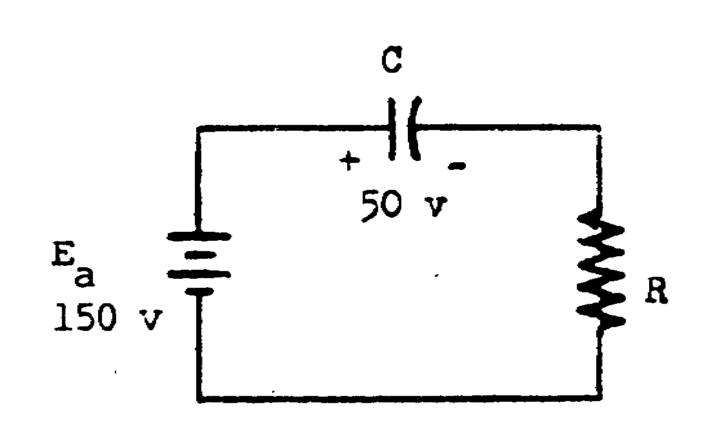

Eeff = _____________________

119

a. 50 v 39. To compute resistor voltage (ER) in a circuit
b. 100 v after a specified period of charge time, Ec and Eapp must be known. By using the quantities Eapp, Ec, and ER and applying them to Kirchhoff's law, the formula Eapp = ER ± Ec is derived. The algebraic sum of Ec and ER is Eapp.

To compute the resistor voltage (ER) in the circuit below after the switch has been closed for 400 microseconds, the following method is used.

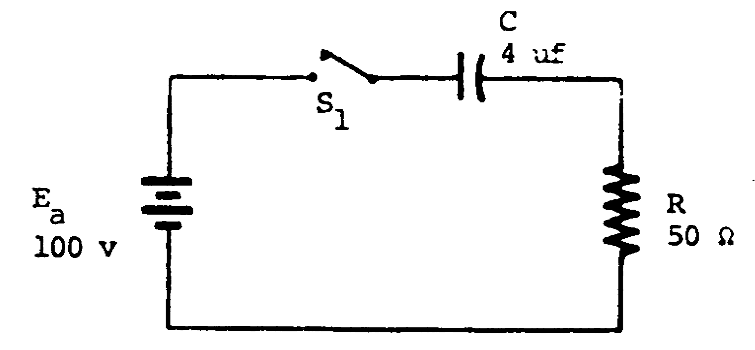

Compute RCT.

T = RC
= 50 x 4 x 10-6
= 200 x 10-6
T = 200 usec

120

39. (Continued)
Compute #TC.

#TC =

= 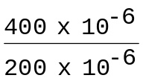

#TC = 2

The universal time constant chart shows that the percentage of change at 2 TC is 87 percent.

Compute Eeff

Eeff = Eapp ± Ec
= 100 v ± 0
Eeff = 100 v

Compute ΔEc.

ΔEc = E eff x %Δ
= 100 v x 87%
= 100 v x 0.87
ΔEc = 87 v

Compute Ec.

Ec = original value of Ec ± ΔEc
= 0 + 87 v
Ec = 87 v

121

39. (Continued)
Compute ER.

ER = Eapp - Ec

= 100 v - 87 v

ER = 13 v

Kirchhoff's voltage law states that the algebraic sum of all the voltage drops in a closed loop must equal Eapp; therefore,

ER will equal 13 volts after the switch has been closed for 400 microseconds.

Compute the resistor voltage for the circuit below after the switch has been closed for 200 microseconds.

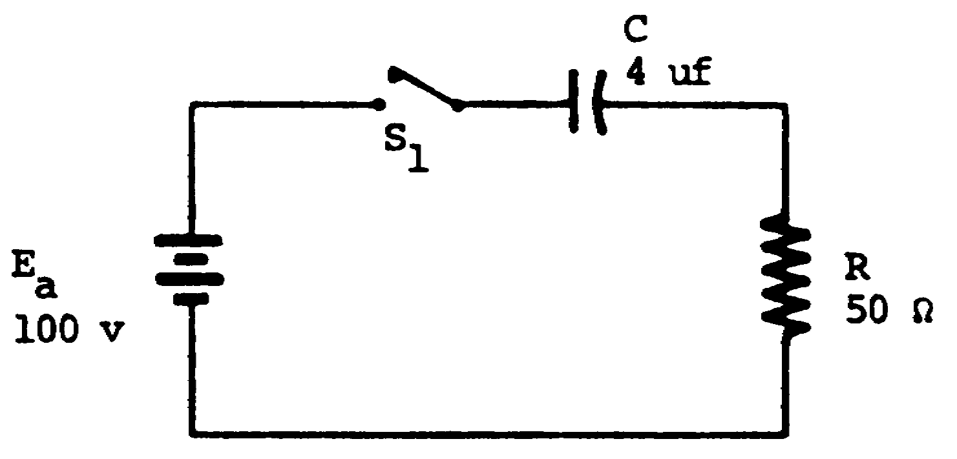

ER = _________________

122

37 v 40. Calculate the capacitor voltage (Ec) for the circuit shown below after the switch has been closed for 100 microseconds.

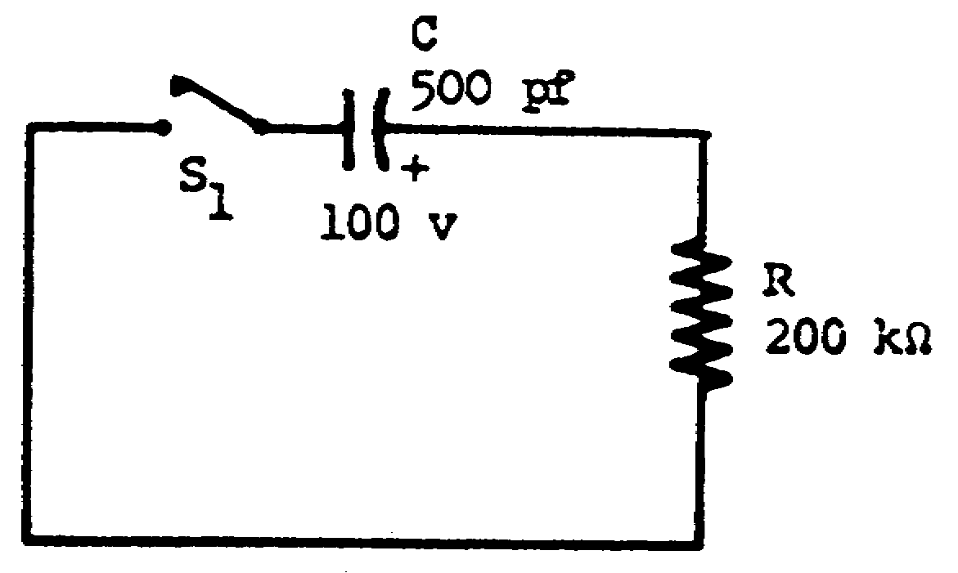

Ec = ____________________

123

37 v 41. Calculate the change in capacitor voltage (ΔEc) in the circuit shown below after the switch has been closed for 1,000 microseconds.

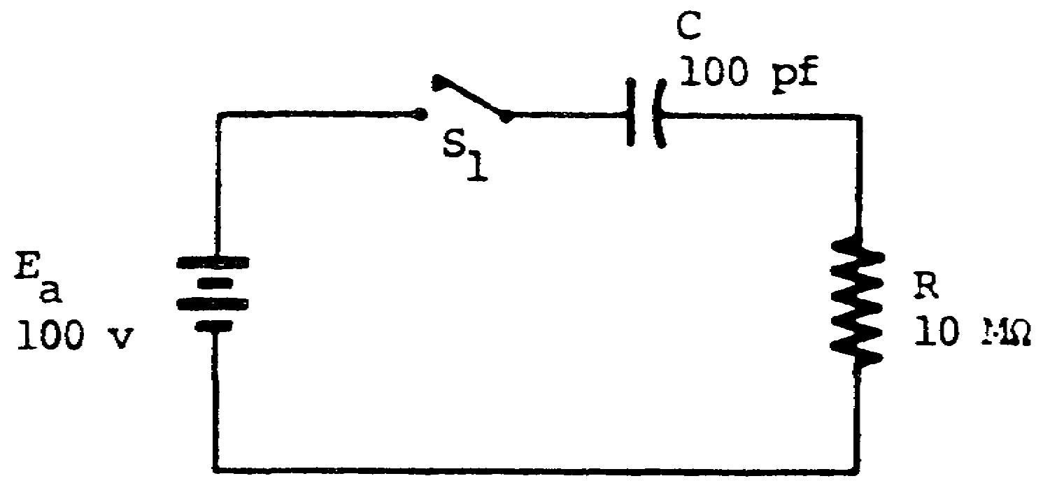

ΔEc _________________

124

63 v 42. To solve for RCT, E eff, #TC, percentage of change, ΔEc, and Ec for a given circuit, a logical procedure should be followed, as shown below (PW = 200 microseconds).

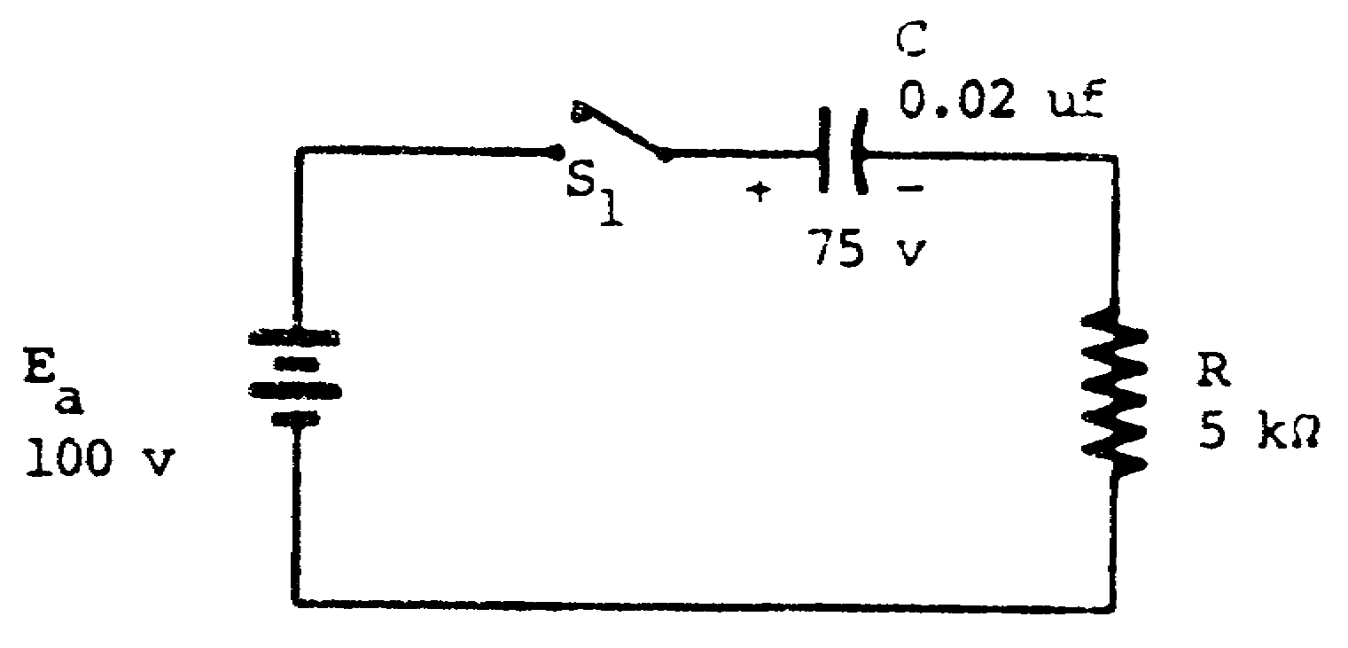

Step 1: Compute RCT.

T = RC
= 5 x 103 x 0.02 x 10-6
= 100 x 10-6
T = 100 usec

Step 2: Compute #TC.

#TC =
#TC = 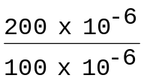
#TC = 2
Step 3: Use the universal time constant chart to find the percentage of change for 2 TC.

%Δ = 87%

125

42. (Continued)
Step 4: Compute Eeff.
Eeff = Ea ± Ec
= 100 v - 75 v
Eeff = 25 v

Step 5: Compute ΔEc.

ΔEc = %Δ x Eeff
= 0.87 x 25 v
ΔEc = 21.7 v

The instant switch S1 is closed; the capacitor seeks a new voltage level. In the preceding example, the capacitor was charged to 75 volts before switch S1 was closed. From the polarities on the battery and the capacitor, it can be seen that the capacitor will charge towards 100 volts.
If the switch remains closed for 200 microseconds, a change of 21.7 volts will occur. Ec equals the algebraic sum of the capacitor voltage before any change and ΔEc.

Ec = original value at Ec ± ΔEc
= 75 v + 21.7 v
Ec = 96.7 v

126

42. (Continued)
Compute RCT, Eeff, #TC, percentage of change, ΔEc, and E c (PW = 75 microseconds).
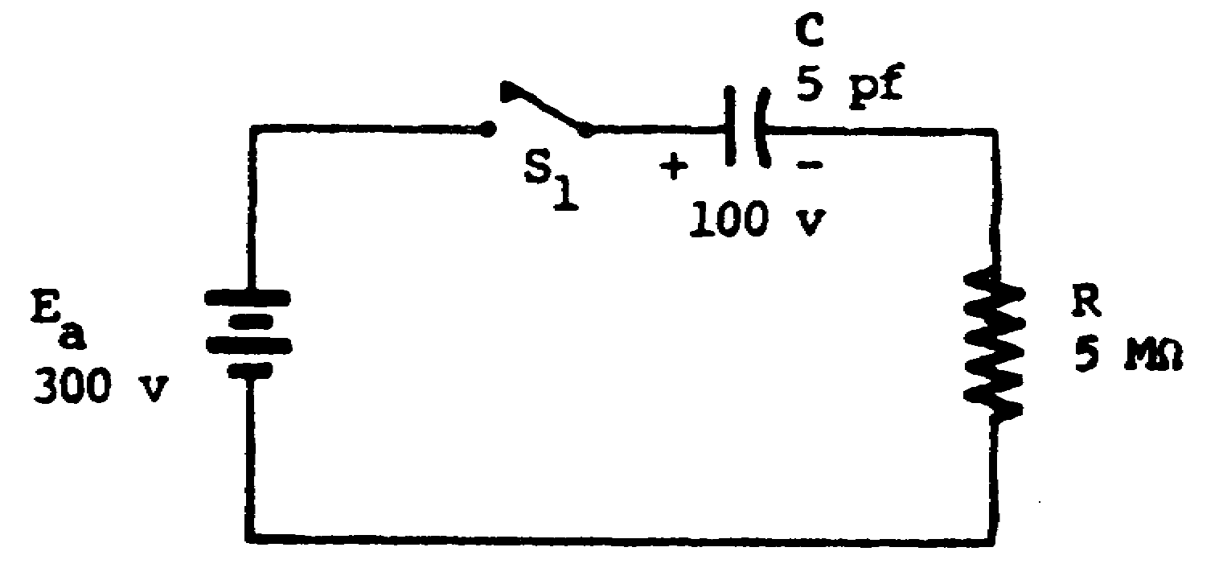

RCT = ___________ %Δ = __________
Eeff = ___________ ΔEc = __________
#TC = ___________ Ec = __________

127

RCT = 25 usec 43. Compute the resistor voltage (ER) for the circuit
Eeff = 200 v shown below after the switch has been closed for
#TC = 3 200 microseconds.
%Δ = 95%
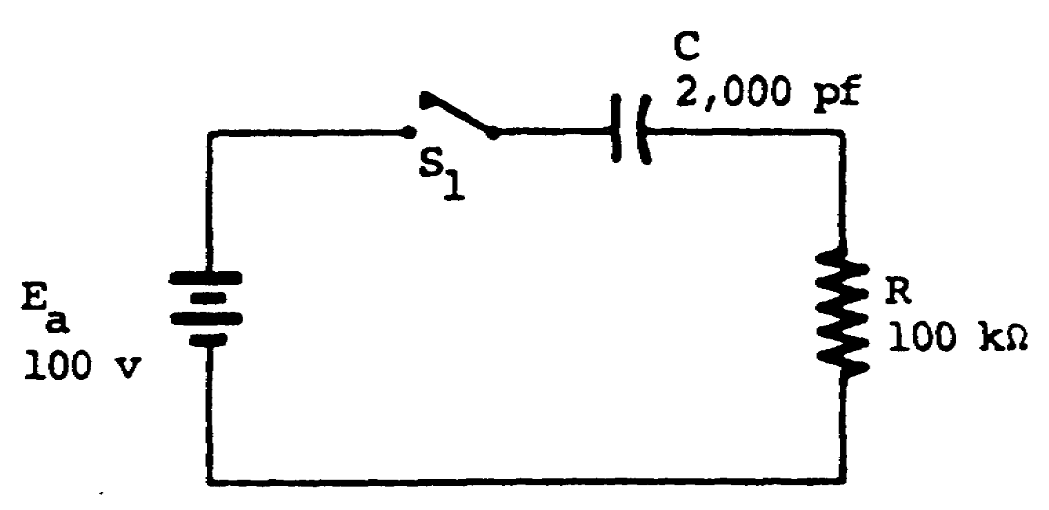
ΔEc = 190 v
Ec = 290 v

ER = _________________

128

37 v 44. Calculate the capacitor voltage (Ec) in the circuit shown below after the switch has been closed for 100 microseconds.

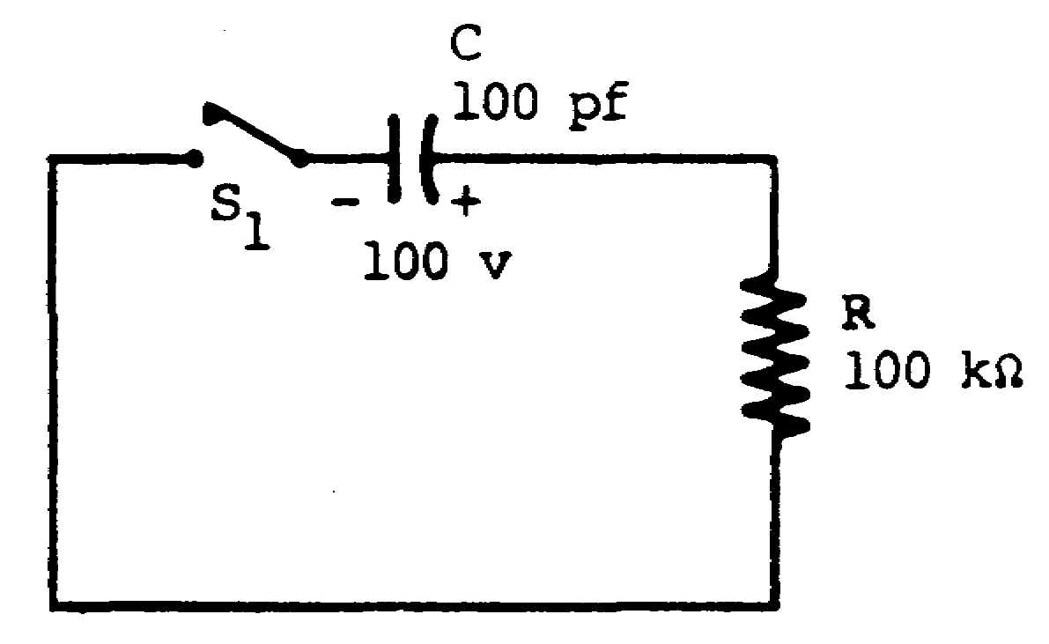

Ec = _______________

0 v 45. State the formulas for RCT, #TC, Eeff, and ΔEc.

RCT = ___________________
#TC = ___________________
Eeff = ___________________
ΔEc = ___________________

129

T = RC 46. Compute the resistor voltage (ER) in the circuit
#TC = shown below after the switch has been closed for
Eeff = Ea ± Ec 30 microseconds.
ΔEc = %Δ x Eeff
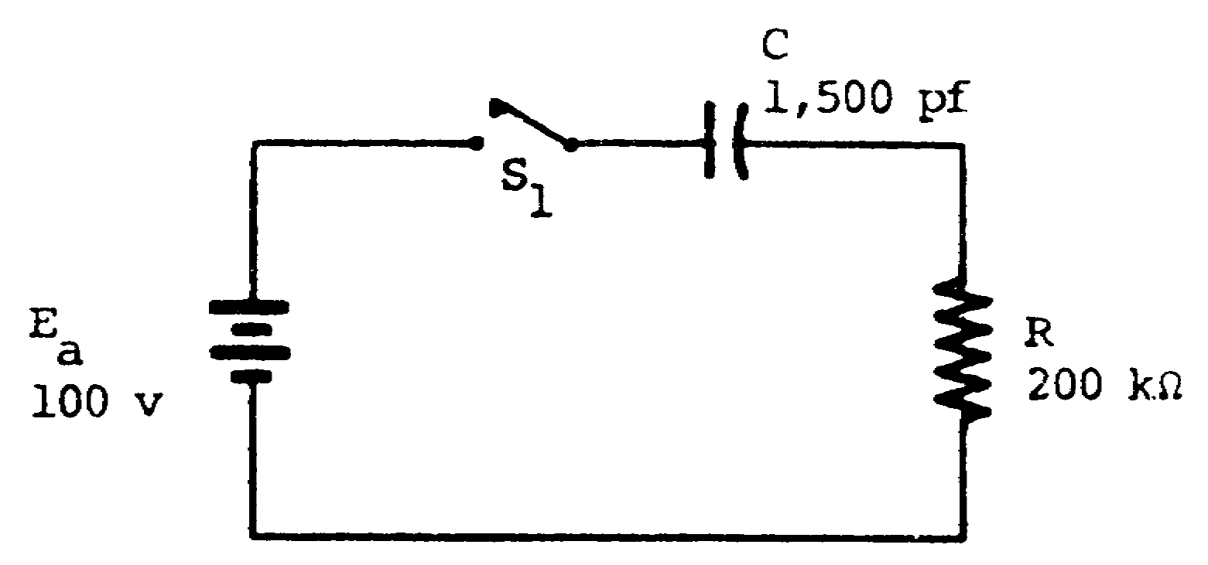

ER = _______________

130

90 v 47. Compute RC time, Eeff, #TC, percentage of change, ΔEc, and Ec in the circuit shown below (PW = 1,800 microseconds).

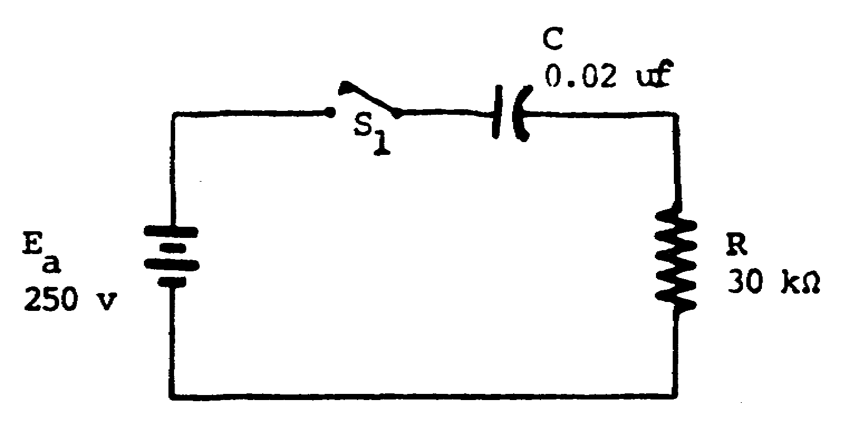

RCT = ___________ %Δ = __________
Eeff = ___________ ΔEc = __________
#TC = ___________ Ec = __________

131

RCT = 600 usec
Eeff = 250 v
#TC = 3
%Δ = 95%
ΔEc = 237.5 v
Ec = 237.5 v

132

